**Corrected figures**



**Figure 1**. Dissolution of Mn from a black copper mineral with the use of Fe0 in 4 experimental series: 1) standard conditions (only H2SO4), 2) with the use of the reducing agent (Fe0) without prior agglomeration (Fe), 3) with prior agglomeration (Fe + pretreatment NaCl) and 4) with prior agglomeration with NaCl addition (Fe+ pretreatment NaCl+ NaCl) (data are average of n=2)



**Figure 2**. Dissolution of Mn from a black copper mineral with the use of Fe2+ in 4 experimental series: 1) standard conditions (only H2SO4), 2) with the use of the reducing agent (Fe2+) without prior agglomeration (Fe2+), 3) with prior agglomeration (Fe2+ + pretreatment NaCl) and 4) with prior agglomeration with NaCl addition (Fe2++ pretreatment NaCl+ NaCl) (data are average of n=2) (Figure modified from Torres et al.,[17])



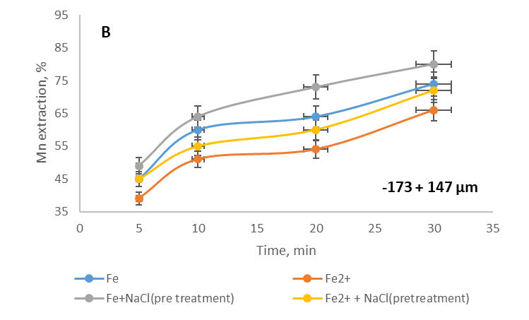

**Figure 3.** Effect of particle size on the Mn extraction from black copper with the use of two reducing agents without prior agglomeration (Fe0 and Fe2+) and with prior agglomeration (Fe0/Fe2+ + pretreatment NaCl) at two particle sizes: A) -90 + 75 µm; B) -173 + 147 µm (data are average of n=2)