Dear reviewer
The particle size used in this study was added in section 2.2 Leaching test.
"Chalcocite ore in a size range between 147 ± 104 µm"

Regarding what was requested, results of similar studies were included for the extraction of copper from chalcopyrite, indicating how the different parameters mentioned influence.

The text and additional figure included in the results section is attached below:

The methodology used in the present manuscript to evaluate the extraction of copper from chalcocite has also been used for other copper minerals, as for example, in the study carried out by Pérez et al. [1] for covelline, and the study by Aguirre et al. [2] for chalcopyrite, the world's most abundant copper mineral [3]–[5]. Aguirre et al. [2] adjusted an analytical model (based on the response surface methodology [6], [7]) to study the dynamics of copper extraction from a pure chalcopyrite mineral, evaluating the working parameters shown in Table 2.
TABLE 2. Experimental parameters for the ANOVA model (modified from Aguirre et al. [2]).
Variable | Low | Medium | High
Imidazolium-based ionic liquid (v/v) | 20 | 40 | 60
Chloride (g/L) | 0 | 50 | 100
H₂SO₄ (mol/L) | 0 | 0.25 | 0.5
Temperature (°C) | 30 | 60 | 90

The results of the work developed by Aguirre et al. [2] indicate that the concentration of chloride in the system and the increase in temperature have a synergistic effect on the extraction of copper from chalcopyrite, while operational variables such as the concentration of ionic liquid and sulfuric acid did not influence the dissolution of CuFeS₂ (see Figure 5). Finally, Aguirre et al. [2] indicate that the optimal working conditions obtained through the response surface methodology are: ionic liquid at a concentration of 20% v/v, chloride at a concentration of 100 g/L and a temperature of 90 °C. These results are consistent with other studies [8]–[13], where high copper extractions from chalcopyrite are not achieved, except when working at temperatures of 60 °C or higher. Only in the studies conducted by Toro et al. [14] and Torres et al. [15] it is possible to dissolve CuFeS₂ at room temperature, working at high concentrations of MnO₂ (MnO₂/CuFeS₂ ratios of 4/1 or higher) and chloride in the system (~ 40 g/L), however, this requires very high concentrations of oxidizing agent with respect to the mineral to be dissolved, which makes it difficult to apply on an industrial scale.
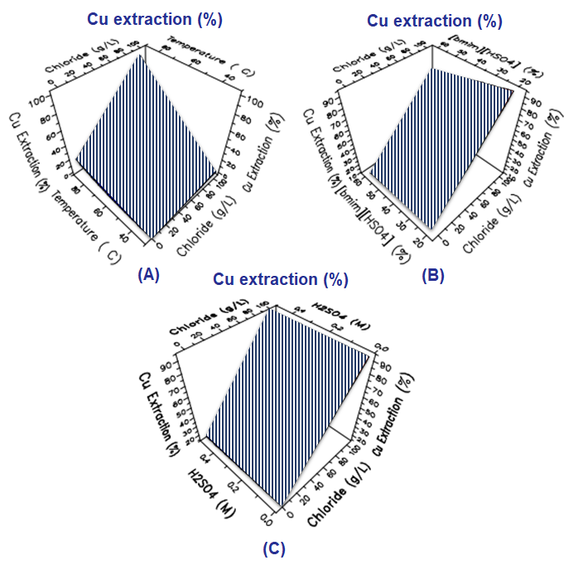
Figure 5. Response surface for the extraction of Cu at chloride concentration and temperature, ionic liquid: 20% v/v; H₂SO₄: 0 M (A), chloride concentrations and ionic liquid at T: 90 °C; H₂SO₄: 0 M (B), and chloride concentration and H₂SO₄ at T: 90 °C; IL: 20% v/v (C).

REFERENCES
[1] K. Pérez, N. Toro, M. Saldaña, E. Salinas-Rodríguez, P. Robles, D. Torres, and R. I. Jeldres, “Statistical Study for Leaching of Covellite in a Chloride Media,” Metals (Basel)., vol. 10, no. 4, p. 477, Apr. 2020.
[2] C. L. Aguirre, N. Toro, N. Carvajal, H. Watling, and C. Aguirre, “Leaching of chalcopyrite (CuFeS2) with an imidazolium-based ionic liquid in the presence of chloride,” Miner. Eng., vol. 99, pp. 60–66, Dec. 2016.
[3] Sokić, Marković, Stanković, Kamberović, Štrbac, Manojlović, and Petronijević, “Kinetics of Chalcopyrite Leaching by Hydrogen Peroxide in Sulfuric Acid,” Metals (Basel)., vol. 9, no. 11, p. 1173, Oct. 2019.
[4] J. Wang, F. Faraji, and A. Ghahreman, “Effect of Ultrasound on the Oxidative Copper Leaching from Chalcopyrite in Acidic Ferric Sulfate Media,” Minerals, vol. 10, no. 7, p. 633, Jul. 2020.
[5] P. C. Hernández, M. E. Taboada, O. O. Herreros, T. A. Graber, and Y. Ghorbani, “Leaching of chalcopyrite in acidified nitrate using seawater-based media,” Minerals, vol. 8, no. 6, 2018.
[6] D. C. Montgomery, Montgomery: Design and Analysis of Experiments, 8th ed. New York: John Wiley & Sons, 2012.
[7] M. A. Bezerra, R. E. Santelli, E. P. Oliveira, L. S. Villar, and L. A. Escaleira, “Response surface methodology (RSM) as a tool for optimization in analytical chemistry,” Talanta, vol. 76, no. 5, pp. 965–977, Sep. 2008.
[8] L. Velásquez-Yévenes, D. Torres, and N. Toro, “Leaching of chalcopyrite ore agglomerated with high chloride concentration and high curing periods,” Hydrometallurgy, vol. 181, pp. 215–220, Nov. 2018.
[9] M. Rodríguez, L. Ayala, P. Robles, R. Sepúlveda, D. Torres, F. R. Carrillo-Pedroza, R. I. Jeldres, and N. Toro, “Leaching chalcopyrite with an imidazolium-based ionic liquid and bromide,” Metals (Basel)., vol. 10, no. 2, pp. 1–13, 2020.
[10] P. Hernández, G. Gahona, M. Martínez, N. Toro, and J. Castillo, “Caliche and Seawater, Sources of Nitrate and Chloride Ions to Chalcopyrite Leaching in Acid Media,” Metals (Basel)., vol. 10, no. 4, p. 551, 2020.
[11] P. Hernández, A. Dorador, M. Martínez, N. Toro, J. Castillo, and Y. Ghorbani, “Use of Seawater/Brine and Caliche’s Salts as Clean and Environmentally Friendly Sources of Chloride and Nitrate Ions for Chalcopyrite Concentrate Leaching,” Minerals, vol. 10, no. 5, p. 477, May 2020.
[12] C. P. Cerda, M. E. Taboada, N. E. Jamett, Y. Ghorbani, and P. C. Hernández, “Effect of pretreatment on leaching primary copper sulfide in acid-chloride media,” Minerals, vol. 8, no. 1, pp. 1–14, 2018.
[13] Y. Li, G. Qian, J. Li, and A. Gerson, “Chalcopyrite Dissolution at 650 mV and 750 mV in the Presence of Pyrite,” Metals (Basel)., vol. 5, no. 3, pp. 1566–1579, Aug. 2015.
[14] N. Toro, K. Pérez, M. Saldaña, R. I. Jeldres, M. Jeldres, and M. Cánovas, “Dissolution of pure chalcopyrite with manganese nodules and waste water,” J. Mater. Res. Technol., vol. 9, no. 1, pp. 798–805, Jan. 2020.
[15] D. Torres, L. Ayala, R. I. Jeldres, E. Cerecedo-Sáenz, E. Salinas-Rodríguez, P. Robles, and N. Toro, “Leaching Chalcopyrite with High MnO2 and Chloride Concentrations,” Metals (Basel)., vol. 10, no. 1, p. 107, Jan. 2020.

