Review article
High temperature materials: properties, demands and applications

Marko Simić¹, Ana Alil², Sanja Martinović³, Milica Vlahović³, Aleksandar Savić⁴,
Tatjana Volkov Husović^{5,}*

¹University of Belgrade, VINČA Institute of Nuclear Science-
National Institute of thе Republic of Serbia, Mike Petrovića Alasa 12-14, Vinča, Belgrade, Serbia
²Innovation Center of the Faculty of Technology and Metallurgy,
Karnegijeva 4, Belgrade, Serbia
³University of Belgrade, Institute of Chemistry, Technology and Metallurgy-
National Institute Of The Republic Of Serbia, Karnegijeva 4, Belgrade, Serbia
⁴University of Belgrade, Faculty of Civil Engineering,
Bulevar Kralja Aleksandra 73, Belgrade, Serbia
⁵University of Belgrade, Faculty of Technology and Metallurgy,
Karnegijeva 4, Belgrade, Serbia
Paper received: 21 April 2020
Paper accepted: 01 July 2020
DOI: https://doi.org/10.2298/HEMIND200421019S
UDC: 666.3: 697.1:621.315.61

*Corresponding author: tatjana@tmf.bg.ac.rs

ABSTRACT
High-temperature materials are used in a wide range of industries and applications such as gas turbine engines for aircrafts, power and nuclear power plants, different types of furnaces, including blast furnaces, some fuel cells, industrial gas turbines, different types of reactors, engines, electronic and lighting devices, and many others. Demands for high-temperature materials are becoming more and more challenging every year. To perform efficiently, effectively and at the same time to be economically viable, the materials used at high temperatures must have certain characteristics that are particularly expected for applying under such extreme conditions, for example, the strength and thermal resistance. In the present review, some important requirements that should be satisfied by high temperature materials will be discussed. Furthermore, the focus is put on refractory concretes, ceramics, intermetallic alloys, and composites as four different categories of these materials, which are also considered in respect to possibilities to overcome some of the current challenges.

Keywords: refractory concretes; ceramics; composites

- INTRODUCTION
High-temperature materials can be defined as materials that are able to withstand temperatures above 540°C [1-4]. For these temperatures, many different materials can be a suitable selection, and some of the commonly used are ceramics, some metals and alloys such as certain stainless steels, superalloys, refractory metals and composites. These materials are used in furnaces for different applications (synthesis processes for metals, ceramics, refractories, heat treatment, etc.), aircraft jet engines, electronic and lighting devices, industrial turbines, and nuclear reactors. Demands for new advanced materials as well as for improvement of the existing construction materials are related to the several mail properties, and moreover, to the combination of properties [5-10, 12] in high-temperature ranges.

  - REQUIREMENTS FOR HIGH TEMPERATURE MATERIALS
Selection of an appropriate material for high-temperature applications should be based on requirements for thermal, chemical, and mechanical properties, as well as on the cost. These properties could be related to the resistance to different influences (chemicals, high temperature, corrosion, pressure, etc). One of the problems with all materials, especially materials for high-temperature application, is associated with requirements for certain service life. Namely, prolonged service life of a material decreases its cost, so it will become consequently more desirable from an economic point of view [13]. It is very hard and challenging to produce a material for high-temperature application with long service life (up to several years in industrial situations). For example, the service life for such materials, used in different applications where the operating temperatures range up to 1500 °C (e.g. steam turbines and high-temperature gas-cooled reactors, etc.), is expected to be 1 million hours [14].
On the other hand, if applied temperatures are significantly higher, for example around 3000 °C, the material maximal lifetime could be just around 10000 hours in advanced application such as in electrical furnace equipment. According to published literature [1] required service life times of selected components at working temperatures can be presented as in Figure 1.
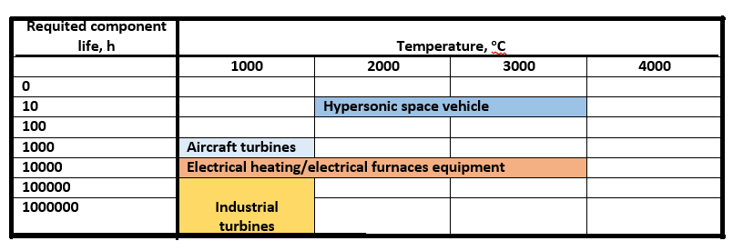
Figure 1. Different components/materials depending on requirements for component material service life and operating temperature [1]

The economic aspect in materials selection is very important and could be focused on variety of parameters such as: long service lifetime (upon several years), low cost of repair and replacement, including the impact to the operation process. Sometimes this could involve many plant start-ups and shutdowns and not all of the operations involve the highest process temperatures [1,15-18]. High-temperature applications may demand components made of several materials if the set design requirement to be achieved is wide, and includes other demands [19]. Such solutions could include special barriers and coatings (thermal barrier coatings, coating with special chemical or mechanical resistance), keeping in mind compatibility of the selected materials. In addition to required chemical, physical, mechanical and thermal properties demands for materials selection often include environmental resistance [20]. Different materials related to the usual temperature range they can withstand are presented in Figure 2.

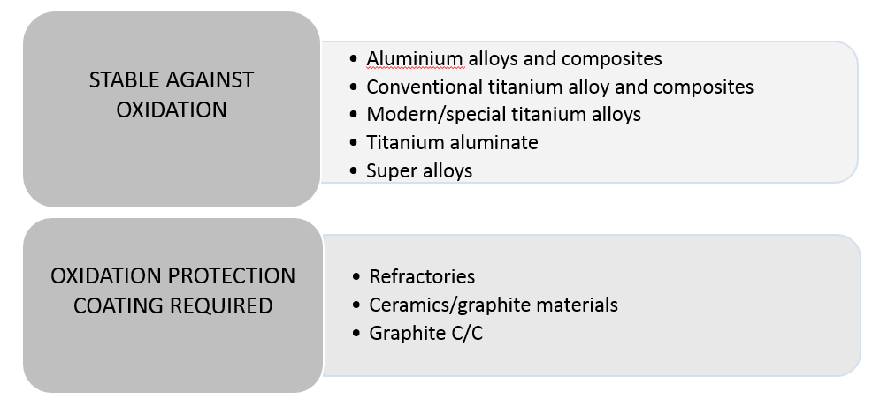
Figure 2. Possible materials for applications in different operating temperature ranges

It can be noticed that it is possible to choose between different materials for the same temperature range depending on other demands and influences (chemical, pressure, mechanical). In applications at low temperatures, up to 1000 °C, usual materials that are used are aluminum and titanium alloys and composites, as well as titanium aluminate. At these temperatures, the applied materials are stable against oxidation. At some more challenging conditions, which include temperatures over 1000 °C, superalloys, ceramic and graphite materials as well as refractory metals are mostly used. These temperatures also often require oxidation protection coatings on the base material, unless refractory concretes are used.
The mostly expected requirements for high-temperature materials are:
1. Environmental resistance
2. Erosion resistance
3. Wear resistance
4. Suitable mechanical behavior
5. Suitable physical properties
Some of these requirements will be discussed in the present review.
High-temperature environment and its influence on the material can be very challenging. At the these temperatures corrosion is often involved, which can include influences of oxygen, sulfur oxides, carbon oxides, nitrogen, and its oxides, as well, ash and salt deposits, including molten salts [21].
Environmental resistance usually includes oxidation resistance, sulfidation resistance, salt-and ash-deposit corrosion resistance, and carburization resistance.
Erosion resistance is usually required when a moving fluid is in contact with the material. Also, the influence of different types and dimensions of particles in the fluid can induce faster erosion processes. Erosion can be occurring in materials alone, but more often it is combined with different types of corrosion processes. Simultaneous effects of erosion and corrosion processes are noticed in fluidized beds used for electric power generation [1].
According to the standard DIN 50320, wear is a continuing mass loss of a material due to mechanical action, i.e. contact and relative movements of a solid, liquid or gaseous counter body. Different wear mechanisms can occur, inducing different wear patterns. Unfortunately, the surface of the material can be subjected to the combination of different wear mechanisms. High temperatures accompanied by friction usually accelerate wear as well as chemical and mechanical influences [22].
There is a wide range of terms available for description of wear mechanisms, but at least four groups can be recognized: adhesive, abrasive, corrosive and fatigue [15, 20-22].
Mechanical behavior considerations for high temperature materials include following features:
– zero-time deformation,
– creep,
– mechanical fatigue,
– thermo-mechanical fatigue, and
– corrosion-fatigue.

Creep is slow, continuous real time deformation in solid materials particularly occurring in materials exposed for long times to high temperatures. For metals, creep occurs at temperatures above 0.3/0.4 of the melting temperature expressed in absolute degrees [1]. At relatively low temperatures, creep is restricted by grain boundaries or precipitates, which restrict dislocation movement. At higher temperatures, dislocations can move (climb out of their blocked slip plane) continuing the creep process [1]. Movement of the dislocations is controlled by diffusion. Many crystalline solids have similar activation energies which are related to creep and self-diffusion processes [15].
A wide range of physical properties have different influences on the behavior of materials at high temperatures, as well as on the lifetime of components. The properties important to study for high-temperature applications are [1]:
- density,
- thermal expansion coefficient,
- thermal conductivity,
- Young's modulus, and
- hardness.

- MATERIALS

There is an abundance of different materials that can find use as high-temperature materials. In this review, four different categories of materials will be assessed as presented in Figure 3.

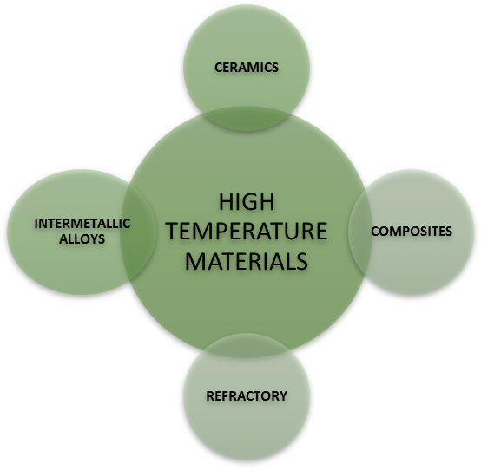
MATERIALS
CONCRETES

Figure 3. Categories of materials for high-temperature applications [23]

2.1 Refractory concretes

For more than 60 years refractory concretes have been applied under high-temperature industrial conditions. The advantage of these materials is in high strength values even at high working temperatures so that they are commonly used in steel, glass and chemical industries among many. Above 400ºC, or more precisely around 500ºC, the hydrated phase (Ca(OH)₂) dehydrates to CaO, which can rehydrate if being left under atmospheric conditions. These phenomena are followed by cracking, expanding, and losing the material strength, therefore, it is believed that refractory concretes need to be used at operating temperatures above 500ºC [24]. Refractory concretes belong to the group of monolithic refractory materials. In the beginning, their applications were intended as substitutes for more complex previously used materials.
Refractory concretes were discovered in the USA, with the first recorded application dating back to as early as the World War Two followed by later applications in Japan. Since these materials are easy and simple to install, soon they found the use in the steel industry. In the last few decades, there is a trend to replace firebricks with refractory concretes becoming prevalent, especially in steel and iron industries, and resulting in the fact that nowadays refractory concrete yields 40% of all refractory materials produced in more developed countries [25]. Also, refractory concretes have become recently one of the fastest-developing branches of the industry of refractories. An important advantage of using refractory concretes is the avoidance of joints distinctive for refractory bricks, and, thus, exclusion of possible weak spots in reactor linings. Refractory concretes can be used at temperatures that exceed 1500ºC. On the market, they are found as dry mixtures that are then mixed onsite with water or another liquid. Upon the mixing, these materials harden at high or normal temperatures, while exhibiting limited shrinkage or expansion at the application temperature [26]. These materials have many advantages over different types of concretes, some of which are listed in Figure 4.
During the use, refractory concretes are exposed to different strains and wear mechanisms, some of them being: mechanical loads, abrasion, and corrosion as well as thermal shock. Under these conditions, behavior of refractory concretes is influenced by their chemical and phase composition as well as the microstructure, which strongly affects the thermal and mechanical properties.
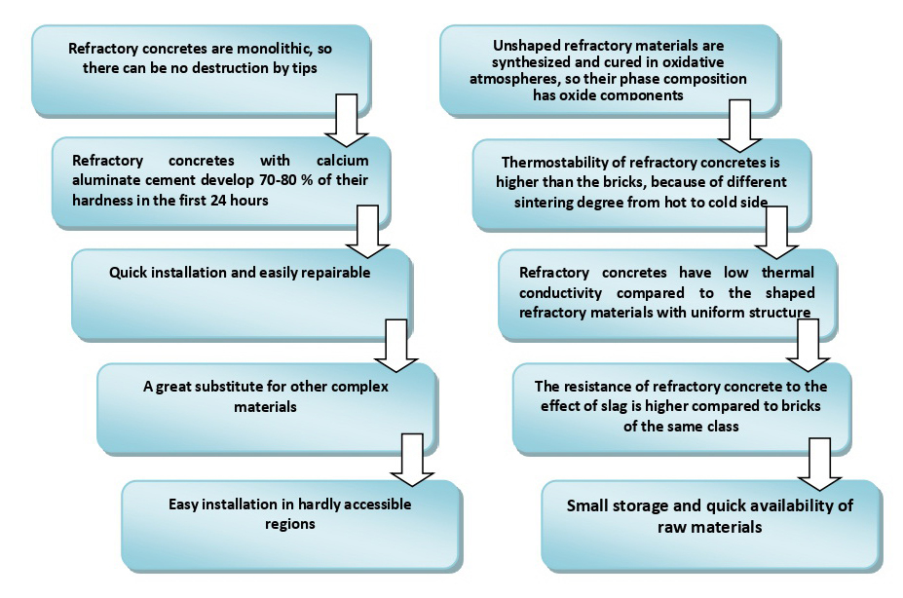
Figure 4. Advantages of refractory concretes [26]

Refractory concretes or so-called "refractory castables" contain certain heat resistant aggregate and the corresponding hydraulic cement. Many ingredients can be added in small quantities with the aim to control the setting time, hardening rate, workability, strength, expansion due to reheat, etc. [24]. The aggregate is the major component of refractory concrete, usually comprising approximately 75% of the mixture. The high-temperature resistant aggregate grains are held together by hydraulic, chemical or ceramic bonds, thus forming a solid mass that has adequate properties both before and after sintering at high temperature. The aggregate purity is an important parameter governing refractory properties so that high purity, in general, will improve the material properties, but unfortunately also increase the costs [26,27]. Aggregate grading and packing are very important in producing a good quality product, so that loose packing can cause low density and therefore low strength. In order to have a compact packing, a close pack system with carefully sized aggregates is applied. Some typical aggregates are calcined fireclay, kyanite, calcined bauxite and sintered alumina [24-26]. When these materials are properly synthesized, cured and sintered, they become inert and volume stable.

2.2. Ceramic materials

Environmental impact of ceramic, as well as of all other building materials, is of ever-growing importance, thus inducing fast development and design of environment-friendly materials. Environmental impacts that should be minimized in order to achieve sustainability are related to all of the ceramic manufacture phases such as raw materials processing, synthesis, forming techniques, transportation, and consumption of natural resources including materials and energy [28-33].
Therefore, ecology and energy are the two main fields regarding which improvements of ceramic materials and the manufacturing process are attempted. The first approach is based on ratification of the Kyoto protocol focusing on preserving the environment by applying novel methods especially directed to minimization of the ozone layer damage [32]. The second approach focuses on saving energy, which is beneficial from both the economical point of view and the attempt to preserve the lacking fossil fuel stocks. Consequently, the emphasis of recent research is put on achieving higher efficiencies, on one hand, and on decreasing harmful emissions, most notably CO₂ and NO_{x}, on the other. Different options are envisaged for achieving this goal, and one of them is weight reduction of turbine and motor components while increasing their operational temperature. If this is accomplished, and in combination with little or absence of cooling air systems, too, lower fuel consumption, reduced harmful emissions and higher reliability will be achieved [33]. Materials used in these applications until now were superalloys. However, increasing demands make these materials not suitable in terms of sustainability, so that ceramic materials have become excellent candidates for replacement [34]. Ceramic materials are usually characterized with good mechanical (compressive and flexural strength, fracture toughness, thermal stability, creep), chemical (resistance to corrosion), tribological (resistance to wear and erosion) and physical properties (thermal conductivity, density, thermal expansion coefficient). Additionally, a very important feature of these materials is stability of all of these properties staying in the same ranges for long operating times including operation at high temperatures [35]. Some of the ceramic material types mostly used at high-temperature conditions, especially in energy and transport industries, are ceramic matrix composites (CMCs), thermal barrier coatings (TBCs), environmental barrier coatings (EBCs), and ceramic materials for solid oxide fuel cells (SOFCs) [36].

Ceramic Matrix Composites (CMCs)

Along with the great potential of ceramic materials for utilization at high temperatures, there is a persistent problem with monolithic ceramics, more precisely, their catastrophic failure under high temperatures and basic brittleness, which cause low damage tolerance of components used under certain conditions. One way for overcoming this problem is by incorporating a reinforcement phase to the matrix as it amplifies the fracture toughness of the material [37].
In addition to oxide ceramics, which are used for a long time and for many applications, recently non-oxide CMCs are being mostly applied for challenging conditions. The reason is related to very high refractoriness and strength values as well as low wetting angles of these materials. These properties are advantageous for many applications in metallurgical engineering (e.g. steel plants, furnaces for different processes). Also, non-oxide CMCs could be used under demanding conditions for different types of turbines [38], engines [39], vehicles [40] and friction systems [41,42]. In these applications carbon or SiC fibers and reinforced SiC-based materials (C/SiC or SiC/SiC composites) are widely utilized especially since such composites exhibit better properties as compared to monolithic materials [43].

Thermal Barrier Coatings (TBCs)
Extreme temperature conditions in certain industrial environments require use of protective ceramic materials as thermal barrier coatings (TBCs) [44]. Application of these materials is related to high temperatures, as well as corrosive and oxidizing environments. TBCs are successfully applied as protective coatings for different turbine types, combustion lines, and different types of blades resulting in extension of the life time of these parts [44-48].

Environmental Barrier Coatings (EBCs)

Materials based on silicon nitride (Si₃N₄) and silicon carbide (SiC) are used for turbine engine combustion environments [40, 42] due to formation of a protective silica layer, which is highly resistant to oxidation [48-50}. However, this layer reacts with water vapor leading to recession. Thus, environmental barrier coatings (EBCs) are developed as a solution to provide chemical protection, phase stability at the working/operating conditions, and low chemical reactivity under different (corrosive or oxidizing) environments [51].

Ceramic Materials for Solid Oxide Fuel Cells (SOFCs)

Power generated by fuel cells, as opposed to that produced by classical energy conversion systems is becoming vastly important. Some fuel cells are more efficient than others, and among them the most productive one is the solid oxide fuel cell (SOFC), which has also the advantage in high flexibility regarding fuel that could be hydrogen, carbon monoxide or hydrocarbons like methane [39]. A SOFC consists of four elements, as it is shown in Figure 5.

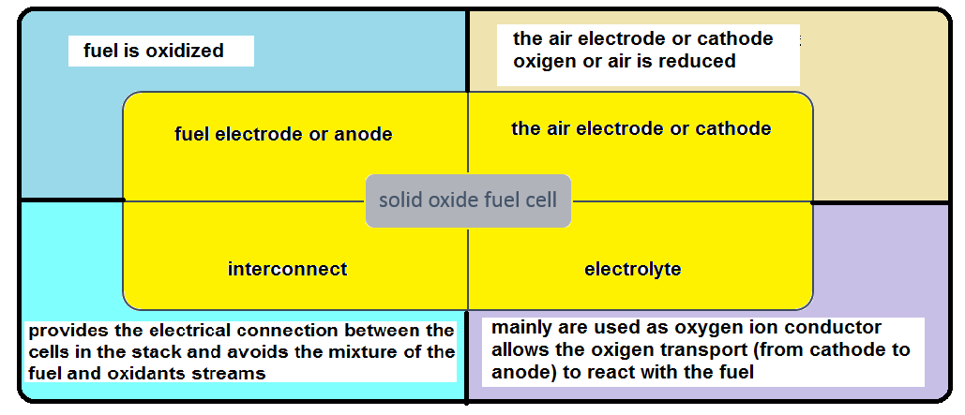
Figure 5. Schematic presentation of a solid oxide fuel cell

The conventional SOFCs operate at high temperatures in the range 800–1000°C, which induce high fabrication costs, especially those of the interconnect. Also, good integration of the SOFC components could be a challenging task to achieve. Therefore, combination of SOFC devices with other ceramic materials should be investigated in order to provide the use at intermediate temperatures (500–700 °C). Another improvement is related to modifications of the cell configuration, which could also result in the cost reduction [39].
There is a huge number of articles related to general [48-52] and specific (electrolyte [50], electrodes [51] and interconnect [52]) problems related to SOFC devices. A specific interest is in the development of SOFCs in combination with ceramic materials different from the previously used (conventional).

2.3 Intermetallic alloys

Intermetallic compounds can be described as crystal structures with an ordered arrangement and consisting of alloy phases formed between two or more metallic or semimetallic elements. In these structures, the alloy phases are arranged as two or more sub-lattices, defining the atomic structure. Intermetallic alloys with arranged structures exhibit superior high-temperature properties, which could be explained by the long-range-ordered super-lattice, which reduces the dislocation mobility, thus also reducing diffusion processes at operating (elevated) temperatures [53]. The usual materials of this type used for high temperature applications are nickel and iron aluminides, different types of steels (carbon and alloy steels, stainless 300 and 400 series), nickel, titanium and aluminum based alloys.
Each class of materials has its own importance based on the unique set of material properties. It is well known that many physical parameters affect the material mechanical properties, so it would be useful to determine several key properties based on available data, that could serve as guides for selection of the appropriate components. There are numerous candidates and possible combinations as the research has shown that there are nearly 300 binary compounds that melt above 1500°C. Two basic physical properties were shown to be crucial for starting the selection: the melting temperature (T_{m}) and the relative density (ρ). There are also several more useful structure intensive properties, such as: stiffness, elastic modulus, and the thermal expansion coefficient [53-56]. Since these properties depend on the final microstructure, they could be helpful indicators of minor variations in alloying elements and resulting mechanical properties. Dependence of these properties on the material structure and the consequent materials selection process are described in literature [53-57].

2.4. Composites

Over the course of the last decade, different composites have shown impressive improvements provoking the primary interest of military and space industries [58]. Most of such applications include service temperatures below 120ºC. A lot of attention is also being put on expanding the usage of composites to different areas with the operating temperatures in the range of 200-400 ºC [59]. Some interesting applications include structural and non-structural parts of aero-engines and airframe components for supersonic or hypersonic aircrafts. Development of different polymer materials with attractive properties (bismalemides, polymides, cyanates, liquid crystalline polymers) make the list of possible composite materials wider [60]. However, the selection of appropriate technologies and processes for composite production has to be carefully performed in order to achieve the specific requirements, as well as to afford the production costs [61]

3. Applications of high temperature materials

Full understanding of material properties (mechanical, physical and chemical) and selected production processes of materials with required properties can lead to innovative materials for entirely different and new applications. It should be kept in mind, that characterization of conventional materials is performed by conventional testing procedures, while new materials and their possible applications will require advanced or new testing methods and procedures for material characterization and understanding [1-7].
High temperature materials are applied in processes and industries with very specific demands for material properties that are hard to achieve. Such examples are: thermal processing (including metallurgical engineering), chemical, marine, road, aircraft and space industries [62].

3.1. Thermal Processing
High temperature processes are employed in many industries, such as chemical and metallurgical engineering, ceramic, cement and glass industries. Equipment in these industries includes many different furnaces, reactors and kilns as well as heat exchangers, which all have in common the need for high temperature resistant materials in the construction [63].

3.2 Chemical Industry
Processes and treatments at high temperatures and pressures can be found in chemical industry, as well. Construction materials for chemical reactors have to exhibit resistance to high temperatures, corrosion, oxidation or reduction processes, high pressures, as well as to other specific environmental conditions. Many of the used materials belong to thermal barrier coatings, alloys with selected properties (stainless steel, spatial aluminum alloys, heat resistant alloys), ceramic and composite materials [64]. As fuels are often used for generating heat required, flue gasses at high temperatures become a problem, which is commonly solved by using heat exchangers for energy efficiency and savings, as well as filters and other waste gas treatment processes and equipment. High temperature materials have to be utilized in these processes as working temperatures in oil industry, in some catalytic processes, for example, may be in the range of 950-1050 °C [65].

3.3 Aircraft and Space Vehicles
Development of novel materials with designed properties is closely related to modern industries, and their demands. Aircraft and space industries are such modern industries, both with specific requirements for materials used in any part of aircraft or space vehicle. In response, many modern materials were designed, such as superalloys, refractory metals, tungsten, and special varieties of graphite and carbide and nitride ceramics and composites. These materials exhibit thermal resistance, resistance to thermal shock, high thermal stresses, and resistance to corrosion and erosion [66].

3.4 High-temperature steam turbines
Steam turbines often operate at temperatures around 600°C, but at some conditions these temperatures could be higher. Requirements for adequate materials include high thermal stability, and resistance to corrosion and cavitation. Based on optimized material for the specific operating conditions parts such are rotors, blades, nozzles, and piping could be produced with high reliability and economic life time [68].

3.5 Nuclear reactors
Compared to materials described in previous chapters and operating conditions in most of industries, materials for nuclear reactors have to be resistant to specific cooling fluids (helium, sodium). Also, along with high temperature resistance materials for nuclear reactors have to be resistant to corrosive and erosive attacks [69].

3.6 Marine INDUSTRY

Traditional materials mostly used in the marine industry over the years include wood, steel and concrete. Influence of salt water and specificities of marine vehicles impose material requirements such as corrosion resistance, good strength to weight ratio, possibilities to achieve specific geometry demands, and low cost. Advanced materials include sulfur concrete [71, 72], cement and cement based composites [73,74], glass reinforced plastic materials, ferrocement, and aramid fibers composites. These new materials require development of novel testing procedures for material life cycle assessment [75].
Some types of ships still use diesel motors, which are subjected to severe mechanical or thermal stresses and corrosive attacks at high temperatures during operation [70]. These temperatures could be around 800°C, at some specific parts, as in pre-combustion chambers, exhaust valves, and parts related to high mechanical stresses.

3.7 Road and Rail

The most widely used material for rails is pearlitic steel, because of its ability to resist wear, which is one of the most important properties for this application. Also, diesel engines are still widely used for road and rail transport, as well mentioned above in marine industry [76]. Besides the wear resistance, corrosion resistance is of high importance, as refined fuels are often used rather than the heavier residual oils utilized in marine engines. Environmental conditions have to be taken into account, such as large temperature intervals including operation at low as well as high temperatures requiring corrosion resistance.
- CONCLUSION
This review paper discusses the most important materials applied under high temperature conditions as well as their main properties and industrial applications. Besides, this review can be considered as a guideline for materials selection according to different needs, as the main uses for all material types are discussed. Requirements for high-temperature applications have been explained, with the most notable being environmental resistance, erosion and wear resistance, and suitable mechanical and physical properties.

Acknowledgements
This work was supported by the Ministry of Education, Science and Technological Development of the Republic of Serbia (451-03-68/2020-14/200135, 451-03-68/2020-14/200026 and 92166/3-19)

REFERENCES
- Meetham GW, Van de Voorde MH. Materials for High Temperature Engineering Applications. 1st ed., Berlin Heidlberg: Springer-Verlag; 2000.
- Gupta OP. Elements of Fuels, Furnaces and Refractories. 6th ed., New Delhi: Khanna Publishers; 2014.
- Schacht CA. Refractories Handbook. 1st ed., New York, NY: Marcel Dekker, Inc.; 2004.
- Bengisu M. Engineering Ceramics. 1st ed., Berlin Heidlberg: Springer-Verlag; 2001.
- Spear KE, Visco S, Wuchina EJ, Wachsman ED. High Temperature Materials. Electrochem. Soc. Interface. 2006; 15: 48-51.
- Bar-Cohen Y. High Temperature Materials and Mechanisms, 1st ed., Boca Raton, FL: CRC Press; 2017.
- Clemens H, Mayer S. Intermetallic titanium aluminides in aerospace applications– processing, microstructure and properties. Mater at High Temp. 2016; 33: 560-570.
- Skelton RP, Gandy D. Creep– fatigue damage accumulation and interaction diagram based on metallographic interpretation of mechanisms. Mater at High Temp. 2008; 25: 27-54.
- Licker M. McGraw-Hill Concise Encyclopedia of Engineering. New York, NY: McGraw- Hill Education- Europe; 2005.
- Naumenko K, Krüger M. Advances in Mechanics of High-Temperature Materials. 1st ed., Springer International Publishing; 2020.
- Total Materia. The world’s most comprehensive database. https://www.totalmateria.com/page.aspx?ID=CheckArticle&site=kts&NM=355. Accessed June 17, 2019.
- Shabalin IL. Ultra-High Temperature Materials I. 1st ed., Springer Netherlands; 2014.
- AZO Materials.
https://www.azom.com/article.aspx?ArticleID=17267. Accessed November 27, 2019.
- Blau PJ. Friction and Wear Transitions of Materials: break-in, run-in, wear-in. 1st ed., Park Ridge, New Jersey, USA: Noyes Publications; 1989.
- Knowels GD. Mechanisms of Wear Particle Formation and Detachment (MSc Thesis). University of British Columbia, Vancouver; 1994.
- Ludema KC. Friction, Wear, Lubrication: A Textbook in Tribology. 1st ed., Boca Raton, FL: CRC Press; 1996.
- Bhushan B. Principles and Application of Tribology. 1st ed., New York, NY: A Wiley-Interscience Publication; 1999.
- Zmitrowicz A. Wear Patterns and Laws of Wear– A Review. J Theor App Mech. 2006; 44: 219-253.
- Drogen M van. The Transition to Adhesive Wear of Lubricated Concentrated Contacts (PhD Thesis). University of Twente, Enschede; 2005.
- Kato K. Classification of Wear Mechanisms/ Models. Proc Instn Mech Engrs, Part J: J Engineering Tribology. 2002; 7: 349-355.
- Wallis RA, Craighead IW. Predicting Residual Stresses in Gas Turbine Components. JOM. 1995; 47: 69-71.
- Varenberg M. Towards a unified classification of wear. Friction. 2013; 1: 333-340.
- Srivastava S. What are recent advantages in high-temperature materials for jet engines?
https://www.prescouter.com/2019/06/jet-engines-high-temperature-materials/. Accessed January 23, 2020.
- Martinovic S, Dojcinovic M, Dimitrijevic M, Devecerski A, Matovic B, Volkov Husovic T. Implementation of image analysis on thermal shock and cavitation resistance testing of refractory concrete. J Eur Ceram Soc. 2010; 30: 3303-3309.
- Martinovic S, Vlahovic M, Boljanac T, Majstorovic J, Volkov Husovic T. Inﬂuence of sintering temperature on thermal shock behavior of low cement high alumina refractory concrete. Compos B Eng. 2014; 60: 400-412.
- Martinovic S. Ispitivanje uticaja temperature sinterovanja na termostabilnost niskocementnih visokoaluminatnih vatrostalnih betona (Doctoral disseration). University of Belgrade, Faculty of Technology and Metallurgy, Belgrade; 2011. (in Serbian)
- Martinovic S, Vlahovic M, Stevic Z, Volkov Husovic T. Inﬂuence of sintering temperature on low level laser (LLL) destruction of low cement high alumina refractory concrete. Eng Struct. 2015; 99: 462-467.
- Tikul N, Srichandr P. Assessing the environmental impact of ceramic tile production in Thailand. J Ceram Soc Jpn. 2010; 118: 887-894.
- Rivela B, Moreira MT, Feijoo G. Life cycle inventory of medium density fibreboard. Int J Life Cycle Assess. 2007; 12: 143-150.
- Asif M, Muneer T, Kelley R. Life cycle assessment: A case study of a dwelling home in Scotland. Build Environ. 2007; 42: 1391-1394.
- Nebel B, Zimmer B, Wegener G. Life Cycle Assessment of Wood Floor Coverings- A Representative Study for the German Flooring Industry. Int J Life Cycle Assess. 2006; 11: 172-182.
- Belmonte M. Advanced Ceramic Materials for High Temperature Applications. Adv Eng Mater. 2006; 8: 693-703.
- Corman GS, Dean AJ, Brabetz S, Brun MK, Luthra KL, Tognarelli L. Rig and engine testing of melt infiltrated ceramic composites for combustor and shroud applications. J Eng Gas Turb Power. 2002; 124: 459–464.
- Naslain R. Design, preparation, and properties of non-oxide CMCs for application in engines and nuclear reactors: An overview. Compos Sci Technol. 2004; 64: 155-170.
- Krenkel W. Applications of fibre reinforced C/C SiC ceramics. Compos Sci Technol. 2003; 80: 31-38.
- Posarac M, Dimitrijevic M, Volkov-Husovic T, Majstorovic J, Matovic B. The ultrasonic and image analysis method for non-destructive quantiﬁcation of the thermal shock damage in refractory specimens. Mater Des. 2009; 30: 3338-3343.
- Krenkel W, Heidenreich B, Renz R. C/C-SiC composites for advanced friction systems. Adv Eng Mater. 2002; 4: 427-436.
- Hirohata Y, Jinushi T, Yamauchi Y, Hashiba M, Hino T, Katoh Y, Kohyama A. Gas permeability of SiC/SiC composites as fusion reactor material. Fusion Eng Des. 2002; 61-62: 699-704.
- Evans AG, Marshall DB. The Mechanical Behavior of Ceramic Matrix Composites, Fusion engineering and design. Acta Metall. 1989; 37: 2567-2583.
- Cao, XQ, Vassen, R, Stoever D. Ceramic materials for thermal barrier coatings. J Eur Ceram Soc. 2004; 24: 1-10.
- Padture NP, Gell M, Jordan E.H. Thermal Barrier Coatings for Gas-Turbine Engine Applications. Sci. 2002; 296: 280-284.
- Smialek JL, Robinson RC, Opila EJ, Fox DS, Jacobson NS. SiC and Si₃N₄ Recession Due to SiO₂ Scale Volatility under Combustor Conditions. Adv Composite Mater. 1999; 8: 33-45.
- More KL, Tortorelli PF, Ferber MK, Keiser JR. Observations of Accelerated Silicon Carbide Recession by Oxidation at High Water-Vapor Pressures. J Am Ceram Soc. 2000; 83: 211-213.
- Robinson RC, Smialek JL. SiC recession caused by SiO2 scale volatility under combustion conditions: I. Experimental results and empirical model. J Am Ceram Soc. 1999; 82: 1817-1825.
- Minh NQ. Ceramic fuel cells. J Am Ceram Soc. 1993; 76: 563-588.
- Steele BCH, Heinzel A. Materials for Fuel-Cell Technologies. Nature. 2001; 414: 345-352.
- Yamamoto O. Solid oxide fuel cells: fundamental aspects and prospects. Electrochim Acta. 2000; 45: 2423-2435.
- Singh P, Minh, NQ. Solid Oxide Fuel Cells: Technology Status. Int J Appl Ceram Technol. 2004; 1: 5-15.
- Brandon NP, Skinner S, Steele BCH. Recent advances in materials for fuel cells. Annu Rev Mater Res. 2003; 33: 183-213.
- Kharton VV, Marques FMB, Atkinson A. Properties of solid oxide electrolyte ceramics: a brief review. J Solid Stat Ion. 2004; 174: 135-149.
- Atkinson A, Barnett S, Gorte RJ, Irvine JTS, Mcevoy AJ, Mogensen M. Advanced anodes for high-temperature fuel cells. Nat Mater. 2004; 3: 17-27.
- Zhu WZ, Deevi SC. Development of Interconnect Materials for Solid Oxide Fuel Cells. Mater Sci Eng A-Struct. 2003; 348: 227-243.
- Fleischer RL. High-strength, high-temperature intermetallic compounds. J Mater Sci. 1987; 22: 2281-2288.
- Fleischer RL, Field RD, Briant CL. High-Temperature Behavior of Precious Metal Base Composites. Metall Trans A. 1991; 22A: 129-137.
- Frost HJ, Ashby MF. Deformation-mechanism maps. Oxford: Pergamon Press; 1982.
- Traiber AJS, Allen SM, Turchi PEA, Waterstrat RM. Electronic structure and phase equilibria in ternary substitutional alloys (Report). Lawrence Livermore National Laboratory, Livermore, California; 1996.
- Sikka VK. Intermetallic-Based High-Temperature Materials. In: Proceedings of CORROSION 99. San Antonio, Texas, 1999, pp. 1-21.
- Boyd J, Chang G. Bismaleimide composites for advanced high-temperature applications. In: Proceedings of 38th International SAMPE Symposium. Covina, California, 1993, pp. 357-369.
- Stenzenberger H. BMI/bis (allyl phenoxyphthalimide)-copolymers: Improved thermal oxidative stability. In: Proceedings of 36th International SAMPE Symposium and Exhibition. San Diego, California, 1991, pp. 1232-1243.
- Shimp V, David A. Speciality matrix resins. In: Peters ST, ed. Handbook of composites. 2nd ed. London: Chapman & Hall; 1998: 99-114.
- Parker J, Kourtides, D, Fohlen, G. Bismaleimides and related maleimido polymers
as matrix resins for high-temperature environments. In: Serafini TT, ed. High temperature polymer matrix composites. Park-Ridge, NJ, USA: Noyes Data Corporation; 1987: 54-75.
- Volkov-Husovic T, Jancic RM, Cvetkovic M, Mitrakovic D, Popovic Z. Thermal shock behavior of alumina based refractories: fracture resistance parameters and water quench test. Mater Lett. 1999; 38: 372-378.
- Marenovic S, Dimitrijevic M, Volkov Husovic T, Matovic B. Thermal shock damage characterization of refractory composites. Ceram Int. 2008; 34: 1925-1929.
- Luković J, Milovanović D, Kumar R, Kijevčanin M, Radović I, Matović B, Volkov-Husović T. Synthesis and characterization of porous tungsten carbide with added tungsten silicides. Int J Refract Met Hard Mater. 2018; 72: 9-14.
- Vuksanović M, Gajić-Kvaščev M, Dojčinović M, Volkov Husović T, Jančić Heinemann R. New surface characterization tools for alumina based refractory material exposed to cavitation- Image analysis and pattern recognition approach. Mater Charact. 2018; 144: 113-119.
- Dimitrijevic M, Posarac M, Majstorovic J, Volkov-Husovic T, Matovic B. Behavior of silicon carbide/cordierite composite material after cyclic ther mal shock. Ceram Int. 2009; 35: 1077-1081.
- Posarac M, Dimitrijevic M, Volkov-Husovic T, Devecerski A, Matovic B. Determination of thermal shock resistance of silicon carbide/cordierite composite material using nondestructive test methods. J Eur Ceram Soc. 2008; 28: 1275-1278.
- Posarac-Markovic M, Veljovic Dj, Devecerski A, Matovic B, Volkov-Husovic T. Nondestructive evaluation of surface degradation of silicon carbide- cordierite ceramics subjected to the erosive wear. Mater Des. 2013; 52: 295-299.
- Matovic B, Bucevac D, Urbanovic V, Stankovic N, Daneu N, Volkov-Husovic T, Babic B. Monolithic nanocrystalline SiC ceramics. J Eur Ceram Soc. 2016; 36: 3005-3010.
- Martinovic S, Vlahovic M, Boljanac T, Dojcinovic M, Volkov Husovic T. Cavitation resistance of refractory concrete: Inﬂuence of sintering temperature. J Eur Ceram Soc. 2013; 33: 7-14.
- Vlahovic M, Jovanovic P, Martinovic S, Boljanac T, Volkov Husovic T. Quantitative evaluation of sulfur–polymer matrix composite quality. Compos B Eng. 2013; 44: 458-466.
- Vlahovic M, Savic M, Martinovic S, Boljanac T, Volkov-Husovic T. Use of image analysis for durability testing of sulfur concrete and Portland cement concrete. Mater Des. 2012; 34: 346-354.
- Ignjatović I, Marinković S, Mišković Z, Savić A. Flexural behavior of reinforced recycled aggregate concrete beams under short-term loading. Mater Struct. 2013; 46: 1045-1059.
- Jevtić D, Zakić D, Savić A. Investigation of cement based composites made with recycled rubber aggregate. Hem Ind. 2012; 66: 609-617.
- Shenoi RA, Dulieu-Barton JM, Quinn S, Blake JIR, Boyd SW. Composite materials for marine applications: key challenges for the future. In: Nicolais L, Meo M, Milella E, eds. Composite Materials. 1st ed. London: Springer; 2011: 69-89.
- Vasic G, Franklin FJ, Kapoor A. New Rail Materials and Coatings, Prepared for The Railway Safety and Standards Board (Report: RRUK/A2/1). University of Sheffield; 2003.

Izvod
Visokotemperaturski materijali: svojstva, zahtevi i primena

Marko Simić¹, Ana Alil², Sanja Martinović³, Milica Vlahović³, Aleksandar Savić⁴,
Tatjana Volkov Husović⁵*
¹Univerzitet u Beogradu, Vinča Institut za nuklearne nauke- Institut od nacionalnog značaja za Republiku Srbiju, Mike Petrovića Alasa 12-14, Vinča, Beograd, Srbija
² Inovacioni centar Tehnološko-metalurškog fakulteta, Karnegijeva 4,Beograd, Srbija
³Univerzitet u Beogradu, Institut za hemiju, tehnologiju i metalurgju-
Institut od nacionalnog značaja za Republiku Srbiju, Karnegijeva 4, Beograd, Srbija
⁴ Univerzitet u Beogradu, Građevinski fakultet, Bulevar kralja Aleksandra 73, Beograd, Srbija
⁵Univerzitet u Beogradu, Tehnološko-metalurški fakultet, Karnegijeva 4, Beograd, Srbija

(Pregledni rad)
U viskotemperaturske materijale spada široki spektar materijala koji se koriste u industriji, za primenu poput turbina za motore i avione, termo i nuklearne elektrane, različite tipove peći uključujući visoku peć, gorivne ćelije, turbine za različiite namene u industriji, razne vrste reaktora, motora, uređaja u elektronici i osvetljenju, kao i mnoge druge. Svake godine zahtevi za visokotemperaturske materijale postaju sve izazovniji. Da bi se ostvarila efikasnost i efektivnost, i da bi se istovremeno postigla ekonomska održivost, materijali koji se koriste na visokim temperaturama moraju zadovoljiti određene zahteve i imati svojstva koja se očekuju u tako ekspremnim uslovima, kao što su, na primer čvrstoća i otpornost na povišene temperature. U ovom preglednom radu razmatrani su neki od značajnih zahteva koji moraju biti zadovoljeni za visokotemperaturske materijale. Rad se odnosi na vatrostalne betone, keramiku, intermetalne legure i kompozite, kao četiri različite kategorije ove vrste materijala. Navedeni materijali su razmatrani u pogledu mogućnosti prevazilaženja nekih trenutnih izazova.

Ključne reči: vatrostalni beton, keramika, kompoziti

