Dear Editor,

We would like to thank You and Reviewers for comments and suggestions to improve the quality of the manuscript: THE INFLUENCE OF NANOFILLER ON THE PROPERTIES OF SILOXANE ELASTOMERS. Authors of this article accepted all mentioned suggestions and thanks to that, we hope that now the quality of paper is improved.

According to Reviewers’ comments and questions, Manuscript was corrected and all required changes in Revised Manuscript are marked. We have found Reviewers’ comments very useful and according to them, responses to Reviewers’ questions are given in the following text:

Reviewer A:

1. Authors should add some text in the Introduction part about a,w-telechelic polydimethylsiloxanes (PDMS) and its applications. Some important references were excluded from the manuscript, for examples: Yilgor et al. (more other papers), V. Antic et al.; Dvornic et al., Webster et al., Riffle et al., Cazacu et al., …

Answer: We would like to thank Reviewer for this suggestion. The text about PDMS and its applications was added, as well as new references.

2. Authors should write a,w-divinyl polydimethylsiloxane, instead vinyl polydimethylsiloxane, check name of hydrogen polydimethylsiloxane
Poly(dimethylsiloxane-comethylhydrosiloxane), trimethylsilyl terminated

Answer: Autors accepted the Reviewers’ suggestion.

3. Authors should check the formula in Figure 2. Structure of central block –[Si(CH3H)O]m- should be checked. In case of polydimethylsiloxane, structure of central block should be –[Si(CH3)2O]m-, please check the formula. Figure should be corrected.

Answer: Based on Reviewers’ kind comment, the figure was corrected.

4. Authors should write in the manuscript exact degree of polymerization (m, n) of a,w-telechelic polydimethylsiloxanes. The degree of polymerization and Mn of a,w-telechelic polydimethylsiloxanes should be check by 1H NMR analysis and results added in the manuscript.

Answer: Authors have the results of molecular weights measurement for both siloxane precursors, but because it is commercially available products we are afraid about this to publish it in paper. We believe that Reviewers will understand our worries about it and that will allow publishing paper without these results.
As supplementary materials we put original report for molecular weights analysis of our sample, in order to confirm that we have these results.

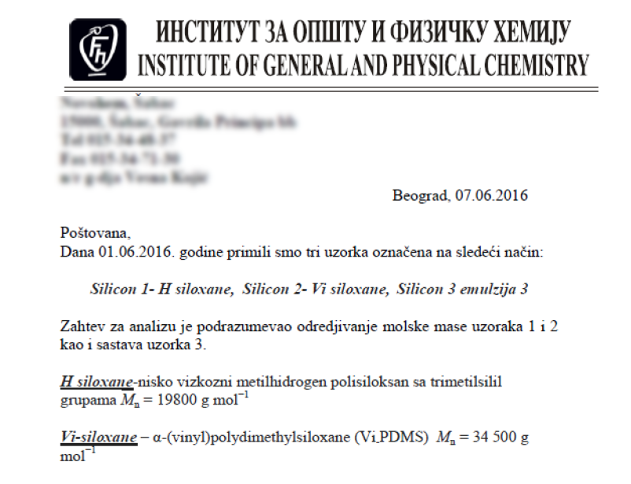

5. In the Experimental part, authors should describe in detail the procedure for preparing of samples for recording by TEM analysis.

Answer: The procedure for samples preparation for recording by TEM analysis was described in detail in the Experimental part of manuscript.

6. Authors should determine swelling degree and crosslinking density of siloxane elastomers.

Answer: According to Reviewers’ comment, that was done.

7. Authors should compare thermal stability of the prepared nanocomposites with that of similar materials presented in the literature.

Answer: Thermal stability of the synthesized samples was compared with that of similar materials presented in the literature.

8. Authors should present results from derivative thermogravimetric analysis and discuss the obtained results.

Answer: Derivative thermogravimetric analysis of the synthesized silicon elastomers and their nanocomposites was presented in the revised manuscript, and the obtained results were discussed.

Reviewer B:

1. I suggest using term siloxane instead of silicone in this manuscript (for example siloxane elastomers). The term siloxane better reflects the chemical nature and structure of elastomers (Si-O bonds).

Answer: The authors are grateful to the referee for his/her appropriate suggestion, the term was changed.

2. I suggest that the authors review and cite the works of prof. Dvornić and his research group from Belgrade, where the reaction of hydrosilylation of vinyl- and hydrogen- terminated oligo- and polysiloxanes, as well as the heterogeneously catalyzed siloxane equilibration reaction for the synthesis of the same oligomers / polymers was examined in great detail.

Answer: According to Reviewers’ suggestion, appropriate literature was cited.

3. The authors should define the reaction of hydrosilylation in this manuscript.

Answer: Based on Reviewers’ comment, this was done and also new reference was cited.

4. Line 28 - Replace the term oligosilanes with the term oligosiloxanes. Oligosilanes are oligomers with Si-C main backbone, while oligosiloxanes, which are used in this work, are oligomers with Si-O main backbone. This is a serious mistake that can seriously confuse the reader.

Answer: The term was replaced in the revised manuscript.

5. Lines 67-69, it is written: “Vinyl-functionalised siloxane, with vinyl terminal group, could be obtained in equilibrium anionic polymerization by means of certain initiators in one step, by the sequential addition of hexamethyl cyclosiloxane and methylvinyl cyclosiloxane.”
Comment: The oligomers can also be synthesized by the heterogeneously catalyzed siloxane equilibration reaction - the works of prof. Dvornić.

Answer: According to comment, appropriate literature was cited.

6. According to Fig.2, you did not use hydrogen poly(dimethylsiloxane) (as you wrote in line 113), but poly(hydrogenmethylsiloxane), since there are 1 methyl group and 1 hydrogen at each Si atom. Please, correct this in the text.

Answer: We would like to thank Reviewer for this observation, the text was corrected.

7. Please, give in the experimental part the molecular weight of vinyl poly(dimethylsiloxane) and poly(hydrogenmethylsiloxane) used for the hydrosilylation reaction, as well as the molar ratio of vinyl groups and hydrogens in each reaction mixture. The weight ratio of H-siloxane and vinyl-siloxane in Table 1 should be given in one column. The second column can be the molar ratio of vinyl groups and hydrogens.

Answer: After the kind suggestion of Reviewer, the Experimental part was modified.

8. Give the formula in Fig.2 consistently - present the formed methylene groups always with all hydrogens, or always only with dashes.

Answer: Based on Reviewers’ comment, the Figure 2 was corrected.

9. Table 2 - There is Serbian i instead of and (in the first raw).

Answer: This mistake was also corrected.

10. The formed crosslinked structure and the properties should be also discussed in the context of the excess/lack of H- or vinyl- groups in the particular reaction mixture, i.e. in the context of the deviation from the equimolar ratio of the reacting groups.

Answer: Comments on the influence of H- and vinyl- groups on the properties of siloxane elastomers were added.

Sincerely,

Dr. Ivan Ristić, corresponding author
University of Novi Sad, Faculty of Technology Novi Sad,
Department of Materials Engineering, Blvd. cara Lazara 1, 21000 Novi Sad, Serbia
E-mail: ivan.ristic@uns.ac.rs

