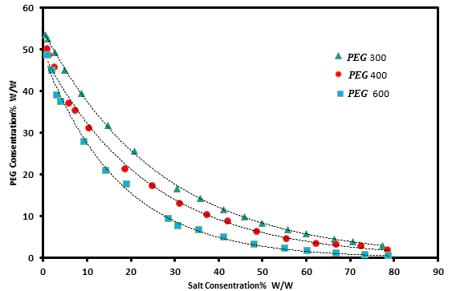
Figure S1. The experimental and correlated binodal curves of PEG 300,400 and 600 + Magnesium sulfate + water ATPSs. The solid line calculated from equation (3).

Figure S2. The experimental and correlated binodal curves of PEG 300,400 and 600 + Aluminum sulfate + water ATPSs. The solid line calculated from equation (3).

Table S1. Density, ρ, and Refractive Index,$n_{D}$, for the binary and ternary of PEG (p) + tri-potassium citrate (s)+ water system at 298.15 Kª and 0.1 MPa^{b} at various mass fractions of polymer, $w_{p}$ and salt, $w_{s}$.
$w_{p}$^{c} |  | $w_{s}$^{c} |  | $$\frac{ρ(±0.0001 )}{kg.m^{-3}}$$ |  | $n_{D}$ ($±0.0001 )$
PEG300 |  | Zinc sulfate
0.05 |  | 0.10 |  | 1.1899 |  | 1.4388
0.10 |  | 0.10 |  | 1.2885 |  | 1.4466
0.15 |  | 0.10 |  | 1.3588 |  | 1.4496
0.20 |  | 0.10 |  | 1.3855 |  | 1.4533
0.25 |  | 0.10 |  | 1.5577 |  | 1.4630
0.00 |  | 0.05 |  | 1.0255 |  | 1.3383
0.00 |  | 0.10 |  | 1.055 |  | 1.3442
0.00 |  | 0.15 |  | 1.0852 |  | 1.3501
0.00 |  | 0.20 |  | 1.1149 |  | 1.3558
0.00 |  | 0.25 |  | 1.1492 |  | 1.3623
0.00 |  | 0.30 |  | 1.1822 |  | 1.3687
0.00 |  | 0.00 |  | 0.9970 |  | 1.3327
0.05 |  | 0.00 |  | 1.0046 |  | 1.3385
0.10 |  | 0.00 |  | 1.0128 |  | 1.3455
0.15 |  | 0.00 |  | 1.0205 |  | 1.3521
0.20 |  | 0.00 |  | 1.0354 |  | 1.3585
0.25 |  | 0.00 |  | 1.0374 |  | 1.3658
0.30 |  | 0.00 |  | 1.0457 |  | 1.3734
1.00 |  | 0.00 |  | 1.1219 |  | 1.4650
PEG300 |  | Magnesium sulfate
0.00 |  | 0.05 |  | 1.0216 |  | 1.337
0.00 |  | 0.10 |  | 1.0473 |  | 1.3421
0.00 |  | 0.15 |  | 1.0728 |  | 1.3472
0.00 |  | 0.20 |  | 1.099 |  | 1.3524
0.00 |  | 0.25 |  | 1.1256 |  | 1.3568
0.00 |  | 0.30 |  | 1.1531 |  | 1.3613
0.05 |  | 0.15 |  | 1.1455 |  | 1.3421
0.10 |  | 0.15 |  | 1.1566 |  | 1.3472
0.15 |  | 0.15 |  | 1.2685 |  | 1.3524
0.20 |  | 0.15 |  | 1.3325 |  | 1.3568
0.25 |  | 0.10 |  | 1.4565 |  | 1.3613
PEG300 |  | Aluminum sulfate
0.00 |  | 0.05 |  | 1.0255 |  | 1.3383
0.00 |  | 0.10 |  | 1.055 |  | 1.3442
0.00 |  | 0.15 |  | 1.0852 |  | 1.3501
0.00 |  | 0.20 |  | 1.1149 |  | 1.3558
0.00 |  | 0.25 |  | 1.1492 |  | 1.3623
0.00 |  | 0.30 |  | 1.1822 |  | 1.3687
0.05 |  | 0.10 |  | 1.1899 |  | 1.4388
0.10 |  | 0.10 |  | 1.2885 |  | 1.4466
0.15 |  | 0.10 |  | 1.3588 |  | 1.4496
0.20 |  | 0.10 |  | 1.3855 |  | 1.4533
0.25 |  | 0.10 |  | 1.5577 |  | 1.4630
ª $298.15±0.0$5 K, ^{b} $100±$0.05 kPa,^{c} %mass $±0.001$

