SUPPLEMENTARY MATERIAL TO
Preparation and Properties of Hydrogen peroxide Oxidized Starch for Industrial use
Nataša Karić¹*, Jelena Rusmirović², Maja Đolić³, Tihomir Kovačević², Ljiljana Pecić⁴, Željko Radovanović¹, Aleksandar Marinković³

¹ Innovation Centre of Faculty of Technology and Metallurgy, Karnegijeva 4,
11070 Belgrade, Serbia
² Military Technical Institute, Ministry of Defense, Ratka Resanovića 1,
11000 Belgrade, Serbia
³ The University of Belgrade, Faculty of Technology and Metallurgy, Karnegijeva 4,
11070 Belgrade, Serbia
⁴Technical College of Applied Studies in Mechanical Engineering Trstenik, Radoja Krstića 19, 37240 Trstenik, Serbia

*Corresponding author: Nataša Karić, Innovation Centre of Faculty of Technology and Metallurgy, Karnegijeva 4, 11070 Belgrade, Serbia
Phone: +381 11 3303750
Email: natasa.karic312@gmail.com

2. Materials and methods

2.1 Materials
Native wheat starch was purchased from Žito Promet Ruma doo (moisture content ≤15,0%, ash content on d.m. 0.46-0.55%), while the chemical used for its modification: absolute ethanol and formic acid (≥99.8% and ≥98.0%, respectively; ZORKA Pharma), potassium and sodium hydroxide (≥90.0% and ≥97.0%, respectively; HeMoss, Belgrade), concentrated HCl (Lachema, Czech Republic), diethyl ether (≥99.0%; Fisher UK), 30% solution of hydrogen peroxide (Centrohem, Stara Pazova), iron(II) sulfate heptahydrate (≥98.0%; Zorka, Šabac), copper(II) sulfate pentahydrate (99.9%; Merck KgaA, Germany), copper(II) acetate monohydrate (99.0%; Kemika, Zagreb), copper(II) chloride (98.0%; Riedel-de Haёn Germany), citric acid (≥99.5%; Sigma-Aldrich, Germany), hydroquinone (≥99.0%; Fluka, Germany), tartaric acid and isopropyl alcohol (≥99.5% and ≥98.0%, respectively; Merck KgaA, Germany).

Methods

Laboratory isolation of ricinoleic acid
The isolation of ricinoleic acid from castor oil was performed analogously to previous published method [1]: 233 g (0.26 mol) of castor oil and 700 mL of absolute ethanol were placed into a four-neck-reactor equipped with reflux condenser, mechanical stirrer, thermometer, dropping funnel and nitrogen inlet. After dissolving of castor oil, the 30% potassium hydroxide (0.91 mol) was slowly introduced in reactor with constant stirring. The reaction mixture was maintained at approximately 10 °C during the addition of potassium hydroxide for 1 h. Hereafter, the reaction mixture was heated to 50 °C and temperature was kept constant for 2 h. After that, two-thirds of the solvent was removed from the mixture by distillation at atmospheric pressure. The obtained slurry was dissolved in distilled water, acidified with concentrated HCl to pH 3.0, purified with activated carbon and filtered. The obtained ricinoleic acid (RA) was extracted by diethyl ether and the obtained solution was dried with anhydrous sodium sulfate, and then in vacuum dryer at 80 ºC/2000 Pa for 5 h. The FTIR spectrum was presented in the section 3.1. Elemental analysis calculated for C₁₈H₃₄O₃ (M_{w} = 298.46 gmol⁻¹ ): C, 71.42; H, 10.32; O, 18.26. Found: C, 70.98; H, 10.31; O, 18.71. The oxygen percent was calculated as the difference to 100%. NMR analysis (FigS1.): ¹H-NMR (200 MHz, CDCl₃-d6, δ / ppm): 0.88 (3H, s, C₁₈H₃), 1.31-1.35 (16H, m, J = 11.0 Hz, C₄₋₇, C₁₄₋₁₇H), 1.44 (2H, m, J = 11.0 Hz, C₁₃H), 1.62 (2H, m, J = 7.0 Hz, C₃H), 2.03 (2H, m, J = 7.0 Hz, C₈H), 2.22 (2H, m, J = 7.0, C₁₁H), 2.33 (2H, dd, C₂H), 3.63 (1H, m, C₁₂H), 5.39-5.53 (2H, m, C₉H and C₁₀H), 6.5 (1H, s, C₁₂OH), 9.65 (1H, s, C₁OH); ¹³C-NMR (50 MHz, DMSO–d6, δ / ppm): 14.0 (C₁₈), 22.6 (C₁₇), 25.5 (C₁₄ and C₃), 28.9-29.3 (C₄-₇ and C₁₅), 32.0 (C₁₆), 35.0 (C₂), 37.0 (C₁₁ and C₁₃), 71.7 (C₁₂), 125 (C₁₀), 133 (C₉), 179 (C₁).
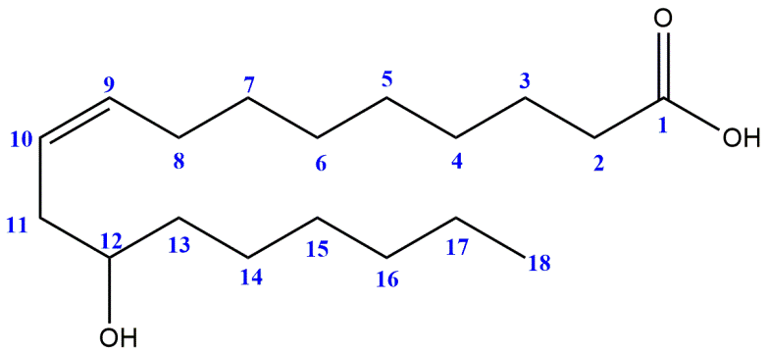
Figure S1. NMR analysis of ricinoleic acid

2.2.2 Laboratory epoxidation of soybean, linseed and sunflower oil
Firstly, 100 g of the soybean, linseed or sunflower oil (SO, LO and SFO, respectively) and 13.9 g of formic acid were poured to glass reactor immersed into water bath and mechanically stirred at the 50 °C and 550 rpm. Afterwards, 116.9 g of 30% hydrogen peroxide was gradually charged into the mixture during the 5 h. The molar ratio of soybean oil:formic acid:hydrogen peroxide was 1:2.64:8.9, which mean the molar ratio of carbon double bonds toward hydrogen peroxide (C=C:H₂O₂) were 1:1.7. After the charging of H₂O₂ was completed, the reaction further continued for the next 5 h. Hereafter, the mixture was cooled down, dilluted with distilled water and subjected to extraction by diethyl ether to separate the oil product from the water phase. The final products, ESO, ELO and ESFO, were obtained after ether evaporation and drying at 40 °C/2000 Pa for 4 h. Epoxy number was determined using 0.4 M HCl in dioxane and titration with solution of silver nitrate in presence of the ammonium thiocyanate as indicator according to the standard method [2]. The obtained yield of epoxide is 68.9%. The FTIR spectrum of ESO was presented in the section 3.1.

2.2.3 Laboratory synthesis of diisopropyl tartarate
In a single-neck flask, 25 g of tartaric acid was dissolved in 120 ml of isopropyl alcohol. Afterwards, the solution was cooled to 0 °C in an ice bath. The esterification of tartaric acid was catalyzed by introduction gaseous HCl for 5h at 0 °C providing mixing at room temperature for 24 h. The excess ethanol was removed by distillation at 40 °C, and diisopropyl tartarate (DIPT), purified by vacum distillation, as a mildly viscous yellow liquid (b.p. 85 ºC/2500 Pa; refractive index 1.437). The FTIR spectrum was presented in the section 3.1. Elemental analysis calculated for C₁₀H₁₈O₆ (M_{w} = 234.25 gmol⁻¹ ): C, 51.27; H, 7.75; O, 40.98. Found: C, 51.25; H, 7.70; O, 40.91. The oxygen percent was calculated as the difference to 100%. NMR analysis (FigS2.): ¹H-NMR (200 MHz, CDCl₃-d6, δ / ppm): 1.35 (12H, dd, 6C₁₋₃H and 6C₉₋₁₀H), 3.10 (2H, s, C₅OH and C₆OH),4.60-4.90 (4H, m, 4C₂,_{5,6,8}H); ¹³C-NMR (50 MHz, DMSO–d6, δ / ppm): 22.0 (C₁, C₃, C₉ and C₁₀), 70.0 (C₂ and C₈), 73.0 (C₅ and C₆), 171 (C₄ and C₇).
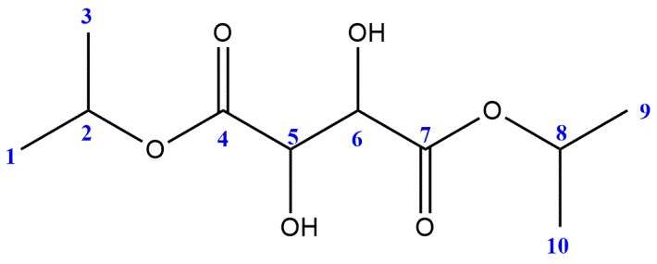
Figure S2. NMR anlaysis of diisopropyl tartarate

2.2.4 Laboratory synthesis of copper citrate
In a typical experiment, 4.2 g of citric acid dihydrate (0.02 mol) and 3.41 g copper chloride dihydrate (0.02 mol) were dissolved in 100 ml of distilled water. The resulting light blue solution was filtered and heated in an oven at 85 °C for 19 h in a teflon reactor. The green crystalline product was separated from the blue solution (pH 4.0) by decantation, thoroughly washed with distilled water, and air-dried (yield 3.2 g, 90% based on Cu). Cu content, determined according to atomic absorption spectroscopy, was 24.5%. The FTIR spectrum was presented in the section 3.1.

2.2.5 Laboratory synthesis of copper ricinoleate
The copper(II) acetate monohydrate in amount of 6 g (0.03 mol) was poured to flask and dissolve in ethanol with stirring at room temperature. Afterwards, 60 ml (0.210 mol) of ricinoleic acid (synthesis 2.2.1) is slowly added during 2h while the reaction mixture was heated to 80 °C. pH (6.5-7.0) was adjusted with sodium hydroxide. After that, the obtained mixture was cooled down and dried in vacuum dryer to evaporate the solvent. Cu content, determined according to atomic absorption spectroscopy, was 7.4% (78% conversion; the product contain ~20% of non-reacted ricinoleic acid and its content was adjusted by experimental condition to provide plasticizing effect in the course of starch oxidation). The FTIR spectrum was presented in the section 3.1.

2.2.6 Laboratory preparation of oxidized starch by the SPS method
Table S1. Quantities of reactants and reaction conditions used in experiments at laboratory level
Sample | Starch,  [g] | Plasticizer,  [ml] |  | Hydrogen peroxide, [ml] | Catalyst,  [g] |  |  | T,  [°C]
Exp 1 | 20 | - |  | 3.6 | FeSO₄∙7H₂O | 0.01 |  | 20
Exp 2 | 20 | - |  | 3.6 | FeSO₄∙7H₂O | 0.01 |  | 80
Exp 3 | 20 | - |  | 1.9 | FeSO₄∙7H₂O | 0.01 |  | 20
Exp 4 | 20 | - |  | 1.9 | FeSO₄∙7H₂O | 0.01 |  | 80
Exp 5 | 20 | - |  | 1.5 | FeSO₄∙7H₂O | 0.01 |  | 20
Exp 6 | 20 | - |  | 1.5 | FeSO₄∙7H₂O | 0.01 |  | 80
Exp 7 | 20 | - |  | 1.2 | FeSO₄∙7H₂O | 0.01 |  | 20
Exp 8 | 20 | - |  | 1.2 | FeSO₄∙7H₂O | 0.01 |  | 80
Exp 9 | 20 | RA | 0.4 | 1.2 | FeSO₄∙7H₂O | 0.01 |  | 20
Exp 10 | 20 | DIPT | 0.4 | 1.2 | FeSO₄∙7H₂O | 0.01 |  | 20
Exp 11 | 20 | ESO | 0.4 | 1.2 | FeSO₄∙7H₂O | 0.01 |  | 20
Exp 12 | 20 | ELO | 0.4 | 1.2 | FeSO₄∙7H₂O | 0.01 |  | 20
Exp 13 | 20 | ESFO | 0.4 | 1.2 | FeSO₄∙7H₂O | 0.01 |  | 20
Exp 14 | 20 | - |  | 1.2 | - |  |  | 20
Exp 15 | 20 | - |  | 1.2 | Cu citrate |  | 0.01 | 20
Exp 16 | 20 | RA | 0.4 | 1.2 | Cu citrate |  | 0.01 | 20
Exp 17 | 20 | - |  | 1.2 | Cu ricinoleate |  | 0.35 | 20

Figure S3. Proposed mechanism of starch oxidation with hydrogen peroxide [3-4]

Industrial starch oxidation by the SPS method

Table S2. Quantities of reactants and reaction conditions used in experiments
Sample | Starch, [kg] | Plasticizer, [l] |  | 10% H₂O₂, [l] | Catalyst, [kg] |  | Hydroquinone, [kg]
Exp 18 | 200 | - |  | 20 | Cu citrate | 0.01 | 0.4
Exp 19 | 200 | RA | 0.4 | 20 | Cu citrate | 0.01 | 0.4
Exp 20 | 200 | ESO | 0.4 | 20 | Cu citrate | 0.01 | 0.4

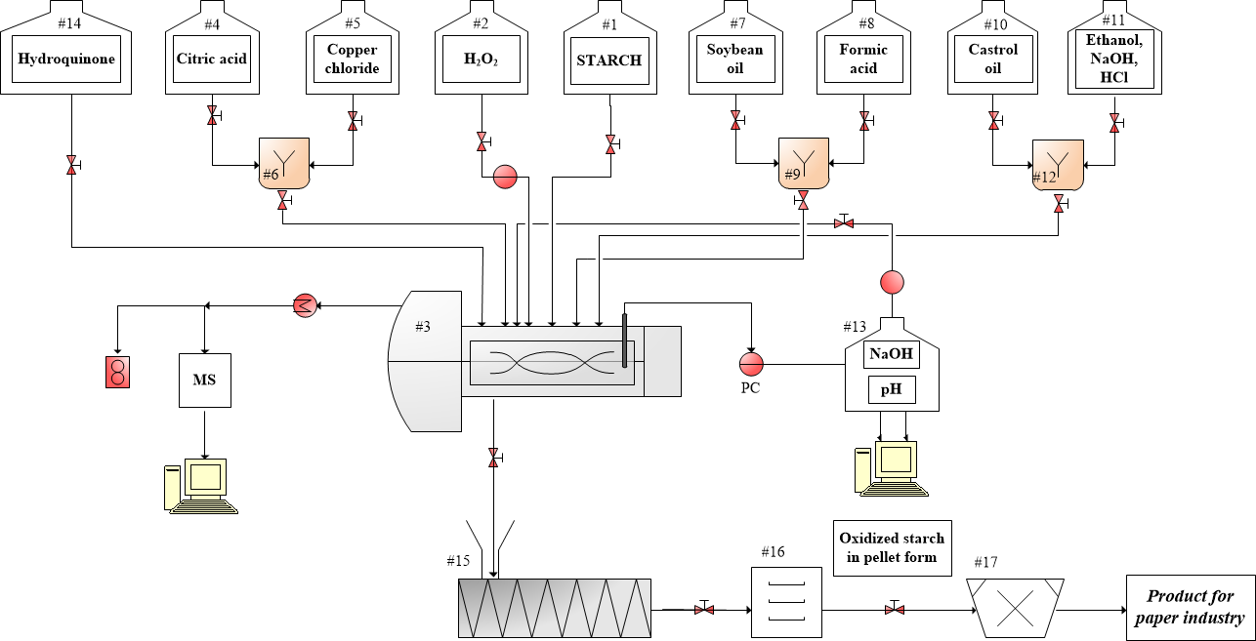
Figure S4. Schematic overview of the technological process for the starch oxidation

Characterization

The carboxyl/carbonyl content (COOH/100 GU and CO/100 GU) and the swelling capacity (SC)/water solubility (WS) of native and oxidized/modified starch were determined as described in the previous publications [5-6], respectively.
The viscosity of oxidized starches obtained at laboratory level was determined using capillary viscometer (Cannon-Fenske viscometer) (CF Method) following the method (Method 1) described in the publication [7]. The viscosity of oxidized starches obtained at industrial level was measured using Brookfield rotational viscometer (Brookfield DV-II + Pro Viscometer) (B Method) according to already described procedure[8] with some changes: before of measuring oxidized starch was heated at 90 ºC for 30 min, and in the course of cooling from 60 ºC viscosity was continuosly recorded.
Fourier transforms infrared (FTIR) spectra of the samples were recorded in absorbance mode using a Nicolet™ iS™ 10 FT-IR Spectrometer (Thermo Fisher SCIENTIFIC) with Smart iTR™ Attenuated Total Reflectance (ATR) Sampling accessories, within a range of 400-4000 cm^{–1}, at a resolution of 4 cm^{–1} and in 20 scan mode.
Nuclear magnetic resonance (¹H NMR and ¹³C NMR) spectra were recorded in a deuterated chloroform (CDCl₃) using a Ascend 400, Bruker, USA, at 400 MHz and 25 °C.
Thermogravimetric (TG) and differential scanning calorimetry analysis (DSC) (SDT Q600 simulated TGA-DTA instrument - TA Instruments) were used for studying the thermal properties of oxidized starches. Samples were heated to 800 °C (10 °C min⁻¹) in a flow of nitrogen (20 cm³ min⁻¹). The morphology of native and modified starches was recorded by a scanning electron microscope (SEM) (FE-SEM, TESCAN Mira3 XMU) operated at 20 kV. Before analysis, oxidized starch products were coated with Au.

3. Results and discussion

3.1 Fourier transform infrared spectroscopy (FTIR)
The FTIR spectra of synthesized plasticizers RA, ESO and DIPT are shown in FigS5. The absorption peak at 1710 cm⁻¹ at FTIR spectrum of RA belongs to the C=O stretching of carboxylic acid. Noticed vibration at 1241 cm⁻¹ belongs to C–O stretching orginate from epoxides which confirms the successful of epoxidation od soybean oilwhich is agree with the previous study [9]. The peak at 1740 cm⁻¹ at spectrum of DIPT originate from the C=O stretch vibration of the esters groups. The absorption peaks at 1404 and 1606 cm⁻¹ at FTIR spectra of Cu citrate [10] and Cu ricinoleate reflect the symmetric and asymmetric stretch from carboxylic acid salts, respectively.
Figure S5. FTIR spectrum of RA, ESO, DIPT, Cu citrate and Cu ricinoleate

Table S3. Area of the characteristic groups in the region of carbonyl and carboxyl vibrations
Sample | Wavenumber, cm⁻¹ | Area
Exp 1 | 1728 | 134.621
 | 1708 | 63.414
Exp 8 | 1726 | 136.356
 | 1710 | 58.203
Exp 10 | 1748 | 219.932
 | 1735 | 243.540
 | 1719 | 71.144
Exp 16 | 1744 | 40.562
 | 1732 | 184.328
 | 1710 | 166.902

3.2 Carboxyl and carbonyl contents
Table S4. Carboxyl and carbonyl contents of native and oxidized starches at laboratory level
Sample | Carboxyl content (COOH/100 GU) | Carbonyl content (CO/100 GU) | Sum (COOH+CO)
Native starch | 0.018 | 0.026 | 0.044
Exp 1 | 0.172 | 0.250 | 0.422
Exp 2 | 0.258 | 0.292 | 0.550
Exp 3 | 0.144 | 0.271 | 0.415
Exp 4 | 0.216 | 0.279 | 0.495
Exp 5 | 0.117 | 0.172 | 0.289
Exp 6 | 0.175 | 0.213 | 0.388
Exp 7 | 0.072 | 0.355 | 0.427
Exp 8 | 0.108 | 0.318 | 0.426
Exp 9 | 0.162 | 0.229 | 0.391
Exp 10 | 0.127 | 0.285 | 0.393
Exp 11 | 0.123 | 0.219 | 0.342
Exp 12 | 0.124 | 0.227 | 0.351
Exp 13 | 0.123 | 0.221 | 0.344
Exp 14 | 0.060 | 0.368 | 0.428
Exp 15 | 0.096 | 0.367 | 0.463
Exp 16 | 0.182 | 0.248 | 0.430
Exp 17 | 0.076 | 0.350 | 0.426

Table S5. Carboxyl and carbonyl contents of native and oxidized starches at industrial level
Sample | Carboxyl content (COOH/100 GU) | Carbonyl content (CO/100 GU) | Sum (COOH+CO)
Native starch | 0.018 | 0.126 | 0.144
Exp 18 | 0.162 | 0.335 | 0.497
Exp 19 | 0.192 | 0.288 | 0.480
Exp 20 | 0.181 | 0.280 | 0.466

Table S6. D-optimal desing with two factor and three replicates used to optimize the starch oxidation
Run | Factor 1  T (ºC) | Factor 2  H₂O₂ (ml) | Response  Carboxyl content (COOH/100 GU)
1 | 50 | 2.5 | 0.188
2 | 80 | 3 | 0.238
3 | 80 | 1 | 0.088
4 | 20 | 2.5 | 0.113
5 | 80 | 3.6 | 0.258
6 | 45 | 2 | 0.174
7 | 50 | 2.3 | 0.192
8 | 20 | 1 | 0.062
9 | 35 | 1.6 | 0.144
10 | 65 | 4 | 0.235
11 | 20 | 4 | 0.144
12 | 40 | 1 | 0.074
13 | 20 | 4 | 0.144
14 | 65 | 1.8 | 0.204
15 | 65 | 4 | 0.235
16 | 50 | 1 | 0.0785
17 | 80 | 4 | 0.257
18 | 20 | 1 | 0.062

An increase in carboxyl group content is observed with increasing the temperature and initial concentration of H₂O₂. According to the results given on FigS6., as an operational parameters temperature of 80 ºC (353 K) and 3.6 ml of H₂O₂ was selected as the most efficient for starch oxidation in presence of iron(II) sulphate catalyst. Similar results was obtained using copper(II) sulfate (differences not higher than 8%; data not presented), which means that both catalyst showed similar activity which depends on metal ion activity and the water content (starch moisture and provided by water solution containing catalyst). Obtained results also indicate significance of the temperature as reaction parameter. Higher temperature (80 ºC) means better hydrogen peroxide/water diffusivity and interior material avalilability (partial starch grain gelaitinization occur).

Figure S6. The influence of temperature (T, ºC) and concentration of H₂O₂ (ml) on the value of carboxyl content (COOH/100 AGU) (a) 3D plot and (b) 2D plot

3.3 Swelling capacity (SC), water solubility (WS) and viscosity (η)
Table S7. Swelling capacity (SC), solubility (S) and viscosity (η)*of native and oxidized starches at laboratory level
Sample | SC, [%] | S, [%] | η, [Pa·s]
Native starch | 11.8 | 19.2 | 1.0630
Exp 1 | 22.7 | 38.6 | 0.0124
Exp 2 | 25.2 | 42.8 | 0.0121
Exp 3 | 19.7 | 33.5 | 0.0195
Exp 4 | 21.8 | 37.1 | 0.0183
Exp 5 | 18.3 | 31.2 | 0.0273
Exp 6 | 20.4 | 34.7 | 0.0252
Exp 7 | 16.3 | 27.8 | 0.0339
Exp 8 | 17.5 | 29.9 | 0.0313
Exp 9 | 23.9 | 36.2 | 0.0153
Exp 10 | 23.1 | 34.1 | 0.0175
Exp 11 | 22.7 | 32.8 | 0.0182
Exp 12 | 21.3 | 32.3 | 0.0189
Exp 13 | 21.5 | 31.5 | 0.0183
Exp 14 | 15.4 | 25.6 | 0.0323
Exp 15 | 18.6 | 29.3 | 0.0298
Exp 16 | 24.6 | 38.5 | 0.0141
Exp 17 | 16.5 | 28.2 | 0.0320
*determined by CF Method
Table S8. Swelling capacity (SC), solubility (S) and viscosity (η)** of native and oxidized starches at industrial level
Sample | SC, [%] | S, [%] | η, [Pa·s]
Native starch | 11.8 | 19.2 | 1.0630
Exp 18 | 16.1 | 29.8 | 0.0451
Exp 19 | 19.5 | 32.3 | 0.0440
Exp 20 | 18.3 | 31.9 | 0.0452
**determined by B Method

3.4 Thermogravimetric analysis
Table S9. Thermal characteristics of native and oxidized starch
Sample | T₅, [°C] | T₅₀, [°C] | Residue content, [wt%] | DTG peaks, [°C]
Native starch | 248.3 | 312.9 | 13.72 | 314.5
Exp 1 | 251.4 | 308.7 | 16.59 | 307.4
Exp 6 | 271.9 | 307.2 | 16.89 | 305.0
Exp 10 | 273.4 | 305.9 | 17.48 | 308.3
Exp 16 | 277.8 | 308.7 | 18.16 | 305.7

T₅ and T₅₀ are temperature at 5 and 50 mass % loss of the specimen, respectively.

References

[1] Popović I, Rusmirović JD, Rančić M, Tasić A, Lazić D, Marinković AD.Synthesis of high-performance alkyd anticorrosion coatings based on waste poly ( ethylene terephthalate ). Zaštita Materijala. 2015; 56: 483–491.
[2] Stenmark GA. Argentimetric Method for Epoxides. Anal. Chem. 1957; 29: 1367–1369.
[3] Parovuori P, Hamunen A. Oxidation of Potato Starch by Hydrogen Peroxide. Starch/Staerke. 1995; 47: 19–23.
[4] Tolvanen P, Mäki-Arvela P, Sorokin AB, Salmi T, Murzin DY. Kinetics of starch oxidation using hydrogen peroxide as an environmentally friendly oxidant and an iron complex as a catalyst. 2009; 154: 52–59.
[5] Diasa ARG, da Rosa Zavarezea E, Helbigb E, de Mouraa FA, Vargasb CG, Ciacco CF . Oxidation of fermented cassava starch using hydrogen peroxide. Carbohydr. Polym.. 2011; 86:185–191.
[6] Kusumayanti H, Handayani NA, Santosa H. Swelling power and water solubility of cassava and sweet potatoes flour. Procedia Environ. Sci.2015; 23: 164–167.
[7] Methylcellulose. The United States Pharmacopeial Convention. 2014; 1–2.
[8] ISI 17-1e Determination of Viscosity of St arch by Brookfield. International Starch Institute. 2002.
[9] Hernandeza NLP, Bonona, Bahúa JO, Barbosaa MIR,b, Maciela MRW, Filhoa RM. Epoxy monomers obtained from castor oil using a toxicity-free catalytic system. J. Mol. Catal. A-Chem. 2016; 426: 550–556.
[10] Eremin K, Stenger J, Huang J, Aspuru-Guzik A, Betley T, Vogt L,2 Kassal I, Speakman S, Khandekar N. Examination of pigments on Thai manuscripts: the first identification of copper citrate. J. Raman Spectrosc. 2008; 39: 1057–1065.

