The use of PWHM and Mie methods in estimation of colloidal silver particle size obtained by chemical precipitation with sodium borohydride
Damir Barbir, Pero Dabić, Mario Meheš

Faculty of Chemistry and Technology, University of Split, Split, Croatia
Abstract  Unique antibacterial properties of silver have been known since the time of Egyptian pharaohs. With the discovery of antibiotics at the beginning of the twentieth century, silver is mostly pushed out from conventional medicine. However, with the excessive use of antibiotics, antibiotic-resistant super bacteria have appeared. Therefore, there is an increased interest in studying the antibacterial effects of colloidal silver. In this paper, the influence of various concentrations of silver nitrate on formation of colloidal silver particles in the solution was investigated. Colloidal silver was prepared by a chemical precipitation method using sodium borohydride as a reducing agent. As influence factors, color of the solution, Tyndall effect, UV/Vis absorption, and nanoparticle size estimated by PWHM (Peak Width at Half Maximum) and Mie methods were used. By increasing the silver concentration, color of the solution ranged from light yellow to dark yellow. All solutions showed Tyndall's effect equally. By the UV/Vis analysis it was found that the solutions absorbed radiation in the wavelength range 390-402 nm, and the intensity increased with increasing silver nitrate concentrations. By the PWHM and Mie methods silver nanoparticle sizes were estimated in the range 12-20 nm.  Keywords: silver nanoparticles; UV/Vis spectroscopy, Tyndall's effect, colloid, absorption, reducing agent. |  |  | Scientific paper  UDK:  546.57+66.065.2: 543.062  Hem. ind. 73 (0) 000-000 (2019)
Available on-line at the Journal web address: http://www.ache.org.rs/HI/
1. INTRODUCTION
Since the time of the Egyptian and Roman Empires, silver was used to preserve drinking water from microbial contamination. In the 18th century immigrants who came to America placed silver in milk to extend its lifetime. The use of silver for medical purposes dates back to the 8th century. With the discovery of antibiotics at the beginning of the 20th century, the use of silver in medicine diminished. However, due to the appearance of so-called antibiotic-resistant super bacteria, interest in studying antibiotic effects of silver revived [1].
Colloidal silver solution is an aqueous suspension of the silver nanoparticles with the particular feature of antibacterial activity [2]. The colloidal silver sols exhibit antibacterial properties due to the silver oligodynamic activity and a large specific surface that allows better interaction with the bacterial cell membrane [3]. There is a special interest in nanoparticulated silver due to its outstanding plasma properties that lead to a major improvement in Raman's signal. SERS (Surface-Enhanced Raman Scattering) is an advanced Raman technique that increases the vibrational spectrum of molecules adsorbed on or near metal particles [4].
The most common chemical method of silver nanoparticle synthesis is chemical reduction based on the use of organic and inorganic reducers. Sodium citrate, three sodium citrate [5,6], sodium ascorbate, sodium borohydride, elemental hydrogen, Tollens reagent, Eriochrome black T [7], N, N'-di-methyl form amide, and polyethylene glycol-block copolymers were commonly used as reducing agents. These substances reduce Ag⁺ to Ag⁰, followed by agglomeration in oligomeric clusters which ultimately leads to formation of colloidal silver particles. In some cases, stabilizers should be used to stabilize the nanoparticle growth and prevent sedimentation and agglomeration [8]. By changing the synthesis method, it is possible to obtain nanoparticles in different shapes and sizes [9].
Green synthesis methods are increasingly being investigated, using natural compounds such as mint fragrant [10], honey [11], white sugar [12], Arab rubber [13], corn dextrose [14], silkworm sericin [15] and glucose [16] as reducers. By synthesis using a spinning disk reactor with glucose as a reducing agent and starch, as a cheap and non-toxic stabilizer, nanoparticles up to 10 nm in diameter were obtained and remained stable over 40 days [17]. Synthesis by using eucalyptus leaves yielded nanoparticles 2-6 nm in size [18]. Other synthesis methods include gamma irradiation, electron beam irradiation, photochemical synthesis, microwave–assisted synthesis, thermal decomposition of silver oxalate and synthetic biological methods [19,20].
Various methods are available to estimate nanoparticle size and distribution. Advanced methods are, as a rule, better and more accurate, but due to the need for continuous measurements, in industry more simple methods are chosen [21].
Nanoparticle size can be estimated by using UV/Vis spectroscopy and PWHM (Peak Width at Half Maximum) analysis [22]. The PWHM or FWHM (Full Width at Half Maximum) can also be used to estimate the nanoparticle size distribution in a solution. The wider the peak at half the maximum absorbance the nanoparticle size distribution is wider with larger nanoparticles. In the case of silver nanoparticles, it is known that the UV/Vis absorption spectrum is very sensitive to nanoparticle size and aggregate state since silver nanoparticles absorb the visible part of light due to the surface plasmon resonance [23]. The absorbance peak is at wavelengths of about 400 nm [24].
Also, the Mie method can be used to estimate nanoparticle size [25]. The method is based on the Mie theory applied to small particles, taking into account optical properties of the sample, diffusion, and absorption of light.
An important parameter that can be calculated by using this theory is a cross-section. Cross section is the geometric value that connects the incident light with scattered, absorbed and depleted energy. From the Mie theory it is possible to calculate scattering (C_{sca}) (eq. 1) and extinction (C_{ext}) cross sections for an arbitrary spherical particle (eq. 2):
(1)
$C_{ext}=\frac{2π}{k^{2}}\sum_{n=1}^{∞}{\left(2n+1\right)Re\left\{a_{n}+b_{n}\right\}}$ (2)
where k and m are optical coefficients and a_{n} and b_{n} are scattering coefficients.
The deleted energy is equal to the sum of scattered and absorbed energies, so that the absorption cross section (c_{abs}) is equal to:
C_{abs} = C_{ext} – C_{sca} (3)
Detailed elaboration of the Mie theory was provided by Bohren and Huffman [26].
DLS analysis (Dynamic Light Scattering) can be also used to evaluate nanoparticle size, and PCS analysis (Photon Correlation Spectroscopy) provides nanoparticle size distribution in solution.
To determine the actual concentration, shape and size of silver nanoparticles in a solution, more complex analysis methods are used, such as atomic emission spectrometry, electron microscopy, XRD (X-ray Diffraction) and AFM (Atomic Force Microscope). A common feature of these methods is high cost of the equipment required for their implementation, so that estimative methods are more commonly used.
In this paper, we have investigated influence of the silver nitrate concentration on colloidal silver synthesis. Estimation of silver nanoparticle size was performed by using PWHM and Mie methods.
2. EXPERIMENTAL
Silver nitrate (AgNO₃, p.a.) from T.T.T. (Croatia) manufacturer was used as a precursor for obtaining silver nanoparticles. Sodium borohydride (NaBH₄, 97 %) from Alfa Aesar manufacturer (USA) was used as a reducing agent. Four silver nitrate solutions with concentrations of 0.5, 1.0, 1.5 and 2.0 mmol dm⁻³ were prepared by dissolving a certain amount of silver nitrate in 0.1 dm⁻³ of demineralized water. A solution of 2.0 mmol dm⁻³ sodium borohydride was prepared separately, by dissolving 0.0378 g of sodium borohydride in 0.5 dm⁻³ of demineralized water. The aqueous silver nitrate solutions during the experiment were kept in the dark. The colloidal silver synthesis was performed by a chemical precipitation method by reduction with sodium borohydride. 30 cm⁻³ of the prepared sodium borohydride solution was added to a 250 cm⁻³ Erlenmeyer flask. The flask was then immersed in an ice bath. After 20 min, the flask was transferred to a magnetic stirrer to provide strong stirring of the solution without any spilling. A silver nitrate solution was poured into a burette and 10 cm⁻³ was poured into the flask, about one drop per second. After the silver nitrate addition, stirring was stopped immediately to prevent particle aggregation. The same procedure was carried out for each prepared silver nitrate concentration, starting with the lowest concentration.
Colloidal silver solutions were transferred to 100 cm⁻³ plastic bottles and Tyndall's effect strength tested by using a laser (wavelength 630-680 nm). The absorbance of the solution was then measured by an Analitik Jena SPECORD® 200 Plus Edition 2010 UV/Vis spectrophotometer (Germany) in a quartz cuvette with a 1 cm optical path length. pH was measured by using a Schott handy lab LF12 pH meter (Germany). Evaluation of silver nanoparticle sizes was performed by using PWHM and Mie methods while Microsoft Excel 2016 (Microsoft Corp., USA) was used for calculation.
3. RESULTS AND DISCUSSION
For preparation of stable silver nanoparticles by chemical reduction, it is very important to select the appropriate reducing agent. In this paper, for reduction of silver nitrate a very strong reducing agent NaBH₄ was used according to the reaction:
AgNO₃ + NaBH₄ → Ag + 0.5H₂ + 0.5B₂H₆ + NaNO₃ (4)
To obtain stable silver nanoparticles, the order and reactants addition rate are very important. It is always necessary to add a silver nitrate solution to the sodium borohydride solution [27]. Otherwise, silver nanoparticles would aggregate. Figure 1 shows UV/Vis spectra of silver nanoparticles prepared with different starting AgNO₃ concentrations in the solution. The UV/Vis analysis has shown that colloidal silver absorbs light in the wavelength range 390-402 nm, and the maximum intensity was between 0.7 and 1.0. From the obtained absorption spectra, it can be seen that the absorbance increases with the increase in the initial silver nitrate concentration.

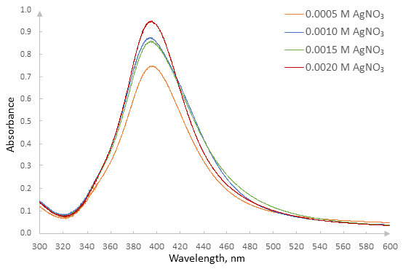
Fig. 1. UV-Vis spectra of colloidal solutions obtained from different initial AgNO₃ concentrations
The absorption peak at about 400 nm is attributed to silver nanosphere surface plasma excitation, which indicates formation of silver nanoparticles [28]. At low initial AgNO₃ concentrations, lower absorbance maxima indicate lower silver nanoparticle concentrations in the obtained colloidal solution. Thus, increasing the initial AgNO₃ concentration increases the silver nanoparticle concentration in the resulting solutions.
Since all solutions exhibited narrow absorption peaks, it is to be assumed that satisfactory dispersion of silver nanoparticles was obtained for all initial AgNO₃ concentrations. The color of the solution was primarily dependent on the AgNO₃ concentration added. By increasing the initial AgNO₃ concentration, the color changed from light yellow to dark yellow. Also, all the resulting solutions showed Tyndall's effect further indicating that in all four solutions a certain amount of silver nanoparticles was formed (Fig. 2). The absorption spectra (Fig. 3) obtained 14 days after the synthesis show that the most stable solution is that with the highest silver concentration while the most unstable solution was that with the initial AgNO₃ concentration of 0.0010 mol dm⁻³.

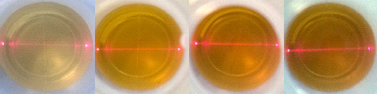
Fig. 2. Tyndall effect of light scattering in the obtained solutions with different initial AgNO₃ concentrations aligned from left to right starting with the lowest concentration. The laser beam passes through the solution to the left

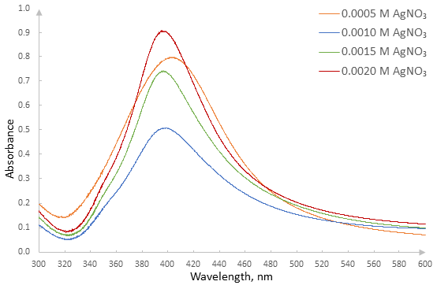
Fig. 3. UV-Vis spectra of colloidal solutions with different initial AgNO₃ concentrations acquired 14 days after the synthesis.

For each obtained silver nanoparticle solution, pH values were measured immediately after the synthesis and after 14 days (Table 1).
Table 1 shows that all the solutions after the synthesis were slightly alkaline with pH values in the range 8.35-8.63. After 14 days the pH value decreased by 0.67-0.88, which was related to the stability and concentration of silver nanoparticles.

Table 1. pH values of colloidal solutions immediately after the synthesis and after 14 days
c(AgNO₃) / mmol dm⁻³ | pH | pH, after 14 days | Δ pH
0.5 | 8.50 | 7.83 | -0.67
1.0 | 8.63 | 7.75 | -0.88
1.5 | 8.39 | 7.62 | -0.77
2.0 | 8.35 | 7.49 | -0.86

The particle size was estimated by the PWHM method while Microsoft Excel 2016 was used for calculation. The measured absorbance peak values and peak widths at the half of the absorbance peak for all colloidal solutions are given in Table 2.
Table 2 shows that the peak width at the half of the absorbance peak for all four solutions was between 53.7-84.7 nm, corresponding to the particle size of 10-20 nm. After 14 days, only slight changes in absorbance peak widths occurred with the exception of the solution with the initial AgNO₃ concentration of 1.0 mmol dm⁻³, where this change was more significant.

Table 2. Maximum absorbance wavelengths (λ_{max}) and the peak widths at the half of the absorbance peak (Δλ) for colloidal solutions with different initial AgNO₃ concentrations (c) after the synthesis and after 14 days
c(AgNO₃) / mmol dm⁻³ | λ_{max} / nm | λ_{max} / nm (after 14 days) | Δλ / nm | Δλ / nm (after 14 days)
0.5 | 399.3 | 402.1 | 84.7 | 86.4
1.0 | 397.1 | 398.0 | 53.7 | 84.4
1.5 | 395.1 | 395.7 | 80.2 | 75.9
2.0 | 393.5 | 394.9 | 74.8 | 70.4

The obtained maximum absorbance wavelengths and peak widths at the half of the absorbance peak are consistent with the results of other researchers. In a research on transmission electron microscopy, Mulfinger and coworkers have shown that the absorbance peak at the wavelength range 395-405 nm, corresponded to the colloidal silver nanoparticle size in the range 10-14 nm [29]. According to Mulfinger, the PWHM method yielded a 50-70 nm peak width. In another study, colloidal silver was synthesized by using N, N'-dimethylformamide and a peak at 410 nm was obtained with a width of 66 nm while transmission electron microscopy (TEM) analysis has shown that the particle size was in the range 12-22 nm [3]. Colloidal silver synthesized by silkworms sericin had the particle size of about 15 nm and showed the absorbance peak at 399 nm with the peak width of 60 nm [15].
According to the Mie's theory, the particle size is directly related to the surface plasmon peak [30]. The absorption spectrum of colloidal silver obtained in the present study exhibits only one peak, indicating that the electrons oscillate only on one main axis. The nanoparticle diameter was calculated by using the simulation computer program MiePlot v4.6.07 [31]. In order to estimate the nanoparticle size, for experimental values of the absorption peak obtained by UV/Vis analysis, it was necessary to calculate c_{ext} for several different nanoparticle diameters as shown in Fig. 4.
The nanoparticle diameter dependence on the surface plasmon peak wavelength is shown in Fig. 5. The specific electrical conductivity of demineralized water used in the experimental work was 1 μS cm⁻¹, while the specific electrical conductivity of the obtained colloidal silver solutions ranged from 18.15-18.78 μS cm⁻¹. The least squares regression of the data yielded a polynomial function:
y = -0.0209x² + 17.457x – 3620.7 (5)
where y is the silver nanoparticle diameter, and x is the absorption peak wavelength. Silver nanoparticle diameter values in initial experimental solutions and after 14 days were then calculated based on this dependence (Table 3).

Table 3. Calculated nanoparticle diameters according to the Mie's theory for all four experimental solutions
c(AgNO₃) / mmol dm⁻³ | Particle diameter, nm | Particle diameter, nm (after 14 days)
0.5 | 18 | 20
1.0 | 16 | 17
1.5 | 14 | 15
2.0 | 12 | 14
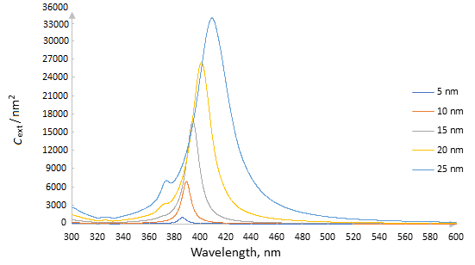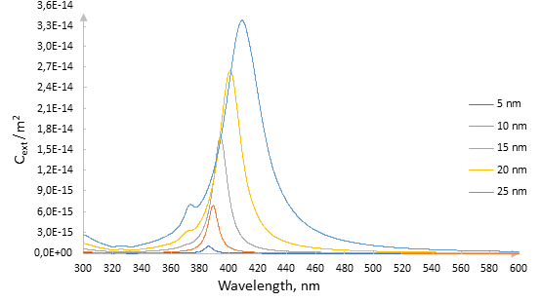
Fig. 4. c_{ext} dependence on the wavelength for different nanoparticle diameters

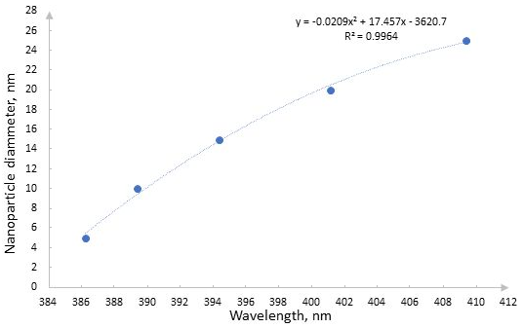
Fig. 5. Dependence of the spherical silver nanoparticle diameter on the surface plasmon peak wavelength
Based on the results of other studies and the results obtained with PWHM and Mie's theories with this experiment it can be estimated that in this paper similar particle diameters (12-20 nm) were obtained.
4. CONCLUSION
Based on the obtained absorption peaks, it can be concluded that silver nanoparticles have been successfully synthesized for all four silver nitrate concentrations. The solutions were stable and after 14 days where slight variations in absorption peak widths (except for the initial AgNO₃ concentration of 1.0 mmol dm⁻³ where this change is more significant). Silver nanoparticles absorbed UV/Vis radiation at wavelengths in the range 393 to 402 nm.
According to PWHM and Mie methods, the estimated nanoparticle size in the solutions was within the range of 12 to 20 nm. Nanoparticles of these sizes do not agglomerate or sediment which can be seen from results after 14 days.
The mathematical dependence of the spherical nanoparticle diameter on the wavelength was obtained by calculating the nanoparticle size based on the absorption peak values obtained by UV-Vis spectroscopy. Mie theory was first time used for silver nanoparticles particle size estimation, and it has shown good agreement with the PWHM method.

REFERENCES
Tien DC, Tseng KH, Liao CY, Huang JC, Tsung TT. Discovery of ionic silver in silver nanoparticle suspension fabricated by arc discharge method. J. Alloys Comp. 2008; 463(1-2): 408-411.
Panáček A, Kvítek L, Prucek R, Kolar M, Vecerova R, Pizúrova N, Sharma VK, Nevecna T, Zboril R. Silver colloid nanoparticles: Synthesis, characterization, and their antibacterial activity. J. Phys. Chem. 2006; 110 B: 16248-16253.
Jegatha Christy A, Kevin A, Nehru LC, Umadevi M. Optical, structural and morphological properties of silver nanoparticles and their antimicrobial activity. Inter. J. Chem. Tech. Res. 2015; 7(3): 1191-1197.
Mikac L, Ivanda M, Gotić M, Mihelj T, Horvat L. Synthesis and characterization of silver colloidal nanoparticles with different coatings for SERS application. J. Nanopart. Res. 2014; 16: 2748-2761.
Kim KY, Choi YT, Seo DJ, Park SB. Preparation of silver colloid and enhancement of dispersion stability in organic solvent. Mater. Chem. Phys. 2004; 88(2-3): 377-382.
Ismail MM, Abd Ulaziz SM. Spectral study of silver nanoparticles prepared by chemical method. Engin. Tech. J. 2014; 32(5): 869-876.
Zhai X, Efrima S. Reduction of silver ions to a colloid by eriochrome black T. J. Phys. Chem. 1996; 100(5): 1779-1785.
Iravani S, Korbekandi H, Mirmohammadi SV, Zolfaghari B. Synthesis of silver nanoparticles: chemical, physical and biological methods. Res. Pharm. Sci. 2014; 6(9): 385-406.
Šileikaite A, Puišo J, Prosyčevas IS, Tamulevičius S. Investigation of silver nanoparticles formation kinetics during reduction of silver nitrate with sodium citrate. Mater. Sci. 2009; 15(1): 21-27.
Kelkawi AHA, Kajani AA, Bordbar AK. Green synthesis of silver nanoparticles using Mentha pulegium and investigation of their antibacterial, antifungal and anticancer activity. IET Nanobiotech. 2017; 11(4): 370-376.
Bezić A. Priprava koloidnog srebra kemijskom redukcijom pomoću NaBH₄ i prirodnim reducensima. Bachelor Thesis, University of Split, Split, 2015. (in Croatian)
Meshram SM, Bonde SR, Gupta IR, Gade AK, Rai MK. Green synthesis of silver nanoparticles using white sugar. IET Nanobiotech. 2013; 7(1): 28-32.
Murali Mohan Y, Mohana Raju K, Sambasivudu K, Singh S, Sreedhar B. Preparation of acacia-stabilized silver nanoparticles. A Green Approach. J. Appl. Polym. Sci. 2007; 165(5): 3375-3381.
Hema JA, Malaka R, Muthukumarasamy NP, Sambandam A, Subramanian S, Sevanan M. Green synthesis of silver nanoparticles using Zea mays and exploration of its biological applications. IET Nanobiotech. 2016; 10(5): 288-294.
Bhat PN, Nivedita S, Subrata R. Use of sericin of Bombyx mori in the synthesis of silver nanoparticles, their characterization and application. Indian J. Fibre Text. Res. 2011; 36: 168-171.
Cheviron P, Gouanvé F, Espuche E. Green synthesis of colloid silver nanoparticles and resulting biodegradable starch/silver nanocomposites. Carbohydrate Polym. 2014; 108: 291-298.
Tai CY, Wang YH, Liu HS. A green process for preparing silver nanoparticles using spinning disk reactor. AIChE J. 2008; 54(2): 445-452.
Jha AK, Prasad K, Kumar V, Prasad K. Biosynthesis of silver nanoparticles using eclipta leaf. Biotech. Prog. 2009; 25(5): 1476–1479.
Lopez-Miranda JL, Vazquez M, Fletes N, Esparza R, Rosas G. Biosynthesis of silver nanoparticles using a Tamarix gallica leaf extract and their antibacterial activity. Materials Letters. 2016; 176(1): 285-289.
Gurunathan S, Kalishwaralal K, Vaidyanathan R, Deepak V, Kumar Pandian SR, Muniyandi J, Hariharan N, Hyun Eom S. Biosynthesis, purification and characterization of silver nanoparticles using Escherichia coli. Colloids and Surfaces B: Biointerfaces. 2009; 74(1): 328-335.
Kontogeorgis GM, Kiil S. Introduction to applied colloid and surface chemistry. Chichester, John Wiley & Sons; 2016.
Mulfinger L, Solomon SD, Bahadory M, Jeyarajasingam AV, Rutkowsky SA, Boritz C. Synthesis and study of silver nanoparticlesJ. Chem. Educ. 2007, 84, 322-325.
Song KC, Lee SM, Park TS, Lee BS. Preparation of colloidal silver nanoparticles by chemical reduction method. Korean J. Chem. Engin. 2009; 26(1): 153-155.
Goharshadi E, Azizi-Toupkanloo H. Silver colloid nanoparticles: Ultrasound-assisted synthesis, electrical and rheological properties. Powder Tech. 2013; 237: 97-101.
Fu Q, Sun W. Mie theory for light scattering by a spherical particle in an absorbing medium. Appl. Opt. 2001; 40: 1354-1361.
Bohren CF, Huffman DR. Absorption and scattering of light by small particles. New York, Wiley-Interscience; 1983.
Van Hyning DL, Zukoski CF. Formation mechanisms and aggregation behavior of borohydride reduced silver particles. Langmuir. 1998; 14(24): 7034–7046.
Liu J, Lee JB, Kim DH, Kim Y. Preparation of high concentration of silver colloidal nanoparticles in layered laponite sol. Colloids Surf A. 2007; 302: 276–279.
Mulfinger L, Solomon SD, Bahadory M, Jeyarajasingam AV, Rutkowsky SA, Boritz C. Synthesis and study of colloidal silver. J. Chem. Educ. 2007; 84(2): 322-325.
Bonsak J, Mayandi J, Thøgersen A, Marstein ES, Mahalingam U. Chemical synthesis of silver nanoparticles for solar cell applications. Physica Status Solidi C. 2011; 3(8): 924–927.
Laven P., http://www.philiplaven.com/mieplot.htm Acessed June 23rd 2019.
Sažetak
Upotreba metode polu-širine pika i Miove teorije u proceni veličine čestica koloidnog srebra dobijenog hemijskim taloženjem pomoću natrijum borhidrida
D. Barbir, P. Dabić, M. Meheš
Kemijsko-tehnološki fakultet, Sveučilište u Splitu, Split, Hrvatska
(Naučni rad)
Jedinstvena antibakterijska svojstva srebra su poznata još od vremena egipatskih faraona. Početkom dvadesetog veka i otkrićem antibiotika srebro je uglavnom potisnuto iz uobičajene upotrebe u medicini. Prekomernom upotrebom antibiotika pojavile su se superbakterije koje su razvile rezistenciju na antibiotike, što je dovelo do povećanog interesovanja za proučavanje antibakterijskih delovanja koloidnog srebra. U ovom radu ispitan je uticaj različitih koncentracija srebro nitrata na stvaranje koloidnih čestica srebra u rastvoru. Koloidno srebro je pripremljeno metodom hemijskog taloženja pomoću natrijum borhidrida kao redukcionog sredstva. Ispitivani su boja rastvora, Tindalov (Tyndall) efekt, apsorpcija UV/vidljivog zračenja, kao i veličina čestica koja je procenjena metodom polu-širine pika (tj. širine pika na polovini visine pika, eng. Peak Width at Half Maximum, PWHM) i primenom Miove (Mie) teorije. Povećavanjem koncentracije srebra boja rastvora je varirala od svetlo žute do tamno smeđe boje. Svi rastvori su podjednako pokazivali Tindalov efekat. UV/vidljivom spektrofotometrijom je ustanovljeno da rastvori apsorbuju zračenje talasnih dužina od 390-402 nm, a da intenzitet opada s porastom koncentracije. Primenom metode polu-širine pika i Miove teorije dobijeno je da rastvori sadrže nanočestice srebra veličine 12-20 nm. |  |  | Ključne reči: nanočestice srebra, UV/Vidljiva spektrofotometrija

Supplementary material to

Corresponding author: Damir Barbir, Faculty of Chemistry and Technology, University of Split; Fax: +381 11 33 70 472, Tel: +381 18 33 70 472 E-mail: dbarbir@ktf-split.hr Paper received: 17 July 2019 Paper accepted: 08 November 2019 https://doi.org/10.2298/HEMIND190719031B

