The authors are grateful to the Reviewer for the valuable comments. All comments of the Reviewer are taken into account in the new version of the article.
All corrections were filled by yellow color.

Detailed answers to all Reviewers' comments:
1. Abstract is too long and too vague. It should be revised to show clearly what the aim of the manuscript was and what are the main results obtained.
Abstract was modified

2. This was not shown in the manuscript just stated.
This sentence was deleted

3. Not shown
This sentence was deleted

4. Just a radial velocity component
Not only radial velocity component, also axial velocity (Eq.14 and its modifications hereinafter the text) and pressure (Eq.18 and its modifications hereinafter the text). Only graphical dependences for radial velocity are presented in the article because this velocity is decisive in calculating the process of jet outflow from a perforated shell.

5. Not shown
This sentence was deleted

6. repeated
This sentence was deleted

7. Please add more keywords and do not use words appearing in the title
Keywords: jet decay, vibration granulator, hydrodynamic flows, melt dispersion process, rotating perforated shell

8. Please check if this expression „one-dimensional drops“ is correct.
monodisperse

9. This company produces aluminum and not nitrogen fertilizers – please check
Please, see https://fertiliser-society.org/Proceedings/US/Prc414.HTM

10. Please check the name of the company and add countries to all companies.
Didier Engineering GmbH,

11. Please chek the company name – ICIS, ICL...?
Imperial Chemical Industries, England

12. This company produces machines for various industries but not for fertilizers – please check.
Please, see http://www.freepatentsonline.com/6117406.html

13. Please provide producers with countries of origin for all devices. If devices are custom-made please state. Please describe dimensions of the main parts of the granulator and the granulator volume.
Manufacturer – Sumy State University, Processes and Equipment of Chemical and Petroleum-Refineries Department, Ukraine; granulator diameter is 560 mm, granulator height is 590 mm

14. Please provide letters and descripetions for each figure a), b),... Please provide terms for each of the numbers present in the figure a).
Fig. 1. Experimental installation of the vibrating granulator. a) A schematic presentation of the granulator (design features of elements which are not described – see [21]): 1- perforated membrane (diameters of holes are 1.0 mm, 1.1 mm, 1.2 mm, 1,3mm, 1,4 mm, number of holes is 1800-2300, bottom shape is toroidal, length is 650 mm, diameter is 560 mm), 2 – housing (height is 590 mm, diameter is 560 mm), 3 – distributive drive, 4 – pipe (diameter is 45 mm), 5 – fan, 6 – liquid distributor, 7 – pipe (diameter is 100 mm), 8 - filter element (metal grid), 9 – vibrator (MFR OTY 77 actuator, range of output frequency 120-1200 is Hz), 10 – rod, 11 - resonator, 12 - buffer bunker, 13 – circulation pump (model Calpeda NC3 25-50/180), 14 – valve, 15 – rotameter (model Raifil RF FM 10), 16 - oscillations sensor, 17 – oscillograph (model С1-65А), 18 – digital frequency meter (model VC3165), 19 – electronic controller, 20, 21 – elements of stroboscope, 22, 23 – manometers (model МТ-2У), 24 – controller (model Euroaqua SKD-1); b) 3D model of vibrating granulator; c) 3D model and photo of experimental installation

The special frequency generator is designed to generate vibration on the radiator of rotating vibrational melting granulator by feeding electric signals of a special shape on the MFR OTY 77 actuator (system operation description - in accordance with [22]).

Main parameters and characteristics:
- frequency range of reproducible oscillations, Hz – 200 –1000
- rated load, W – 50 – 100
- limits of the permissible relative basic error, setting of the oscillation frequency, % – 0.5
- voltage of the mains supply of the generator, V – 220±10
- frequency of the mains, Hz – 60
- active resistance of the moving coil, Ohm – 8
- established trouble-free operating time, h – 1000 (with a confidence probability 0,95)

Operating conditions:
- ambient temperature – -10 – + 70 ° C
- relative humidity – 50 – 80% at a temperature of +25 °C
- atmospheric pressure – 86 – 106.7 kPa

The special frequency generator consists of:
- Generator of electrical signals of a special form
- Actuator MFR OTY 77

The generator of electrical signals of a special form consists of:
- Block of digital synthesis of frequency
- The amplifier
- Power supply unit

Specifications of the electrical signal generator:
- frequency range – 200 – 1000 Hz
- the minimum frequency setting step is 0.01Hz
- output power – 60W
- load resistance – 3.7 Ohm
- harmonic coefficient at the frequency of 500 Hz – 0.1%
- load inductance – 7.3 mH
The digital synthesis unit performs direct digital frequency synthesis (DDS – Direct Digital Sinthesizer) and is implemented on a microprocessor. Due to this, the generator has a high frequency stability and a small step of its tuning. The unit allows you to store 10 preset frequencies in the non-volatile memory. Each of which can be easily changed during operation. Indication of the generated frequency is carried out on the liquid crystal display.
The amplifier provides the necessary amplification of signals from the generator to feed them into a low-resistance load. The amplifier is implemented on an integrated microcircuit. The output stage is made on field-effect transistors. This ensures a high efficiency amplifier. The amplifier has a built-in protection system against overload, overheating and "soft start" system.
To power the whole device a power supply made by the classical transformer scheme is used. Two bipolar rectifiers supply а +/- 12V – the circuit for digital synthesis of frequency, and +/- 24V – amplifier.

Actuator MFR OTY 77
Electromagnetic vibrator consists of control block and vibro-converter. Control block is used for delivery of a signal of set frequency and amplitude to vibro-converter. A signal received from the control block, is transferred to the vibro-converter where under influence of magnetic field a reorientation of crystal lattice of the core alloy material occurs. As a result the core changes its length. The radiator of granulator’s vibrations is joined to the bottom part of the core. Cooling of vibro-converter is provided by cooling air expulsion. The vibro-system has an input and output signal 4-20 мА what will allow to automatically control the frequency of vibration depending on the change of the fusion level in granulator. Control block of the vibro-system is fixed on CPU.

15. This sentence is repeated – please omit here or above.
Done

16. Please check if the meaning of the sentence is right.
ОК

17. This part is not clear - is the frequency fixed and measured by the frequency meter? Please revise.
Next, the electronic oscillator 19 is switched on and the electrodynamic vibrator 9 started resulting in vibration of the resonator at a certain frequency, which is fixed for the testimony of digital frequency meter 18, which is connected to the vibration sensor 16 (measurer of frequency) of the granulator basket.

18. What is interstitial granulator position? This whole second part of the sentence is not clear. Based on manometer measurements pressure is monitored and not produced. Pressure is produced by working of the fan and the regulator
24. Please revise this sentence accordingly.
Air is supplied into the granulator volume by turning the fan 5 on, then when the interstitial position is changed, the given pressure is installed based on manometer data.

19. This sentence is not clear - what is changed to obtain the lower limit for the stable granulator operation. This and the next sentence can be probably combined in one sentence explaining what is kept constant and what is changed to obtain ranges at which monodisperse drops are obtained.
These liquid and air parameters are changing by changing the vibration frequency with electronic generator 19 by the lower limit of granulator stable operation range.

20. vibration frequency?
and
21. vibration frequency? It cannot be liquid flow because in the begining of the sentence it is said that different velocities are achieved in two ways.
Ranges of stable operation are determined for different liquid leakage velocities from holes in the basket, which can be achieved by changing the granulator performance under constant air pressure or by changing the air pressure by using the pressure regulator at the constant granulator performance

22. Is this geometrical similarity of the experimental vibrating granulator and the pilot rotation vibrating granulator? If so, then this should be moved to section explaining the modified granulator.
This text as replaced to the discription of modernized granulator

23. This sentence is repeated in the next section so it is deleted from here..
OK

24. Please state the number that you have used and how it was determined.
where φ is the discharge coefficient and set to 0.96-0.98 [24].

25. Please correct all equations in the text. Here the symbols for sigma and the sum are not displayed well.
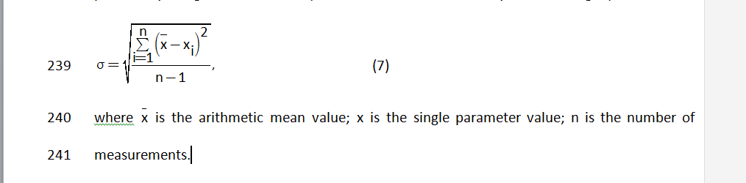

26. single?
The maximum possible error of a single measurement, Δ, was determined by the three sigma rule:

27. should be sigma
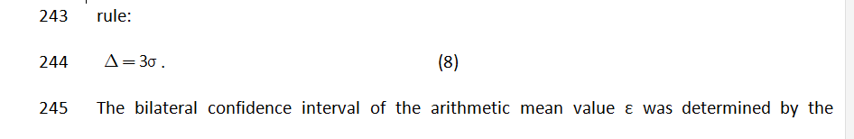
28. Please correct.
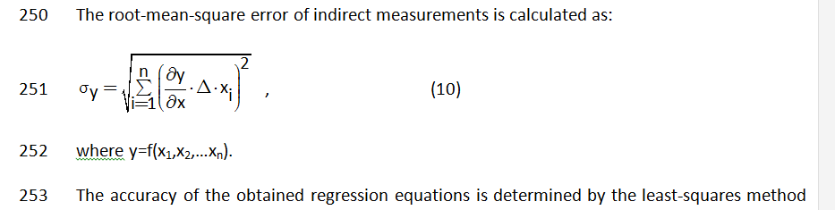

29. controllers?
Connection between measurement devices and controllers was provided with a maximum error of processing signals within 1.5%.

30. Please stet the grades of chemicals and producers and countries of origin.
Melt of ammonium nitrate and urea was used. Manufacturer of ammonium nitrate (agrotechnical chemical) - PSC “Azot”, Ukraine. Main parameters of ammonium nitrate – according to [29].

31. Please correct all equations and use the equation editor
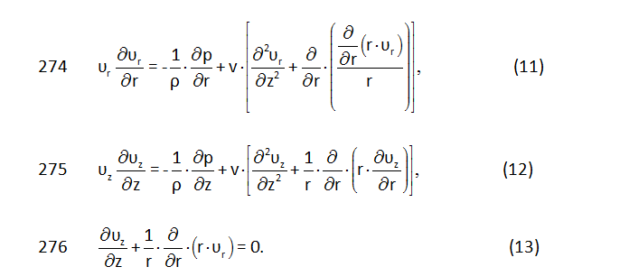
For all equations MathType editor was used

32. This is not clear. Is it d(F1(z=0))/dz=0 or better dF1/dz(z=0)=0?
dF1/dz(z=0)=0
33. Please change the symbol on the figure from Vr to r as it is in the text. Please denote T1, T2 and T3 on the figure instead of Vr1, Vr2 and Vr3.
Figure was changed

34. Please provide data either here or somewhere in the text.
Dependence of the radial component of the jet velocity of the ammonium nitrate melt on the axial distance, z, from the hole of 1.3 mm diameter at different temperatures of the melt at T1 = 175°C, T2 =180°C, T3 = 185°C and the vibration frequency of 340 Hz (viscosities were 5.36, 5.03, 4.74 mPa·s, densities were 1434, 1431, 1428 kg/m³ respectively).

35. The same comments as for the Fig. 2. Please change Vr0001,... to d1, d2, etc.
Dependence of the radial component of the jet velocity of the ammonium nitrate melt on the axial distance, z, from the holes of different diameters: d₁=1.0 mm, d₂=1.1 mm, d₃=1.2 mm, d₄=1,3mm, d₅=1,4 mm at the temperature of 185°C (viscosity was 4.74 mPa·s, density was 1428 kg/m³) and the vibration frequency of of 340 Hz
Figure was changed

Table 1. An example of comparison of theoretical calculations and experimental results of υ_{r} measurement (hole diameter was 1.3 mm, temperatures of the melt was 175°C (viscosity was 5.36 mPa·s, density was 1434 kg/m³), vibration frequency was 340 Hz, granulator basket rotation velocity was n = 60 rpm and a load was 37 t/h)
z=0 m |  |  | z=0.0005 m
υ_{r.theor} ,m/s | No of measurement | υ_{r.exp} ,m/s | _{υr.theor} ,m/s | No of measurement | υ_{r.theor},m/s
0 | 1 | 0 | -0.05 | 1 | -0.04
0 | 2 | -0.003 | -0.05 | 2 | -0.02
0 | 3 | 0.002 | -0.05 | 3 | -0.08
0 | 4 | 0 | -0.05 | 4 | -0.07
0 | 5 | 0.004 | -0.05 | 5 | -0.09
0 | 6 | -0.005 | -0.05 | 6 | -0.04
z=0.001 m |  |  | z=0.0015 m
υ_{r.theor} ,m/s | No of measurement | υ_{r.exp} ,m/s | _{υr.theor} ,m/s | No of measurement | υ_{r.theor},m/s
-0.2 | 1 | -0,21 | -0,4 | 1 | -0,4
-0.2 | 2 | -0,19 | -0,4 | 2 | -0,42
-0.2 | 3 | -0,19 | -0,4 | 3 | -0,39
-0.2 | 4 | -0,19 | -0,4 | 4 | -0,38
-0.2 | 5 | -0,18 | -0,4 | 5 | -0,4
-0.2 | 6 | -0,2 | -0,4 | 6 | -0,41
z=0.002 m |  |  | z=0.0025 m
υ_{r.theor} ,m/s | No of measurement | υ_{r.exp} ,m/s | _{υr.theor} ,m/s | No of measurement | υ_{r.theor},m/s
0 | 1 | -0,01 | 2.5 | 1 | 2,44
0 | 2 | 0,01 | 2.5 | 2 | 2,53
0 | 3 | 0,02 | 2.5 | 3 | 2,51
0 | 4 | 0 | 2.5 | 4 | 2,41
0 | 5 | -0,03 | 2.5 | 5 | 2,56
0 | 6 | 0 | 2.5 | 6 | 2,6

36. Please mark the photos with a) and b) and state what is shown there: Phorograph of drops of ? (urea or ammonium nitrate?) melt forming after exiting the holes of ? mm in diameter, at the vibration frequency of ?, and temperature of ?
Fig. 4. Jet disintegration into drops after the outflow from the perforated shell: a) ammonium nitrate drops, vibration frequency of 200 Hz; b) ammonium nitrate drops, vibration frequency of 340 Hz. Diameter of hole was 1.1 at the temperature of 185°C (viscosity was 4.74 mPa·s, density was 1428 kg/m³). Granulator basket rotation velocity was n = 60 rpm and a load of 37 t/h.

37. The same comment as for the Fig. 4.
Fig. 5. Steady jet disintegration into drops after the outflow from the perforated shell: ammonium nitrate drops, vibration frequency of 340 Hz. Diameter of hole was 1.1 at the temperature of 185°C (viscosity was 4.74 mPa·s, density was 1428 kg/m³). Granulator basket rotation velocity was n = 60 rpm and a load of 37 t/h.

38. This disperser is not described in the experimental section so that this whole description should be moved there or here provided some details of the granulator design.
Section with description was moved after the fig. 5.

39. Please add the hole diameter
Mass fractions of ammonium nitrate granules with sizes 2.0 – 2.5 mm and 2.5 - 3.0 mm as functions of the vibration frequency at the granulator basket rotation velocity of n = 60 rpm and a load of 37 t/h and the hole diameter of 1.2 mm
Also figure was corrected

40. In the figure „the“ should be added before the frquency.
Figure was corrected

41. This figure is obtained directly from the figure 7 and does not present any new information and should be omitted. Also the coordinates should be changed as granule amount and granule diameter.
Figures 7 and 8 were combined. Figure was corrected

42. How is this firgure determined? Is there a reference?
References was added.

43. Please state the reference.
Reference was added

44. Please state the reference.
Reference was added

45. Where was this shown in this manuscript?
This text as deleted

46. This could be in Introduction or somewhere in Results and Discussion.
Replace in section „Results and Discussion“

47. Is this the granulator presented in Fig. 1? Please be specific.
and
48. at which frequency?
The vibrating granulator (fig. 6) with an electromagnetic vibration system (vibration frequency of 340 Hz) provided production of a product with the following granulometric composition as mass fractions: 0.02-0.2% of granules < 1.0 mm and over 96% of granules 2.0 - 4.0 mm in size. Also, for the fraction of granules in the size range 2.0 - 2.5 mm was not lower than 88% with the main size in the range 2.1-2.5 mm. When the vibration frequency was changed to 400 Hz , the granulator provided production of the product with the main fraction (over 65 %) of granules of 2.5 - 3.0 mm simultaneously increasing the hardness of the main fraction granules (hardness value was confirmed in [12]).
This text was replaced to section „Results and Discussion“

49 This was not shown.
hardness value was confirmed in [12]

50 Please state the reference.
Reference was added

51. The list should be extended to include all symbols appearing such as Gs, D, sigma, epsilon, constants A1, A2, A3, z0, etc.
list of symbols was extended
Symbols
A₁, A₂, A₃ – coefficients of parabolic equation;
C₁ – differential equation solution constant;
d_{dr} - diameter of drop, m;
– bigger and smaller diameter of drops, m (mm);
– absolute difference of drop diameters, m;
– relative deviation of drop diameters;
F₁(z) – polynomial function;
f₁, f₂ – upper and lower limits of frequency, 1/s;
f_{avi} – average frequency of vibration, which provides monodisperse jets decay, 1/s;
g – acceleration of gravity, m/s²;
G_{S} – melt flowrate, m³/s;
G_{τ} – the measured volume of the melt, m³;
H – liquid column height (head), m;
n – number of measurements; granulator basket rotation velocity, rpm;
p – the outflow jet pressure, Pa;
p₀ – pressure of the surrounding environment, Pa;
r – radius of the jet, m;
t – the Student’s criterion;
V – velocity of the liquid leaking from the granulator holes, m/s;
– arithmetic mean value;
x – single parameter value;
z_{o} – initial axial distance, holes, m;
z – axial distance, holes, m;
Δ – maximum possible error of a single measurement, %;
ε – bilateral confidence interval of the arithmetic mean value;
λ_{max}, λ_{min} – maximum and minimum lengths of the wave, m;
ρ – liquid density, kg/m³;
σ – root-mean-square deviation;
τ – the experimental time of melt outflow through the granulator hole, s.
υ_{θ} υ_{r}, υ_{z} – tangential, radial and axial components of the jet velocity respectively, m/s;
– initial axial component of the jet velocity respectively, m/s;
φ – discharge coefficient.

