**Removal of the herbicide 2,4-dichlorophenoxyacetic acid from water by using an ultrahighly efficient** **thermochemically activated carbon**

Danijela V. Bojić, Miloš M. Kostić*, Miljana D. Radović Vučić, Nena D. Velinov, Slobodan M. Najdanović, Milica M. Petrović, Aleksandar Lj. Bojić

Department of Chemistry, Faculty of Science and Mathematics, University of Niš, Višegradska 33, 18 000 Niš, Serbia

**Paper received: 11 April 2019**

**Paper accepted: 16 July 2019**

**DOI: https://doi.org/10.2298/HEMIND190411019B**

**UDC: 66.081.3:544.723.2:536.7**

*Corresponding author: Miloš Kostić

Tel.: +381 63 484475; fax: +381 16 260 437.

*E-mail address:* [mk484475@gmail.com](mailto:mk484475@gmail.com), [milos.kostic@pmf.edu.rs](mailto:milos.kostic@pmf.edu.rs)

*Postal address:* University of Niš, Department of Chemistry, Faculty of Sciences and Mathematics, Višegradska 33, 18 000 Niš, Serbia

**Abstract**

*Lagenaria vulgaris* activated carbon (LVAC) was synthesized from *Lagenaria vulgaris* biomass by treatment with diluted H2SO4 followed by thermo-chemical carbonization and overheated steam activation process and used for removal of the herbicide 2,4-dichlorophenoxyacetic acid (2,4-D). Fourier transform infrared spectroscopy indicated that 2,4-D is adsorbed in micropores of the very porous LVAC (665m2/g). LVAC showed high sorption capacity as compared to many previously used sorbents at optimal conditions: the stirring rate of 300 rpm, the sorbent dose of 1.0 g/dm3and pH from 2 to 7. The experimental maximum sorption capacity of LVAC was 333.3 mg/g. The pseudo-second-order model and Chrastil model described the 2,4-D sorption kinetics by LVAC. Thermodynamic studies have indicated that the sorption process was endothermic, spontaneous and physical in nature. LVAC was shown to be an ultrahighly efficient sorbent for removal of 2,4-D from groundwater, which could be also recycled and reused.

**Keywords:** activated carbon; 2,4-D; groundwater; recycling and reusing; thermodynamics

1. **Introduction**

Nowadays, the growing population and high demand for food lead to the increasing use of herbicides in agricultural activities. This is a serious environmental problem because many herbicides are toxic and their excessive use creates negative impacts on organisms and the environment, including their accumulation in soils and water, and entrance in the food chain [1]. The herbicide 2,4-dichlorophenoxyacetic acid (2,4-D), C8H6Cl2O3 is used for the control of broad-leafed weeds in gardens and farms as a plant growth regulator [2]. The soil/water adsorption coefficient (*K*D) determines the strength of herbicide binding to soil particles (*K*D greater than 5 indicates strong adsorption onto soil and organic matter and a lower probability of leaching). The *K*D of 2,4-D is 1.24, which indicates non-persistence in the soil, and therefore, the possibility to persist in the aquatic environment and to reach groundwater [3]. In addition, 2,4-D is non-volatile but highly soluble in water. This is the reason why herbicides are often found in the water environment, causing water pollution. The International Agency for Research on Cancer (IARC) classified 2,4-D as a class 2B carcinogen [2]. Exposure of humans to 2,4-D, will cause cytogenetic damage in lymphocytes, eye damage, hepatotoxicity and nephrotoxicity. The World Health Organization has declared that 2,4-D is moderately toxic to humans and animals (class II) and its maximum permissible concentration in drinking water is 70 μg/dm3[4]. Presence of 2,4-D (as residues) in food grains, vegetables, fruits, surface waters and groundwater has drawn concerns in many countries [5, 6]. Therefore, removal of 2,4-D from environment became urgent. Many methods have been used to remove 2,4-D from water such as electrochemical oxidation [7], photocatalytic degradation [8], photodegradation [9], combined microwave-assisted degradation and UV irradiation [10], ozonation [11], sorption [12] and sorption by activated carbon [3, 13-19]. Among these technologies, activated carbon, the main conventional sorbent, is the most effective and widely used for removal of organics from aqueous solutions. Removal of 2,4-D by using activated carbon could be one of the most competitive methods because of the simple process, relatively low cost and mild operating conditions.

The present study focuses on evaluation of 2,4-D sorption potential on the activated carbon obtained from lignocellulosic material *Lagenaria vulgaris* by a thermo-chemical synthesis. Effects of the contact time, pH, and the initial 2,4-D concentration, as well as the possibility of recycling and reusability of the material for 2,4-D sorption were also investigated. The *Lagenaria vulgaris* activated carbon (LVAC) was characterized by scanning electron microscopy with energy dispersive X-ray spectroscopy (SEM-EDS), Brunauer-Emmett-Teller (BET), and Fourier transform infrared spectroscopy (FTIR) analyses. Equilibrium and kinetic studies of the sorption process were examined to understand the sorption mechanism of the herbicide 2,4-D onto LVAC from aqueous solutions in a batch process. Also, possibilities for using this material in real waters and the possibility of its regeneration and reuse were examined.

1. **Materials and methods**
   1. **Chemical materials**

All chemicals were of reagent grade and used without further refinement. HNO3, NaOH, and   
2,4-D (the purity of 98%) were purchased from Merck (Germany). All solutions were prepared with deionized water (18 mΩ). 1 g/dm3 of stock solution was prepared by dissolving the 2,4-D with deionized water. This stock solution was used for preparing a series of   
2,4-D concentrations ranging from 50 to 500 mg/dm3.

* 1. **Preparation of the sorbent**

The biomass was prepared from *Lagenaria vulgaris* shell [20]. Seeds and inner spongy white pith were removed, while the outer shell was crushed into 2 to 3 cm pieces and cleaned of the rest of the internal content. Small pieces of the broken shell were then cleaned with deionized water and dried at 333 K. Next, dry pieces of the shell were cut into small pieces as well as grinded to particle sizes from 0.80 to 1.25 mm. After that, the biomass sample was soaked into 10 % by weight H2SO4 and stirred occasionally within 48 h. The obtained precursor was washed several times with deionized water until neutral pH and dried. The sample was then carbonized in a tubular furnace under the protective atmosphere of nitrogen by heating from the room temperature to 673K for 1 h. The heating rate was set at 276K/min. After 1 h, the precursor was activated by introducing overheated steam into the furnace at the flowrate of 110 cm3/min along with a gradual increase in the temperature from 673 to 973 K. Finally, the obtained wet *Lagenaria vulgaris* activated carbon (LVAC) was consigned in an oven for complete drying at 378 K and stored in a polyethylene jar until the subsequent use.

* 1. **Analysis and Characterization**

The UV–Vis technique was used for determination of 2,4-D concentration in samples by using a spectrophotometer Shimadzu UV–Vis 1650 PC (Shimadzu, Japan), at a wavelength of 284 nm. The infrared spectrum of LVAC was obtained by using a Fourier transform infrared spectrometer (Bomem MB-100 spectrometer, Hartmann & Braun, Canada). Morphology of the LVAC surface was analyzed by SEM (Hitachi SU8030, Hitachi, Japan). EDS analysis (Thermo Scientific NORAN System 7, USA) was used to obtain information on elements present *via* the analysis of X-ray emissions from the LVAC surface. Elemental composition was analyzed by the Perkin Elmer series II CHNS/O System Analyzer 2400 (Perkin Elmer, USA). The specific surface area was measured by nitrogen adsorption using the Micromeritics Gemini 5 Surface Area Analyzer (Micromeritics, USA).

* 1. **Batch sorption experiments**

A stock solution of 2,4-D was prepared by dissolving an accurate quantity of the herbicide in deionized water. Working standard solutions were prepared just before the use by appropriate dilutions of the stock solution. For sorption studies, a fixed sorbent dose 0.2 g (1 g/dm3) of LVAC was put in a 250 cm3 Erlenmeyer flasks, followed by 200 cm3 of 2,4-D solutions of initial concentrations in the range 50 - 500 mg/dm3. Samples (3 cm3) were collected after 0.5, 1, 5, 10, 20, 40, 60, 90, 120, 180 and 240 min and analyzed for the residual 2,4-D concentration. The pH of the solution in the sorption experiments was native and the temperature was kept constant at 303K and the stirring rate was 300 rpm. The effect of pH on the 2,4-D sorption was studied in the pH range of 2.0 - 11.0. The pH of solution was adjusted to the required value with 0.1/0.01 mol/dm3 NaOH/HNO3 solutions using a pH-meter (H260G, HACH, USA). The native pH values of solutions were from 3.1 to 4.3 and were not additionally adjusted during the treatment,. The effect of sorbent dose on the 2,4-D sorption was studied in the native pH, stirring rate of 300 rpm and temperature 303 K. Samples were collected after 240 min. The effect of stirring rate on the 2,4-D sorption was studied in the native pH, sorbent dose of 1 g/dm3 and temperature 303 K. Samples were collected after 240 min and residual concentration of 2,4-D was determinated in solution. The pH at the point of zero charge (pHPZC) of the LVAC was determined by simplified mass potentiometric titration [21]. Investigation of the effects of LVAC concentration were carried out by varying the dose of LVAC from 0.125 to 2.0 g/dm3 at 500 mg/dm3 of the 2,4-D concentration, at native pH and the temperature of 303K. The effect of temperature on 2,4-D sorption was investigated at three different temperatures (283, 293 and 303 K). The temperature was held at the specified temperatures (±1K) by a thermostated bath Julabo F12-ED (Refrigerated/Heating Circulator, Germany). The initial concentration in these experiments was 500 mg/dm3.. All the experiments were carried out in triplicate.

The sorbed amount per mass of the sorbent at time *t*, *q*t (mg/g), and the removal efficiency (*RE* %) were determined by using the equations (1) and (2), respectively:

 (1)

 (2)

where *c*0 and *c*t are the initial and the concentration of the herbicide in the solution at time *t* (mg/dm3), *V* is the solution volume (dm3) and *m* is the mass of the sorbent (g).

* 1. **Data analyses**

Kinetic studies were performed to investigate the sorption mechanism of 2,4-D on LVAC, confirm the efficiency of the sorption process and predict the rate. The kinetic results were assessed by applying three models: pseudo-first-order (Eq. 4) [22], pseudo-second-order (Eq. 5) [23]and the Chrastil’s model (Eq. 7) [24] in non-linearized forms :

 (4)

 (5)

 (6)

 (7)

where *q*t (mg/g) is the sorbed amount per mass of the sorbent at time (*t*), *q*e,cal (mg/g) is the sorbed amount per mass of the sorbent at equilibrium (equilibrium sorption capacity of the sorbent), *k*1 (1/min) is the pseudo-first-order adsorption rate constant, *k*2 (g/mgmin) is the rate constant of the second order sorption, *K*id (mg/g min1/2) is the internal diffusion coefficient, *C* is the intercept, *k*c is the specific rate constant of the Chrastil’s model (dm3/g min), which depends on the diffusion coefficient and the sorption capacity of the sorbent, *A*0 is the dose of the sorbent (g/dm3) and *n* is the heterogeneous structural diffusion resistance constant, which is in the range from 0 to 1. When the diffusion resistance is small, *n* tends to 1 and the reaction is of the first order. If the system is strongly limited by diffusion resistance, *n* is small. In addition, when *n* > 1, a consecutive reaction order may be expected. Parameters intra-particle diffusion model (Eq. 6) can be determined from a plot of *q*t versus *t*1/2 (the values of intercept give us an idea about the thickness of the boundary layer).

In order to assess the sorption capacity and distribution of 2,4-D molecules between the liquid and solid phases, the collected experimental sorption data at equilibrium were applied employing several isotherm models, such as: Langmuir [25], Freundlich [26], Sips [27] and Brouers–Sotolongo [28]. The non-linear forms of the Langmuir (Eq. 8), Freundlich (Eq. 9), Sips (Eq. 10) and Brouers–Sotolongo (Eq. 11) models are represented below:

 (8)

 (9)

 (10)

 (11)

where *q*e is the equilibrium sorption capacity of the sorbent (mg/g); *c*e is the concentration (mg/dm3) of 2,4-D in the solution at equilibrium; *q*m is the maximum sorption capacity of the sorbent (mg/g); *K*L is the Langmuir constant related to the energy of sorption (dm3/mg), *K*F is the Freundlich equilibrium constant (mg/g) (dm3/mg)1/n and *n* is the exponent; *b*S (dm3/mg) in the Sips model is the affinity constant for sorption; *K*W is the Brouers–Sotolongo isotherm constant (dm3/mg) and α is the Brouers–Sotolongo model exponent.

*R*L is the separation factor or the equilibrium parameter determined from the Langmuir isotherm for predicting whether a sorption system is favorable (0<*R*L<1), unfavorable (*R*L< 1), linear (*R*L=1) or irreversible (*R*L = 0) and can be estimated by the equation (12) [29]:

 (12)

The best fitting model was selected based on the determination coefficient values (r2) determined after non-linear and linear regression analysis by applying the software OriginPro 2016 (OriginLab Corporation, USA) and the relative deviation of calculated *q*e values from experimental *q*e values was calculated by the following equation:

 (13)

where *q*e,exp is the experimental sorption capacity at equilibrium (mg/g), *q*e or m,cal(mg/g) is the sorption capacity at equilibrium and calculated by the corresponding kinetic and isotherm models.

The effect of temperature on the 2,4-D sorption was investigated at three different temperatures in order to determine spontaneity, the enthalpy (ΔH°) and entropy (ΔS°) for the sorption reactions [30]. The change of free energy ΔG° was calculated using the following equation:

 (14)

 (15)

The enthalpy (ΔH°) and entropy (ΔS°) parameters were calculated by following equations:

 (16)

 (17)

where R is the universal gas constant (8.314 J/mol K), *T* is the temperature (K) and *K*D is the coefficient of distribution, *c*a and *c*e are the 2,4-D concentration (mg/dm3) on the sorbent and in the solution, respectively, at equilibrium.

* 1. **Recycling and reusing the LVAC sorbent**

For evaluation of the recycling and reusing potential of the sorbent, five consecutive desorption/regeneration cycles were performed. In the sorption test, 0.25 g of LVAC was exposed to 250 cm3 of 2,4-D solution with the concentration of 500 mg/dm3 and stirred for 180 min. After that, LVAC was separated by centrifugation at 3000 rpm for 5 min. The 2,4-D concentration was determined in supernatant. Desorption of 2,4-D from LVAC pores was performed by heating at 473 K in a muffle furnace (Sel-Horn R-3 L, J.P. Selecta, Spain) for 90 min in air. At this temperature, 2,4-D is decomposed and thus removed from the LVAC. The sorption/desorption experiment was repeated in five successive cycles.

* 1. **Removal of 2,4-D from groundwater**

To test the efficiency of LVAC for removal of herbicide 2,4-D from groundwater, the groundwater from the location of the city of Niš, Serbia, was used as a sorption solution to which the herbicide 2,4-D was added in the concentration of 10 mg/dm3. Table 1 shows characteristics of the used groundwater to which 2,4-D was added.

***Table 1.*** *Characteristics of the groundwater with 2,4-D added.*

|  |  |
| --- | --- |
| Ion | Concentration [mg/dm3] |
| CO32- | 132.4 |
| Cl- | 64.3 |
| NO3- | 22.4 |
| SO42- | 163.3 |
| Na+ | 92.6 |
| K+ | 8.6 |
| Ca2+ | 126.4 |
| Mg2+ | 72.4 |
| Mn2+ | 0.66 |
| Fe2+ | 1.51 |
| COD | 296.6 |
| 2,4-D | 10.0 |

1. **Results and discussion**
   1. **Characterization of LVAC**

Figure 1a) shows FTIR spectra of LVAC samples before and after the sorption of 2,4-D. In the initial LVAC FTIR spectrum the peaks are shown at 3418 cm-1 and around 1632 cm-1, that could be ascribed to O–H stretching vibration of hydroxyl groups and C=C stretching vibration in aromatic rings, respectively. The absorption band around 1057 cm-1 indicates the existence of C–OH stretching vibrations in alcohols or phenols. The FTIR spectrum of LVAC after the sorption of 2,4-D (initial 2,4-D concentration in the solution 500 mg/dm3, sorbed amount of ~333 mg/g) does not show any additional peaks, since the 2,4-D sorption is carried out in pores of the very porous LVAC, and, thus, 2,4-D cannot be detected by the transparent IC spectroscopy. This result is the evidence that the sorption takes place in pores of the microporous LVAC.

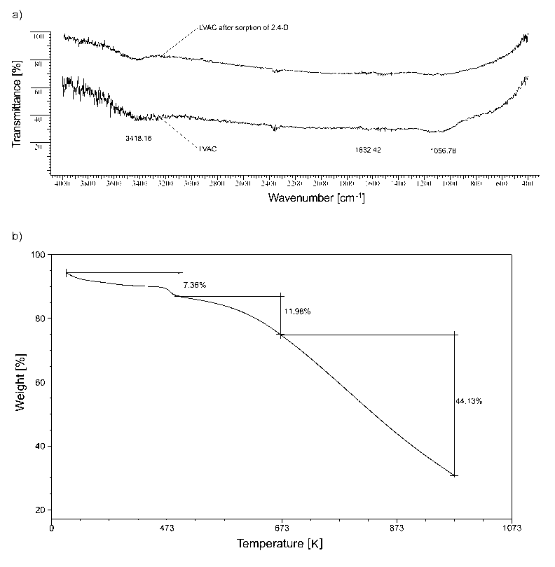

***Figure 1.*** *a) FTIR spectra of LVAC and LVAC after 2,4-D sorption and b) TG analyses of LVAC*

Figure 1 b) shows the TG curve for LVAC. The mass loss of about 7.4 % at temperatures up to 473K is due to the loss of the various forms of water. Further mass loss (12 %) in the temperature range from 473 to 673 K can be primarily due to the release of a large number of pyrolysis gases and due to the degradation of carbon species, especially those including oxygen-containing functional groups from LVAC. The mass loss from 673 to 973 K is caused by oxidation of the powdered activated carbon (about 44 %).

Morphology and structure of LVAC after 2,4-D sorption were observed by SEM (Fig. 2a). The SEM image of LVAC before sorption was presented before [20]. Macroporous, sponge-like, and amorphous structure and openings distributed on the surface indicated a good possibility for the herbicide sorption onto the LVAC surface. These cavities resulted from evaporation of organic and inorganic volatile compounds, which arises during the carbonization process, leaving spaces previously occupied by the reagents or basic building blocks of the starting structure. The Brunauer–Emmett–Teller (BET) surface area and the total pore volume of pores were 665.51 m2/g and 0.37cm3/g, respectively [20]. Gas adsorption isotherm for LVAC is classified as a type I isotherm combined to a certain extent with type II and indicates microporosity of the material.



***Figure 2******.*** *SEM-EDS results: a) SEM micrograph of LVAC after 2,4-D sorption, b) EDS spectrum for LVAC, c) EDS spectrum for LVAC after 2,4-D sorption*

The EDS analysis (Fig. 2b)) shows that carbonization and activation of *Lagenaria vulgaris* led to a carbonized material LVAC with a high carbon content, which is typical for thermally carbonated materials. Peaks corresponding to oxygen were extremely low and there were other heteroatoms (S, K) present in the activated carbon. A significantly lower proportion of oxygen was observed in the LVAC than in other activated carbons, in which the content of this element is higher [31]. High temperature of carbonization leads to condensation of aromatic rings, resulting in the release of low molecular weight volatile components of biomass. Therefore, most of oxygen and hydrogen are lost, inducing an increase in the carbon content. After 2,4-D sorption (Fig. 2c) significant changes can be observed: (a) a decrease in the intensity of the signal of C, (b) an increase in the intensity of the signal of O, and (c) the presence of a signal that represents Cl originating from 2,4-D. Thus, the EDS analysis provided a direct evidence for the sorption of 2,4-D on LVAC.

* 1. **Sorption and removal of 2,4-D herbicide by LVAC**
     1. **Effect of the initial concentration and** **contact time**

Effects of the contact time and initial concentration on removal of 2,4-D by LVAC were studied at different initial 2,4-D concentrations of 50, 100, 200, 300, 400 and 500 mg/dm3 with the constant amount of LVAC of 1.0 g/dm3, at the stirring rate of 300 rpm and at the temperature of 303K (Fig. 3 a). The sorbed amount increased from 49.7 to 333.3 mg/g with the increase in the initial 2,4-D concentration from 50 to 500 mg/dm3. There are two possible reasons for such behavior: the active sites at LVAC were further utilized with the increase in the concentration of 2,4-D (the higher concentration gradient), and the probability of collision between 2,4-D molecules and LVAC was enhanced with the increase in the concentration of 2,4-D [17]. The higher the initial concentration is, the longer time is required to attain the equilibrium. As can be seen in Figure 3 a), the sorption process was rapid within the first 20 min, and it gradually slowed down as the equilibrium approached. However, the equilibrium time depended on the initial 2,4-D concentrations. Equilibrium was attained after 10 min for 2,4-D solutions with initial concentrations in the range 50 - 200 mg/dm3 while about 90 min was required to reach the equilibrium for 2,4-D solutions with initial concentrations in the range 300 - 500 mg/dm3. A large number of free surface sites were available for 2,4-D sorption in the initial stage of sorption. After this, the sorption slowed down, as most of the sorption sites were already occupied.



***Figure3. 2,4-D sorption by LVAC.*** *a) Effect of the contact time: sorbed amount qt as a function of time at different initial 2,4-D concentrations (50, 100, 200, 300, 400 and 500 mg/dm3; amount of LVAC 1.0 g/dm3; stirring rate 300 rpm; temperature 303 K), b) effect of pH on the sorbed amount qt (initial 2,4-D concentration 500 mg/dm3, amount of LVAC 1.0 g/dm3, stirring rate 300 rpm, temperature 303 K), c) effect of the sorbent dose on the sorbed amount after 240 min qt, equilibrium 2,4-D concentration in the solution ce, and the removal efficiency RE% (initial 2,4-D concentration 500 mg/dm3, stirring rate 300 rpm, temperature 303 K), d) effect of the stirring rate on the sorbed amount qt at time 240 min (initial 2,4-D concentration 500 mg/dm3, amount of LVAC 1.0 g/dm3, temperature 303 K)*

* + 1. **The effect of initial pH on sorption**

The effect of initial pH on 2,4-D sorption by LVAC was studied in the pH range from 2 to 11 with the initial 2,4-D concentration of 500 mg/dm3, at the stirring rate of 300 rpm and at 303 K. As shown in Figure 3b, the *sorbed amount* of LVAC at equilibrium decreased from 333.3 to 223.2 mg/g with the increase of pH from 2 to 11. The *sorbed amount* for 2,4-D slightly decreased (about 10%) in the pH range from 2 to 7. The pHPZC value of the LVAC was 7.2. At pH values lower than the pHPZC, the surface of LVAC is positively charged, while at pH values greater than the pHPZC, the surface of LVAC is negatively charged. The pKa of the 2,4-D is 2.64 [32]. At pH values above the pKa value, 2,4-D is dominantly present in the anionic state, and when the pH increases, the extent of dissociation of these molecules increases and they became more negatively charged. However, when pH is less than pKa, 2,4-D is present in the non-ionic molecular form. The removal efficiency of 2,4-D decreases with increasing in the solution pH because of increased repulsion between the negatively charged surface of the sorbent and negatively charged 2,4-D molecules. At strongly alkaline pH, high mobility of OH- ions may compete with the 2,4-dichlorophenoxyacetate anion for sorption sites [33]. Native pH values of solutions at initial 2,4-D concentrations from 50 to 500 mg/dm3 were in the range from 3.1 to 4.3 and were not additionally adjusted during the experiments, because the effect of pH on 2,4-D sorption onto LVAC in that range was found to be negligible.

* + 1. **Effects of the sorbent dose and the stirring rate**

The effect of LVAC dose on sorption of 2,4-D is shown in Figure 3c. Experiments were carried out at the initial 2,4-D concentration of 500 mg/dm3 and different sorbent dosages (0.5, 1.0, 1.2, 1.7 and 2 g/dm3) at the temperature of 303 K and the stirring rate of 300 rpm. The results have shown that the removal efficiency (RE%) increased with the increase in the sorbent dose while the sorbed amount of 2,4-D decreased. Initially, the increase in the removal efficiency was possible because of increased availability of binding sites for 2,4-D and enlarged surface area with the increase in the sorbent dose [34]. The removal efficiency was found to be about 67% when the amount of LVAC was 1.0 g/dm3. Further increase in the dosage (1.2, 1.7 and 2.0 g/dm3) did not lead to a significant increase in the 2,4-D removal efficiency and amounted to 74 %. Thus, the sorbent dose of 1.0 g/dm3 was used in further experiments.

The effect of stirring rate from 0 (without stirring) to 600 rpm on sorption of 2,4-D at the initial concentration of 500 mg/dm3at 303 K is shown in Figure 3d. The obtained results have shown that the increase in stirring rate from 0 to 300 rpm significantly increased the sorbed amount (*q*t on 240min) () from 94.0 to 333.3 mg/g. The increasing in stirring rate improves the convective mass transport by decreasing the liquid boundary layer. Diffusion processes in the solution are accelerated by increasing the stirring rate in the examined system. However, high stirring rate of 400 rpm, leads to the sorption reduction due to desorption of the already sorbed 2,4-D as the result of vigorous stirring. Therefore, a stirring rate of 300 rpm was selected for further experiments.

* + 1. **Kinetics study**

In order to study controlling mechanisms of the sorption process, the equations (4) - (7) were applied to the experimental results obtained for different initial 2,4-D concentrations. The estimated kinetic constants are presented in Table 2. Additional information regarding the non-linear fitting (plots of *qt* vs. *t*) are shown in Figure S1 in Supplementary material. Figure S1 clearly shows that the pseudo-first-order model does not describe well the experimental data, which is also supported by the correlation coefficients in the range from 0.942 to 0.993 and relative deviations in the range from 1.348 to 7.068 % as the initial concentration is increased (Table 2). Consequently, sorption of 2,4-D on LVAC cannot be described by using this kinetic model.

The pseudo-second-order model successfully described the experimental data (Fig. S1) with higher *r*2 values as compared to the pseudo-first-order kinetic model and the smallest relative deviations the range from 0.302 to 2.952 %). So, the obtained results suggest that 2,4-D sorption on LVAC could be described well with the pseudo-second-order kinetic model.

The Chrastil model also described well the experimental data (Fig. S1) with *r*2 values close to 1. Value of the relative deviation were in the range from 0.334 to 3.360%, which is slightly higher than those obtained by the pseudo-second-order model. Values of the diffusion resistance coefficient (*n*) were in the range from 0.271 to 0.426, which indicates that the sorption process was strongly limited by the diffusion resistance.

Based on the obtained predictions, correlation coefficients and values of the relative deviation, kinetics of the 2,4-D sorption process on LVAC could be successfully described by the pseudo-second-order and Chrastil models. The sorption process on LVAC is governed simultaneously by the surface reaction, and diffusion through the sorbent pores. Therefore, sorption on LVAC is a heterogeneous process.

***Table 2.****Parameters of the applied kinetic models for sorption of 2,4-D onto LVAC.*

|  |  |  |  |  |  |  |
| --- | --- | --- | --- | --- | --- | --- |
| Parameters | 50  [mg/dm3] | 100  [mg/dm3] | 200  [mg/dm3] | 300  [mg/dm3] | 400  [mg/dm3] | 500  [mg/dm3] |
| *q*e,exp [mg/g] | 49.7±0.32 | 98.7±0.54 | 195.2±2.15 | 284.4±6.20 | 329.9±6.45 | 333.3±8.25 |
| Pseudo-first-order | | | | | | |
| *q*e,cal | 49.0±0.30 | 97.2±0.48 | 188.4±2.31 | 271.7±7.73 | 307.8±10.7 | 309.8±9.64 |
| *k*1 | 1.787 | 2.774 | 0.828 | 0.273 | 0.205 | 0.247 |
| *r*2 | 0.996 | 0.997 | 0.988 | 0.948 | 0.929 | 0.940 |
| Relative deviation % | 1.3 | 1.5 | 3.5 | 4.5 | 6.7 | 7.1 |
| Pseudo-second-order | | | | | | |
| *q*e,cal | 49.5±0.11 | 97.6±0.36 | 194.2±1.01 | 282.8±3.36 | 321.9±6.64 | 323.5±5.26 |
| *k*2 | 0.0917 | 0.1302 | 0.0067 | 0.0018 | 0.0011 | 0.0013 |
| *r*2 | 1.000 | 0.999 | 0.998 | 0.991 | 0.980 | 0.987 |
| Relative deviation % | 0.3 | 1.1 | 0.5 | 0.6 | 2.4 | 2.9 |
| Chrastil model | | | | | | |
| *q*e,cal | 49.5±0.09 | 98.3±0.21 | 191.0±1.75 | 280.0±2.36 | 322.9±3.18 | 322.1±4.52 |
| *k*c | 0.151 | 0.026 | 0.254 | 0.071 | 0.037 | 0.052 |
| *n* | 0.097 | 0.021 | 0.373 | 0.334 | 0.286 | 0.305 |
| *r*2 | 1.000 | 1.000 | 0.994 | 0.997 | 0.997 | 0.992 |
| Relative deviation % | 0.4 | 0.3 | 2.2 | 1.6 | 2.1 | 3.4 |

* + 1. **Sorption isotherms**

The experimental equilibrium data were fitted with Langmuir, Freundlich, Sips and Brouers – Sotolongo models. The best isotherm model was determined based on the qualitative agreement with the experimental data, *r*2 value and the relative deviation. Calculated model parameters are presented in Table 3 while best model predictions and experimental data (the plot of *q*e vs. *c*e) are shown in Figure S2 in the Supplementary material. The model that best described the equilibrium 2,4-D sorption data on LVAC was the Brouers – Sotolongo isotherm. This model indicates the presence of active sites with heterogeneous sorption interactions, originating from two sources known as geometrical and chemical ones [35]. Based on the Brouers–Sotolongo model exponent (α < 1) the heterogeneous surface of LVAC is confirmed. The maximum sorption capacity obtained by the Brouers–Sotolongo isotherm was closes to the experimentally obtained value for sorption of 2,4-D onto LVAC. The Langmuir monolayer sorption capacity (*q*m) was determined as 341.2 mg/g and was very similar to the experimental value (*q*e,exp exp  for the initial concentration of 500 mg/dm3) with a relative deviation of 2.4 %. Also, the determination coefficient was high for this model, too, amounting to 0.994. However, the Langmuir sorption model fails to account for the surface roughness of the sorbate and a potential multi-layered sorption phenomenon that caused slight deviations from the experimental values. For the initial 2,4-D concentrations in the range from 50 to 500 mg/dm3 used in the isotherm study, the values of *R*L ranged from 0.031 to 0.006, indicating favorable sorption on LVAC. The maximum sorption capacity of LVAC determined by the Sips model was very similar to the experimental *q*e,exp  for the initial concentration of 500 mg/dm3. According to the Figure S2 as well as the parameters shown in Table 3 it can be concluded that the Freundlich isotherm model is not suitable to describe the equilibrium sorption of 2,4-D on LVAC. Based on the *r*2 and relative deviation values, the suitability of tested isotherm models for sorption 2,4-D by LVAC is as follows: Brouers-Sotolongo > Langmuir > Sips > Freundlich. It can be concluded that the sorption of 2,4 D by LVAC may be heterogeneous in character. The additional equilibrium data at different temperatures are needed to precisely determine the best model.

***Table 3.*** *Parameters of the applied**Isotherm models for 2,4-D sorption on LVAC at 303 K*

|  |  |  |  |  |  |  |  |  |
| --- | --- | --- | --- | --- | --- | --- | --- | --- |
| Isotherm | Calculated parameters | | | | | | *r*2 | Relative deviation % |
| *q*e,exp | 333.3 |  | | | |  |  |
| Langmuir | *q*m | 341.2 | *K*L | 0.311 | | | 0.994 | 2.4 |
| Freundlich | *K*F | 114.616 | *n* | 4.289 | | | 0.864 |  |
| Sips | *q*m | 351.7 | *b*S | 0.287 | *n*S | 0.862 | 0.995 | 5.5 |
| B–S | *q*m | 332.7 | *K*W | 0.309 | *α* | 0.666 | 0.999 | 0.2 |

* + 1. **Thermodynamics study**

Values of Δ*H*° and Δ*S*° were calculated from the slope and the intercept of the plot ln*K*D versus 1/*T* (Fig. 4) at different temperatures (283, 293 and 303 K), and shown in Table 4. The obtained values for the Gibbs free energy (*ΔG°*) were negative and increased in the negative direction with the increase in temperature, indicating a more favorable and spontaneous process of 2,4-D sorption at higher temperatures. The positive value of *ΔH°* demonstrated that the sorption process is endothermic, which indicates the presence of an energy barrier in the sorption process. The positive value of *ΔH°* might correspond to intraparticle diffusion of 2,4-D in the pores, as diffusion is an endothermic process. The *ΔH°* value obtained in this study was lower than 40 kJ/mol, thus corresponding to a physical sorption. Also, the positive values of ΔS° showed that the sorption system favored increased disorder and randomness at the solid-solution interface.



***Figure 4.*** *Plot of lnKD vs. 1/T for 2,4-D sorption by LVAC*

***Table 4.*** *Thermodynamic parameters for 2,4-D sorption onto LVAC*

|  |  |  |  |
| --- | --- | --- | --- |
| *T* [K] | *ΔG°*  [J/mol] | *ΔH°*  [kJ/mol] | *ΔS°*  [J/mol] |
| 273 | -675.04 | 14.47 | 53.46 |
| 283 | -1162.16 |
| 303 | -1746.70 |

* 1. **Comparative analysis of sorption capacities of various sorbents**

To evaluate the effectiveness of LVAC for removal of the 2,4-D herbicide from aqueous solutions, maximal sorption capacities and other parameters obtained in this study and other studies with similar sorbents are compared in Table 5. As it can be seen, LVAC has a considerably higher sorption capacity than most of the sorbents. Two major advantages of this sorbent as compared to the others are the ultrahigh sorption capacity and the possibility of efficient removal of 2,4-D in a wide pH range from 2 to 7.

***Table 5.*** *Comparison of maximal sorption capacities for 2,4-D and other parameters for LVAC and some sorbents reported in literature.*

|  |  |  |  |  |  |
| --- | --- | --- | --- | --- | --- |
| Sorbents | pH | Sorbent dose  [g/dm3] | Sorption capacity  [mg/g] | Maximum 2,4-D concentration [mg/dm3] | References |
| Activated carbon from corncob | 3.5 | 1.0 | 334.8 | 400 | [13] |
| **LVAC** | **2-7** | **1.0** | **333.3** | **500** | **This study** |
| Iron oxide nanoparticles-doped carboxylic ordered mesoporous carbon | 3 | 1 | 310.8 | 500 | [4] |
| Activated carbon prepared from H3PO4-activated langsat empty fruit bunch | 2 | 0.8 | 261.2 | 400 | [3] |
| Pumpkin seed hull activated carbon | 2 | 1.0 | 260.8 | 400 | [14] |
| Activated carbon from date stones | 2 | 1.0 | 238.1 | 400 | [15] |
| Carbonaceous adsorbent prepared from carbon slurry | 6.5–7.5 | 1.0 | 212.0 | No data | [16] |
| Granular activated carbon | 3-3.8 | 1.0 | 181.8 | 300 | [17] |
| Carbon-coated electrospun polyacrylonitrile fiber | 3 | 0.6 | 164.5 | 300 | [18] |
| Carbon black | 2-7 | 2.0 | 72.2 | 200 | [19] |

* 1. **Recycling and reusing of the LVAC sorbent**

Recycling and reusing is an important feature of all sorbents, which are used for removal of contaminants, in order to reduce the need for new sorbent amounts and to lower the cost of the sorbent material. Removal efficiency of 2,4-D by LVAC before and after two consecutive regeneration cycles were 66.6, 57.8, 51.9, 49.4 and 49.0 % (Fig. 5). In five sorption-desorption cycles there was ~18% reduction in the sorbed amount of 2,4-D, which indicates that the used LVAC had a good capacity for recycling and reusing. The used LVAC after recycling could be disposed in regular landfills.

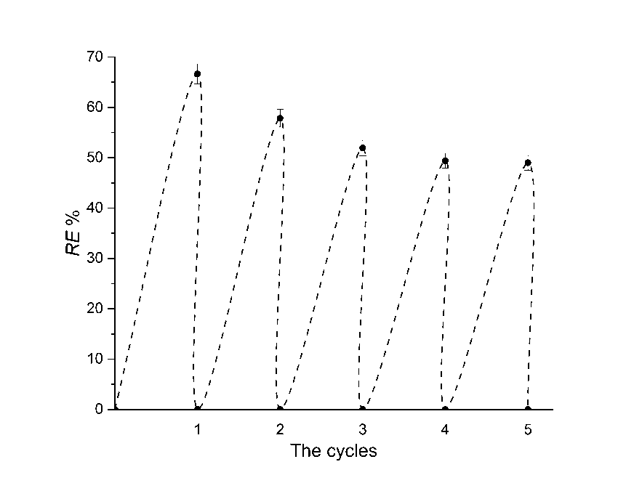

***Figure5.*** *Recycling and reusing cycles of LVAC for 2,4-D: removal efficiency (RE%) as a function of the sorption-desorption cycle*

* 1. **Removal of 2,4-D from** **groundwater**

Removal of 2,4-D from contaminated groundwater was very efficient (Fig. 6). Compared with the results obtained by using the 2,4-D solution in deionized water, in which the equilibrium was attained in 60 s, in the contaminated groundwater the equilibrium was achieved after 105 s. The removal efficiency in both cases was 100%. The longer equilibrium time was likely due to the presence of various ions and organic compounds in the groundwater along with 2,4-D molecules, which competed for sorption sites. Results of this experiment show that LVAC is a reliable and ultrahighly efficient sorbent for the removal of 2,4-D from groundwater.

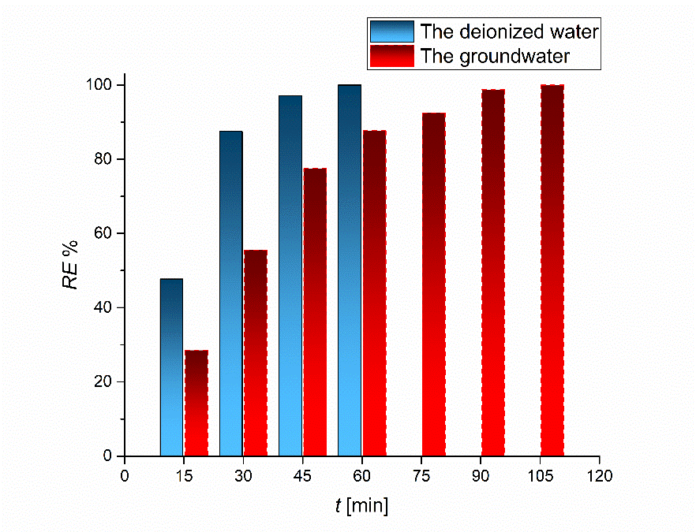

***Figure 6.*** *Comparison of the results of 2,4-D removal from contaminated groundwater and deionized water*

1. **Conclusions**

In this study, activated carbon was produced from *Lagenaria vulgaris* shell by treatment with diluted H2SO4 followed by thermo-chemical carbonization and overheated steam activation. The material was characterized by using TGA, SEM-EDS, BET and FTIR techniques. The optimal values of experimental parameters, such as the initial herbicide concentration, LVAC dose, initial pH, stirring rate and temperature were determined. Changes in the structure and morphology of LVAC before and after 2,4-D sorption were not found. BET analysis of the LVAC has shown high specific surface area and also a high pore volume corresponding to the obtained maximal experimental sorption capacity of 333.3 mg/g. FTIR analysis has shown that the sorption takes place in the pores of LVAC. Kinetic and isotherm data showed that the sorption kinetics could be successfully described by the pseudo-second-order and the Chrastil models, while, based on the determination coefficient and the relative deviation, the Brouers-Sotolongo model described the best the experimental isotherm, predicting the calculated maximum sorption capacity of 332.7 mg/g at 303 K. LVAC has shown a considerable higher sorption capacity than many similar sorbents for removal of 2,4-D in a wide range of pH values. Values of ΔG°, ΔH° and ΔS° indicated favorable, spontaneous, and physical sorption of the herbicide 2,4-D by LVAC, endothermic in nature. LVAC was also successfully recovered and reused in 5 consecutive cycles. Based on the overall results obtained in this study, LVAC can be suggested as a powerful and ultrahighly efficient sorbent for removal of the hazardous herbicide 2,4-D from water.

**Acknowledgement**

The authors would like to thank the Ministry of Education, Science and Technological Development of the Republic of Serbia for supporting this work (Grant no TR 34008).

**References**

1. Ghimire N, Woodward RT. Under and overuse of pesticides: An international analysis. *Ecol. Econ.* 2013; 89: 73–81.
2. Abigail EAM, Melvin SS, Chidambaram R. Application of rice husk nanosorbents containing 2,4-dichlorophenoxyacetic acid herbicide to control weeds and reduce leaching from soil. *J. Taiwan. Inst. Chem. Eng.* 2016; 63: 318–326.
3. Njoku VO, Islam MA, Asif M, Hameed BH. Adsorption of 2,4-dichlorophenoxyacetic acid by mesoporous activated carbon prepared from H3PO4-activated langsat empty fruit bunch. *J. Environ. Manage*. 2015; 154: 138–144.
4. Tang L, Zhang S, Zeng GM, Zhang Y, Yang GD, Chen J, Wang JJ, Wang JJ, Zhou YY, Deng YC. Rapid adsorption of 2,4-dichlorophenoxyacetic acid by iron oxide nanoparticles-doped carboxylic ordered mesoporous carbon. *J. Colloid Interface Sci.* 2015; 445: 1–8.
5. Zhong S, Zhou C, Zhang X, Zhou H, Li H, Zhu X, Wang Y. A novel molecularly imprinted material based on magnetic halloysite nanotubes for rapid enrichment of 2,4-dichlorophenoxyacetic acid in water. *J. Hazard. Mater.* 2014; 276: 58–65.
6. Ding L, Lu X, Deng H, Zhang X. Adsorptive removal of 2,4-Dichlorophenoxy- acetic acid (2,4-D) from aqueous solutions using MIEX resin. *Ind. Eng. Chem. Res.* 2012; 51: 11226–11235.
7. Gao J, Zhao G, Liu M, Li D. Mechanism of Enhanced Electrochemical Oxidation of 2,4-dichlorophenoxyacetic Acid with in situ Microwave Activated Boron-doped Diamond and Platinum Anodes. *J. Phys. Chem. A.* 2009; 113: 10466–10473.
8. Sandeep S, Nagashree KL, Maiyalagan T, Keerthiga G. Photocatalytic degradation of 2,4-dichlorophenoxyacetic acid - A comparative study in hydrothermal TiO2 and commercial TiO2. *Appl. Surf. Sci.* 2018; 449: 371–379.
9. Barrera A, Tzompantzi F, Lara V, Gómez R. Photodegradation of 2,4-D over PdO/Al2O3–Nd2O3 photocatalysts prepared by the sol–gel method. *J. Photochem. Photobiol. A Chem.* 2012; 227: 45–50.
10. Horikoshi S, Hidaka H, Serpone N. Environmental remediation by an integrated microwave/UV-illumination technique: IV. Non-thermal effects in the microwave-assisted degradation of 2,4-dichlorophenoxyacetic acid in UV-irradiated TiO2/H2O dispersions. *J. Photochem. Photobiol. A. Chem.* 2003; 159: 289–300.
11. Maldonado MI, Malato S, Perez-Estrada LA, Gernjak W, Oller I, Domenech X, Peral J. Partial degradation of five pesticides and an industrial pollutant by ozonation in a pilot-plant scale reactor. *J. Hazard. Mater.* 2006; 38: 363–369.
12. Pukcothanung Y, Siritanon T, Rangsriwatananon K. The efficiency of zeolite Y and surfactant-modified zeolite Y for removal of 2,4-dichlorophenoxyacetic acid and 1,1′-dimethyl-4,4′-bipyridinium ion. *Microporous Mesoporous Mater*. 2018; 258: 131–140.
13. Njoku VO, Hameed BH. Preparation and characterization of activated carbon from corncob by chemical activation with H3PO4 for 2,4-dichlorophenoxyacetic acid adsorption. *Chem. Eng. J.* 2011; 173: 391–399.
14. Njoku VO, Foo KY, Hameed BH. Microwave-assisted preparation of pumpkin seed hull activated carbon and its application for the adsorptive removal of 2,4-dichlorophenoxyacetic acid. *Chem. Eng. J.* 2013; 215–216: 383–388.
15. Hameed BH, Salman JM, Ahmad AL. Adsorption isotherm and kinetic modeling of 2,4-D pesticide on activated carbon derived from date stones. *J. Hazard. Mater.* 2009; 163: 121–126.
16. Gupta VK, Ali I, Suhas, Saini VK. Adsorption of 2,4-D and carbofuran pesticides using fertilizer and steel industry wastes. *J. Colloid Interface Sci.* 2006; 299: 556–563.
17. Salman JM, Hameed BH. Adsorption of 2,4-dichlorophenoxyacetic acid and carbofuran pesticides onto granular activated carbon. *Desalination* 2010; 256: 129–135.
18. Zhao R, Li X, Sun B, Ji H, Wang C. Diethylenetriamine-assisted synthesis of amino-rich hydrothermal carbon-coated electrospun polyacrylonitrile fiber adsorbents for the removal of Cr(VI) and 2,4-dichlorophenoxyacetic acid. *J. Colloid Interface Sci.* 2017; 487: 297–309.
19. Kuśmierek K, Szala M, Światkowski A. Adsorption of 2,4-dichlorophenol and 2,4-dichlorophenoxyacetic acid from aqueous solutions on carbonaceous materials obtained by combustion synthesis. *J. Taiwan. Inst. Chem. Eng.* 2016; 63: 371–378.
20. Bojić D, Momčilović M, Milenković D, Mitrović J, Banković P, Velinov N, Nikolić G. Characterization of a low cost Lagenaria vulgaris based carbon for ranitidine removal from aqueous solutions. *Arab. J. Chem.* 2015; 10: 956–964.
21. Cardenas-Peña AM, Ibanez JG, Vasquez-Medrano R. Determination of the point of zero charge for electrocoagulation precipitates from an iron anode. *Int. J. Electrochem. Sci.* 2012; 7: 6142–6153.
22. Lagergren S. Zurtheorie der sogenannten adsorption gelosterstoffe, Kungliga Svenska Vetenskapsakademiens. Handlingar 1898; 24: 1. (in German)
23. Ho YS, McKay G. Sorption of dye from aqueous solution by peat. *Chem. Eng. J.* 1998; 70: 115–124.
24. Chrastil J. Adsorption of direct dyes on cotton: kinetics of dyeing from finite baths based on new information. *Text. Res. J.* 1990; 60: 413–416.
25. Langmuir I. The adsorption of gases on plane surfaces of glass, mica and platinum. *J. Am. Chem. Soc.* 1918; 40: 1361–1403.
26. Freundlich HMF. Über die Adsorption in Lösungen. *Zeitschrift Für Physikalische Chemie* 1907; 57:385–490. (in German)
27. McKay G, Mesdaghinia A, Nasseri S, Hadi M, Aminabad MS. Optimum isotherms of dyes sorption by activated carbon: fractional theoretical capacity & error analysis. *Chem. Eng. J.* 2014; 251: 236–247.
28. Brouers F, Sotolongo O, Marquez F, Pirard JP. Microporous and heterogeneous surface adsorption isotherms arising from Levy distributions. *Physica A* 2005; 349: 271–282.
29. Ahmadi-Pour M, Khosravi-Nikou MR, Shariati A. Adsorption of xylene isomers using Ba-faujasite type zeolite: Equilibrium and kinetics study. *Chem. Eng. Res. Des.* 2018; 138: 387–397.
30. Mondal S, Aikat K, Siddharth K, Sarkar K, DasChaudhury R, Mandal G, Halder G. Optimizing ranitidine hydrochloride uptake of Parthenium hysterophorus derived N-biochar through response surface methodology and artificial neural network. *Process. Saf. Environ. Prot.* 2017; 107: 388–401.
31. Kaouah F, Boumaza S, Berrama T, Trari M, Bendjama Z. Preparation and characterization of activated carbon from wild olive cores (oleaster) by H3PO4 for the removal of Basic Red 46. *J. Clean. Prod.* 2013; 54: 296–306.
32. AksuZ, KabasakalE.Batch adsorption of 2,4-dichlorophenoxy-acetic acid (2,4-D) from aqueous solution by granular activated carbon. *Sep. Purif. Technol.* 2004; 35(3): 223–240.
33. Diaz-Flores PE, Leyva-Ramos R, Rangel-Mendez JR, Ortiz MM, Guerrero-Coronado RM, Mendoza-Barron J. Adsorption of 2,4-dichlorophenoxyacetic acid from aqueous solution on activated carbon cloth. *J. Environ. Eng. Manag.* 2006; 16: 249–257.
34. Iriel A, Bruneel SP, Schenone N, Fernández AF. The removal of fluoride from aqueous solution by a lateritic soil adsorption: kinetic and equilibrium studies. *Ecotoxicol. Environ. Saf.* 2018; 149: 166–172.
35. Dabrowski A, Podkosicielny P, Hubicki Z, Barczak M. Adsorption of phenolic compounds by activated carbon-a critical review. *Chemosphere* 2005; 58: 1049–1070.

Izvod

**Uklanjanje herbicida 2,4-dihlorofenoksi sirćetne kiseline iz vode korišćenjem ultra-efikasnog termohemijski dobijenog aktivnog uglja**

Danijela V. Bojić, Miloš M. Kostić*, Miljana D. Radović Vučić, Nena D. Velinov, Slobodan M. Najdanović, Milica M. Petrović, Aleksandar Lj. Bojić

Departman Hemija, Prirodno-matematički fakultet, Univerzitet u Nišu, Višegradska 33, 18000 Niš, Srbija

**(Naučni rad)**

Aktivni ugalj *Lagenaria vulgaris* (LVAC), sintetisan iz biomase *Lagenaria vulgaris* tretiranjem sa razblaženom H2SO4, praćenim termohemijskom karbonizacijom i procesom aktivacije pomoću pregrejane pare, korišćen je za uklanjanje herbicida 2,4-dihlorofenoksi sirćetne kiseline (2,4-D). Fourierova infracrvena spektroskopija je ukazala da se sorpcija 2,4-D odvija u mikroporama vrlo poroznog LVAC (665 m2/g). LVAC je pokazao veliki kapacitet sorpcije u poređenju sa mnogim prethodno korišćenim sorbentima u optimalnim uslovima: brzina mešanja od 300 rpm, doza sorbenta 1,0 g/dm3 i pH od 2 do 7. Maksimalni eksperimentalni sorpcioni kapacitet LVAC bio je 333,3 mg/g. Model pseudo-drugog reda i Krastilov (Chrastil) model su dobro opisali sorpciju 2,4-D na LVAC. Termodinamička ispitivanja su pokazala da je proces sorpcije bio endoterman, spontan i fizičke prirode. LVAC se pokazao kao ultra-efikasan sorbent za uklanjanje 2,4-D iz podzemnih voda, a takođe moguće ga je reciklovati i ponovo koristiti.

Ključne reči: aktivni ugalj; 2,4-D; podzemna voda; recikliranje i ponovna upotreba; termodinamika