Dear reviewer,

The authors would like to thank you for your comments, suggestions and advices, which will certainly improve the quality of our manuscript. You can see below point by point corrections which we included to the Manuscript.

1. Line 71: Authors/plural
2. Line 79: Šećerov Sokolović et. al /space between words
3. Line 82. Statement The acceptable effluent oil concentration is set to be 15 mg/L, which is often the recommended limit of oil concentration in wastewater [24, 25].

Transferred from line 176 to Introduction with additional references.

1. Line 83: instead of effect we put affect.
2. Line 92: Obtained results for application of PPDJ are compared…
3. Line 109: Explanation: Composite sample is one sample which is the mixture of 250 ml of samples takin in 45, 50, 55 and 60 minutes after experiment was beginning.
4. Line 140: On the base of suggestion of another reviewer correction is “PPDJ looks completely different comparing to material PP.
5. Line 142: already replaced with even.
6. Line 151: …PPDJ has significantly lower porosity… Word “significantly” was deleted.
7. Line 15:

**Questions 1:** Is there any reason why this porosity can’t be lower. You can find explanation below.

**Questions 2**: What factors limit porosity to have such high values? **The answer is**: The limitation is dominantly dimensions of fibers and some time rigidity .

**Questions 3:** Would not it be better if bed porosity is lower and more fibers are used for oil separation?

**Explanation**

In steady-state bed coalescence, fibers are not used for separation, liquid inside pores names "capillary-conducted phase" which allows droplets coalescence on its surface. See references

[6] Spielman LA, Goren S L. Theory of Coalescence by Flow through Porous Media. Ind. Eng. Chem. Fundam. 1972a; 11: 66-72.

[7] Spielman LA, Goren SL. Experiments in Coalescence by Flow through Fibrous Mats. Ind. Eng. Chem. Fundam. 1972b; 11: 73-83.

[8] Spielman LA, Cukor PM. Deposition of Non-Brownian Particles under Colloidal Forces. J. Colloid Interface Sci. 1973; 43: 51−65.

**Part of explanation existed in Introduction: lines 57-63:**

”..Coalescer can operate in steady and non-steady state regime [6-8]. Steady-state regime is reached, when capillary-conducted disperse phase is formed inside the bed. This phase is spread from inlet to outlet of the bed. According to some authors, capillary-conducted phase is formed very quickly, in 20 minutes maximum from the beginning of emulsion flow [6-8]. Small droplets entering the bed are coalescing on capillary-conducted surface, while large globules are detached from the surface and settled after leaving the bed [1, 3, 6-8]…”

For better understanding how coalescer works in steady-state regime, please see the given illustration

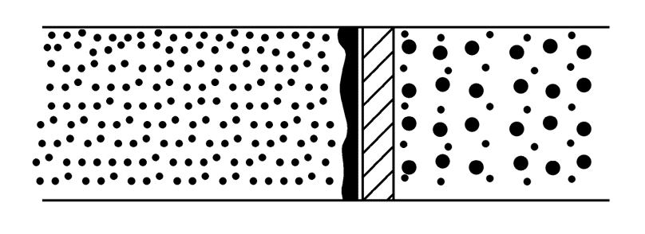

There are additional explanation and clarification (a part of this clarification is now included in manuscript --- lines 191-196):

Steady-state regime is reached, when capillary-conducted disperse phase is formed inside the bed. When bed pores are much bigger than droplets of dispersed phase then the droplets migrate through the bed forming very quickly capillary-conducted phase [6-8]. On the surface of this capillary-conducted phase, droplets that are entering the bed are coalescing. According to Spielman, amount of this capillary-conducted phase is determined by pore volume and fluid velocity. The maximum amount of this phase is 30% of the pore volume. Separation of oil droplets is better over higher bed permeability, because then porosity is higher as well, what causes the lowest interstitial velocity. In these circumstances in pores of the bed the highest amount of capillary-conducted phase is formed. This favors the effective coalescence of the drops and thus their better separation.

1. Line 170: We deleted “free”
2. Line 185: Word “over” replaced with “for”.
3. Line 189: “Why for PPDJ only three different bed permeability were tested while for PP it was tested for five? Give the explanation.”

Sorry. Axis x on diagram was from number 2, now x axis begins with number zero and all five point are included.

1. Line 194: Put figure 6 and 7 in () instead of , ,. It was done.
2. Line 195: Explain how the figures 6 and 7 were obtained (form some simulation (and what were the equations for it) or by experiments?

Explanation is that Contour diagrams made in software Origin Pro 2016. For this it is necessary to form data in x, y, z columns. After selection z column we need to convert data to matrix.



After that we choose 

And expanded columns and rows 

On tis way we obtain simulation points.

1. Line 203: Put figure 6 in () instead of comma. It was done.
2. Line 212: Put figure 7 in () instead of comma. It was done.
3. Line 215. We corrected sentence as follow: that critical velocity is the best parameter for analysis of the results obtained from research of fiber bed coalescence.
4. Line 231: Please see explanation number 15.
5. Line 244. We replaced gives by with.