Dear reviewer,
The authors would like to thank you for your comments, suggestions and advices, which will certainly improve the quality of our manuscript. However, we need to comment on some of your views.

Reviewer
Although this polyolefin is relatively easily disposed by other techniques (e.g. pyrolysis or incineration).

Author comment
Pyrolysis and incineration are very complex techniques with extremely high capital and operational cost. Our country does not have any of this installation. Our suggestion how to solve this problem is cheap and easy to obtain.

Reviewer
The concern is with regards to a repeatability to design porous bed having the similar structure.

Author comment
We work with randomly packed fibers longer than 25 years. From Fig. 3. using experimental dependence of bed porosity on bed permeability for PPDJ and relation which follows, we can identify the mass of material which obtained wanted bed permeability for wanted volum and length of bed:

= 1 - _{n} /
- porosity
_{n –} bulk density
- density of used material.

Reviewer
The other doubt can be a relatively high value of IFT, which in fact reflects a not very difficult liquid-liquid system to separate. Such surfactant free system of two immiscible liquids form rather unstable emulsion, which easily “break” and is often spontaneously separated.

Author comment
Value of interfacial tension is not the only property which influence on the droplet separation efficiency. Oil viscosity and droplets size also determined droplets separation efficiency and coalescence rate. We have droplets smaller than 10 µm and these droplets need a long time to separate spontaneously.You can see reference:

Han, Y., He, L., Luo, X., Lü, Y., Shi, K., Chen, J., Huang, X.
A review of the recent advances in design of corrugated plate packs applied for oil–water
separation 2017 Journal of Industrial and Engineering Chemistry, 53, pp. 37-50.
From his article:
This separation tank can be categorized as a gravity oil–water separation device, and it had many advantages including simple structure, easy-maintainability and high oil removal efficiency. The minimum diameter of oil droplets which could be removed was about 100–150 µm.

Shel Company developed Corrugated Plate Interceptor (CPI) [12] which increased the oil–water separation area by using corrugated plate. The minimum diameter of oil droplets could be removed was about 60 µm.

Mean droplets in our exeiments was 10 µm.
Second reason: Mineral oil, which used in experiments has very low viscosity. It is well known that it is problem to separate this kind of oils.
In addition of these comments, we want to note that our system is no surfactant free. We did not add surfactant, but there are some natural surfactant coming from mineral oils.

In the following text, you will find a point by point realization of your suggestions with the explanation given to some of your comments.
We hope that we properly addressed all your remarks.

- Reviewer: Chapter 2.2 line 116: “size of fibers” is not a proper name, maybe stripes (they are flat, 1000x20 micron)

Authors: We added “stripes” in sentence: The surface morphology, microstructure, size of the fibers and stripes were characterized by scanning..
- Reviewer: Chapter 2.2 line 116: not clear what is the “packing phenomena”?

Authors: We deleted “packing phenomena”

- Reviewer: Line 136: “…bags…PPDJ are shown” (plural)

Authors: We corrected this mistace.

- Reviewer: Line 138: comparing to (btw. “compare with” – when two things are similar, but when you underline difference and compare two significantly different items use “compare to”)

Authors: We corrected this mistace.

- Reviewer: Line 143: repeated the same that is said in 138

Autors: We corrected this

- Reviewer: Line 166: “When the fiber diameters of different materials are similar AND PACKING DENSITY (OR POROSITY) IS MAINTAINED, then the spec. surf. area should be similar” (and usually this value is provided in [m2/m³]) – the difference of this value can arise from both different df and .

Authors: We corected text as follow: The other property that characterizes the material is the specific surface area. When the fiber diameters of different materials are similar, and bulk density is also similar, then specific surface area of materials should be similar, too. For material PPDJ, specific surface area is 2.2 m²/m³, while for material PP is significantly higher and it is 10.0 m²/m³.

- Reviewer: Line 176-177: “If the results are analyzed,…” – maybe “The exp. results show or confirm that…”

Authors: We corected text as follow: The experimental results confirm that both materials have difficulties to separate oil P1 from water.
- Reviewer: Lines 188-189: It is widely observed that “tighter” packing of filter media, whatever it is, makes separation more efficient. But dense packing means low permeability. In Fig. 5 the tendency is opposite. These are, however, past results, but any comments clarifying this counterintuitive behavior or at least hypothesis should be included.
Authors: Part of explanaton existed in Introduction: lines 57-63:
”..Coalescer can operate in steady and non-steady state regime [6-8]. Steady-state regime is reached, when capillary-conducted disperse phase is formed inside the bed. This phase is spread from inlet to outlet of the bed. According to some authors, capillary-conducted phase is formed very quickly, in 20 minutes maximum from the beginning of emulsion flow [6-8]. Small droplets entering the bed are coalescing on capillary-conducted surface, while large globules are detached from the surface and settled after leaving the bed [1, 3, 6-8]….”

For better understanding how coalescer works in steady-state regime, please see the given illustration
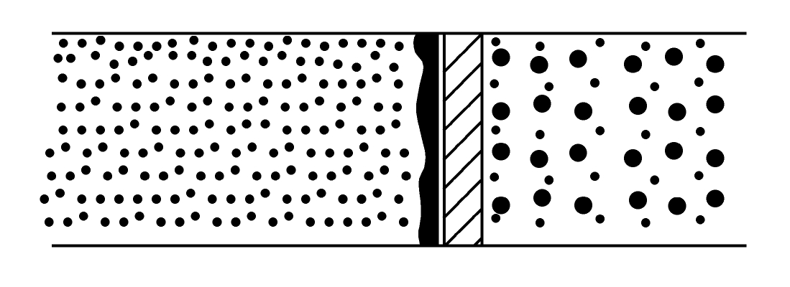

There are additional explanation and clarification (a part of this clarification is now included in manuscript --- lines 191-196):
Steady-state regime is reached, when capillary-conducted disperse phase is formed inside the bed. When bed pores are much bigger than droplets of dispersed phase then the droplets migrate through the bed forming very quickly capillary-conducted phase [6-8]. On the surface of this capillary-conducted phase, droplets that are entering the bed are coalescing. According to Spielman, amount of this capillary-conducted phase is determined by pore volume and fluid velocity. The maximum amount of this phase is 30% of the pore volume. Separation of oil droplets is better over higher bed permeability, because then porosity is higher as well, what causes the lowest interstitial velocity. In these circumstances in pores of the bed the highest amount of capillary-conducted phase is formed. This favors the effective coalescence of the drops and thus their better separation.

- Reviewer: Figure 4 and 5: the legend is not clear (I can guess what v30 or v40 means, but proper description should be included on the graph, incl. units).

Authors: We included in figures captures explanation:

Figure 4. Dependence of effluent oil concentration on bed permeability for different
superficial velocities (v16 to v50 in m h⁻¹) for material PPDJ

Figure 5. Dependence of effluent oil concentration on bed permeability for different
superficial velocities (v16 to v50 in m h⁻¹) for material PP

- Reviewer: Line 203: “…3…” – should be 3·10⁻⁹

Authors: It is realized: over permeabilities lower than 3 10⁻⁹…

- Reviewer: Line 224: Authors refer to highest critical velocity 50 m/h – it is included in Figure 4, but not in Fig. 6 (these two Figs are not consistent with regards to the upper limit of the velocity range).

Authors: Sory. We corrected Fig.6.

