Supplementary material
Spectroscopic and quantum chemical elucidation of newly synthesized 1-aryl-3-methyl-3-phenylpyrrolidine-2,5-diones as potential anticonvulsant agents
Jelena Petković Cvetković¹, Bojan Božić^{2,*}, Nebojša Banjac³, Jelena Lađarević¹, Vesna Vitnik⁴, Željko Vitnik⁴, Nataša Valentić¹, Gordana Ušćumlić¹
¹ Faculty of Technology and Metallurgy, University of Belgrade, Karnegijeva 4, P. O. Box 3503, 11120, Belgrade, Serbia
² Faculty of Biology, Institute of Physiology and Biochemistry, University of Belgrade, Studentski trg 16, 11000 Belgrade, Serbia
³ Faculty of Agriculture, Food Technology and Biochemistry, University of Belgrade, Nemanjina 6, 11080, Belgrade, Zemun, Serbia
⁴ Department of Chemistry, ICTM, University of Belgrade, Studentski trg 12-16, 11000 Belgrade, Serbia

*Correspondence: Bojan Božić
Faculty of Biology, Institute of Physiology and Biochemistry, University of Belgrade, Studentski trg 16, 11000 Belgrade, Serbia
E-mail address: bbozic@bio.bg.ac.rs (B. Božić)
Contents
Characterization of investigated compounds 2
Tables 6
Figures 17

Characterization of investigated compounds

1-(4-Hydroxyphenyl)-3-methyl-3-phenylpyrrolidine-2,5-dione (1, C₁₇H₁₅NO₃). White solid; Yield: 52%; mp: 173.2–174.9 ºC; FT-IR (KBr): |ν| cm^{–1} = 1774 (C=O), 1687 (C=O); ¹H NMR (200 MHz, DMSO): |δ| ppm = 9.78 (s, 1H, –OH), 7.50–7.27 (m, 5H, –C₆H₅), 7.12 (d, J = 8.0 Hz, 2H, –C₆H₄–), 6.87 (d, J = 8.0 Hz, 2H, –C₆H₄), 3.13 (s, 2H, –CH₂–), 1.73 (s, 3H, –CH₃); ¹³C NMR (50 MHz, DMSO): |δ| ppm = 180.42 (C2), 175.03 (C5), 157.49 (Ph), 142.59 (Ph), 128.81 (Ph), 128.44 (Ph), 127.24 (Ph), 125.90 (Ph), 123.52(Ph), 115.49 (Ph), 47.53 (C4), 44.60 (C3), 24.51 (C6). Anal. calcd. for C₁₇H₁₅NO₃: C, 72.58; H, 5.37; N, 4.98; Found: C, 72.44; H, 5.31; N, 4.89.
1-(4-Methoxyphenyl)-3-methyl-3-phenylpyrrolidine-2,5-dione (2, C₁₈H₁₇NO₃). Black solid; Yield: 62%; mp: 104.0–126.0 ºC; FT-IR (KBr): |ν| cm^{–1} = 1772 (C=O), 1710 (C=O); ¹H NMR (200 MHz, DMSO): |δ| ppm = 7.52–7.31 (m, 5H, –C₆H₅), 7.25 (d, J = 8.0 Hz, 2H, –C₆H₄–), 7.05 (d, J = 8.0 Hz, 2H, –C₆H₄–), 3.79 (s, 3H, –OCH₃), 3.14 (ABq, 2H, Δν_{AB} = 8.72 Hz, J = 18Hz, –CH₂–), 1.74 (s, 3H, –CH₃); ¹³C NMR (50 MHz, DMSO): |δ| ppm = 180.33 (C2), 174.94 (C5), 159.10 (Ph), 142.54 (Ph), 128.80 (Ph), 128.47 (Ph), 127.25 (Ph), 125.93 (Ph), 125.02 (Ph), 114.21 (Ph), 55.40 (–OCH₃), 47.58 (C4), 44.61 (C3), 24.45 (C6). Anal. calcd. for C₁₈H₁₇NO₃: C, 73.20; H, 5.80; N, 4.74; Found: C, 73.14; H, 5.71; N, 4.63.
1-(4-Methylphenyl)-3-methyl-3-phenylpyrrolidine-2,5-dione (3, C₁₈H₁₇NO₂). White solid; Yield: 55%; mp: 105.5–106.6 ºC; FT-IR (KBr): |ν| cm^{–1} = 1772 (C=O), 1707 (C=O); ¹H NMR (200 MHz, DMSO): |δ| ppm = 7.53–7.20 (m, 9H, –C₆H₅ and N–C₆H₄–), 3.17 (ABq, 2H, J = 18Hz, –CH₂–), 2.35 (s, 3H, Ph–CH₃), 1.75 (s, 3H, succ–CH₃); ¹³C NMR (50 MHz, DMSO): |δ| ppm = 180.17 (C2), 174.77 (C5), 142.79 (Ph), 138.05 (Ph), 129.88 (Ph), 129.44 (Ph), 128.80 (Ph), 127.24 (Ph), 126.99 (Ph), 125.90 (Ph), 47.63 (C4), 44.62 (C3), 24.45 (C6), 20.71 (–CH₃). Anal. calcd. for C₁₈H₁₇NO₂: C, 77.40; H, 6.13; N, 5.01; Found: C, 77.34; H, 6.01; N, 4.93.
1-phenyl-3-methyl-3-phenylpyrrolidine-2,5-dione (4, C₁₇H₁₅NO₂). White solid; Yield: 45%; mp: 105.5–106.6 ºC; FT-IR (KBr): |ν| cm^{–1} = 1784 (C=O), 1721 (C=O); ¹H NMR (200 MHz, DMSO): |δ| ppm = 7.56–7.28 (m, 10H, –C₆H₅ and N–C₆H₅), 3.18 (ABq, 2H, J = 18Hz, –CH₂–), 1.75 (s, 3H, –CH₃); ¹³C NMR (50 MHz, DMSO): |δ| ppm = 180.12 (C2), 174.72 (C5), 142.45 (Ph), 132.47 (Ph), 128.99 (Ph), 128.82 (Ph), 128.54 (Ph), 127.25 (Ph), 125.94 (Ph), 47.69 (C4), 44.64 (C3), 24.46 (C6). Anal. calcd. for C₁₇H₁₅NO₂: C, 76.96; H, 5.70; N, 5.28; Found: C, 76.87; H, 5.61; N, 5.30.
1-(4-Fluorophenyl)-3-methyl-3-phenylpyrrolidine-2,5-dione (5, C₁₇H₁₄NO₂F). White solid; Yield: 57%; mp: 119.8–121.1 ºC; FT-IR (KBr): |ν| cm^{–1} = 1782 (C=O), 1712 (C=O); ¹H NMR (200 MHz, DMSO): |δ| ppm = 7.54–7.28 (m, 9H, –C₆H₅ and N–C₆H₄–), 3.18 (s, 2H, –CH₂–), 1.76 (s, 3H, –CH₃); ¹³C NMR (50 MHz, DMSO): |δ| ppm = 180.10 (C2), 174.68 (C5), 161.62 (d, J = 244.0 Hz, Ph), 142.41 (Ph), 129.49 (d, J = 9.0 Hz, Ph), 128.80 (Ph), 128.69 (d, J = 3 Hz, Ph), 127.28 (Ph), 125.98 (Ph), 115.91 (d, J = 22.5 Hz, Ph), 47.67 (C4), 44.64 (C3), 24.54 (C6). Anal. calcd. for C₁₇H₁₄NO₂F: C, 72.07; H, 4.98; N, 4.94; Found: C, 72.00; H, 4.86; N, 4.30.
1-(4-Chlorophenyl)-3-methyl-3-phenylpyrrolidine-2,5-dione (6, C₁₇H₁₄NO₂Cl). White solid; Yield: 65%; mp: 120.2–122.2 ºC; FT-IR (KBr): |ν| cm^{–1} = 1778 (C=O), 1710 (C=O); ¹H NMR (200 MHz, DMSO): |δ| ppm = 7.63–7.27 (m, 9H, –C₆H₅ and N–C₆H₄–), 3.18 (ABq, 2H, Δν_{AB} = 12.65 Hz, J = 18Hz, –CH₂–), 1.75 (s, 3H, –CH₃); ¹³C NMR (50 MHz, DMSO): |δ| ppm = 179.90 (C2), 174.47 (C5), 142.32 (Ph), 133.02 (Ph), 131.29 (Ph), 129.03 (Ph), 128.78 (Ph), 127.28 (Ph), 125.96 (Ph), 47.70 (C4), 44.61 (C3), 24.58 (C6). Anal. calcd. for C₁₇H₁₄NO₂Cl: C, 68.12; H, 4.71; N, 4.67; Found: C, 68.04; H, 4.59; N, 4.59.
1-(3-Chlorophenyl)-3-methyl-3-phenylpyrrolidine-2,5-dione (7, C₁₇H₁₄NO₂Cl). White solid; Yield: 66%; mp: 128.6–130.3 ºC; FT-IR (KBr): |ν| cm^{–1} = 1774 (C=O), 1709 (C=O); ¹H NMR (200 MHz, DMSO): |δ| ppm = 7.56–7.28 (m, 9H, –C₆H₅ and N–C₆H₄–), 3.17 (ABq, 2H, Δν_{AB} = 12.65 Hz, J = 18Hz, –CH₂–), 1.76 (s, 3H, –CH₃); ¹³C NMR (50 MHz, DMSO): |δ| ppm = 179.82 (C2), 174.37 (C5), 142.28 (Ph), 133.79 (Ph), 133.04 (Ph), 130.60 (Ph), 128.77 (Ph), 128.55 (Ph), 127.27 (Ph), 126.11 (Ph), 126.01 (Ph), 47.71 (C4), 44.68 (C3), 24.56 (C6). Anal. calcd. for C₁₇H₁₄NO₂Cl: C, 68.12; H, 4.71; N, 4.67; Found: C, 68.07; H, 4.60; N, 4.59.
1-(4-Bromophenyl)-3-methyl-3-phenylpyrrolidine-2,5-dione (8, C₁₇H₁₃NO₂Br). White solid; Yield: 66%; mp: 112.3–114.4 ºC; FT-IR (KBr): |ν| cm^{–1} = 1776 (C=O), 1709 (C=O); ¹H NMR (200 MHz, DMSO): |δ| ppm = 7.73 (d, J = 8 Hz, 2H, –C₆H₄– ), 7.53–7.27 (m, 7H, –C₆H₅ and N–C₆H₄–), 3.18 (ABq, 2H, Δν_{AB} = 8.72 Hz, J = 18Hz, –CH₂–), 1.75 (s, 3H, –CH₃); ¹³C NMR (50 MHz, DMSO): |δ| ppm = 179.86 (C2), 174.44 (C5), 142.32 (Ph), 131.99 (Ph), 131.73 (Ph), 129.35 (Ph), 128.80 (Ph), 127.29 (Ph), 125.97 (Ph), 121.53 (Ph), 47.72 (C4), 44.62 (C3), 24.57 (C6). Anal. calcd. for C₁₇H₁₄NO₂Br: C, 59.32; H, 4.10; N, 4.07; Found: C, 59.25; H, 4.01; N, 3.99.
1-(3-Bromophenyl)-3-methyl-3-phenylpyrrolidine-2,5-dione (9, C₁₇H₁₃NO₂Br). White solid; Yield: 66%; mp: 118.8–121.1 ºC; FT-IR (KBr): |ν| cm^{–1} = 1772 (C=O), 1709 (C=O); ¹H NMR (200 MHz, DMSO): |δ| ppm = 7.69–7.28 (m, 9H, –C₆H₅ and N–C₆H₄–), 3.17 (ABq, 2H, Δν_{AB} = 12.65 Hz, J = 18Hz, –CH₂–), 1.76 (s, 3H, –CH₃); ¹³C NMR (50 MHz, DMSO): |δ| ppm = 179.82 (C2), 174.38 (C5), 142.27 (Ph), 133.91 (Ph), 131.42 (Ph), 130.86 (Ph), 130.06 (Ph), 128.76 (Ph), 127.26 (Ph), 126.50 (Ph), 126.01 (Ph), 121.22 (Ph), 47.70 (C4), 44.68 (C3), 24.56 (C6). Anal. calcd. for C₁₇H₁₄NO₂Br: C, 59.32; H, 4.10; N, 4.07; Found: C, 59.22; H, 4.03; N, 3.97.
1-(4-Carboxyphenyl)-3-methyl-3-phenylpyrrolidine-2,5-dione (10, C₁₈H₁₅NO₄). White solid; Yield: 61%; mp: 173.5–174.7 ºC; FT-IR (KBr): |ν| cm^{–1} = 1783 (C=O), 1710 (C=O); ¹H NMR (200 MHz, DMSO): |δ| ppm = 13.15 (bs, 1H,–COOH), 8.09 (d, J = 10 Hz, 2H, –C₆H₄– ), 7.54–7.28 (m, 7H, –C₆H₅ and N–C₆H₄–), 3.21 (ABq, 2H, Δν_{AB} = 12.65 Hz, J = 18Hz, –CH₂–), 1.76 (s, 3H, –CH₃); ¹³C NMR (50 MHz, DMSO): |δ| ppm = 179.85 (C2), 174.44 (C5), 166.76 (–COOH), 142.31 (Ph), 136.27 (Ph), 130.68 (Ph), 130.02 (Ph), 128.85 (Ph), 127.36 (Ph), 127.25 (Ph), 125.99 (Ph), 47.81 (C4), 44.65 (C3), 24.58 (C6). Anal. calcd. for C₁₈H₁₅NO₄: C, 69.89; H, 4.89; N, 4.53; Found: C, 69.72; H, 4.73; N, 4.46.
1-(4-Cyanophenyl)-3-methyl-3-phenylpyrrolidine-2,5-dione (11, C₁₈H₁₄N₂O₂). White solid; Yield: 58%; mp: 93.9–95.3 ºC; FT-IR (KBr): |ν| cm^{–1} = 1784 (C=O), 1713 (C=O); ¹H NMR (200 MHz, DMSO): |δ| ppm = 8.01 (d, J = 8 Hz, 2H, –C₆H₄– ), 7.63 (d, J = 10 Hz, 2H, –C₆H₄– ), 7.55–7.28 (m, 5H, –C₆H₅), 3.21 (ABq, 2H, Δν_{AB} = 12.65 Hz, J = 18Hz, –CH₂–), 1.77 (s, 3H, –CH₃); ¹³C NMR (50 MHz, DMSO): |δ| ppm = 179.61 (C2), 174.17 (C5), 142.18 (Ph), 136.51 (Ph), 133.08 (Ph), 128.80 (Ph), 127.34 (Ph), 128.05 (Ph), 126.01 (Ph), 118.35 (–CN), 111.09 (Ph), 47.81 (C4), 44.62 (C3), 24.61 (C6). Anal. calcd. for C₁₈H₁₄N₂O₂: C, 74.47; H, 4.86; N, 9.65; Found: C, 74.39; H, 4.79; N, 9.67.
1-(4-Nitrophenyl)-3-methyl-3-phenylpyrrolidine-2,5-dione (12, C₁₇H₁₃N₂O₄). White solid; Yield: 60%; mp: 106.9–108.1 ºC; FT-IR (KBr): |ν| cm^{–1} = 1773 (C=O), 1705 (C=O); ¹H NMR (200 MHz, DMSO): |δ| ppm = 7.95 (d, J = 8 Hz, 2H, –C₆H₄– ), 7.71 (d, J = 10 Hz, 2H, –C₆H₄– ), 7.55–7.27 (m, 5H, –C₆H₅), 3.23 (ABq, 2H, Δν_{AB} = 12.65 Hz, J = 18Hz, –CH₂–), 1.85 (s, 3H, –CH₃); ¹³C NMR (50 MHz, DMSO): |δ| ppm = 179.61 (C2), 174.17 (C5), 142.15 (Ph), 138.05 (Ph), 128.82 (Ph), 128.21 (Ph), 127.37 (Ph), 128.05 (Ph), 126.03 (Ph), 112.42 (Ph), 47.86 (C4), 44.61 (C3), 24.60 (C6). Anal. calcd. for C₁₇H₁₃N₂O₄: C, 66.00; H, 4.24; N, 9.06; Found: C, 59.94; H, 4.26; N, 9.09.

Tables
Table S1. Long-frequencies UV absorption maxima of 1-aryl-3-methyl-3-pheylpyrrolidine-2,5-diones 1–12 in ethanol and Hammett constants for corresponding substituents.

Comp. No. | 1 | 2 | 3 | 4 | 5 | 6 | 7 | 8 | 9 | 10 | 11 | 12
ν_{max} × 10⁻³ | 43.48 | 43.48 | 45.87 | 48.31 | 46.30 | 44.44 | 47.62 | 43.48 | 47.62 | 41.67 | 41.32 | 36.63
σ_{p/m} | -0.37 | -0.27 | -0.17 | 0.00 | 0.06 | 0.23 | 0.37 | 0.23 | 0.39 | 0.45 | 0.66 | 0.78

Table S2. ¹³C NMR chemical shifts (δ/ppm) of the investigated succinimides.
No. | Substituents | SCS in δ/ppm
 |  | C2 | C5
1 | 4-OH | 0.30 | 0.31
2 | 4-OCH₃ | 0.21 | 0.22
3 | 4-CH₃ | 0.05 | 0.05
4 | H | 180.12 | 174.72
5 | 4-F | -0.02 | -0.04
6 | 4-Cl | -0.22 | -0.25
7 | 3-Cl | -0.30 | -0.35
8 | 4-Br | -0.11 | -0.15
9 | 3-Br | -0.30 | -0.34
10 | 4-COOH | -0.27 | -0.28
11 | 4-CN | -0.51 | -0.55
12 | 4-NO₂ | -0.51 | -0.55

Table S3. Electronic energies (E_{HF}) and ZPE corrected energies (E_{ZPE}) in a.u., relative energies (E_{R}) in kcal mol⁻¹ and the statistical Boltzmann distribution weighted values (ω) of all isomers for the compound 4 obtained by B3LYP and M06-2X methods and a 6-311G(d,p) basis set.

Conf. | B3LYP
 | Vacuum |  |  |  | Ethanol |  |  |  | DMSO
 | E_{HF} | E_{ZPE} | E_{R} | ω | E_{HF} | E_{ZPE} | E_{R} | ω | E_{HF} | E_{ZPE} | E_{R} | ω
I | -862.292747 | -862.012164 | 0.02 | 35.3 | -862.305019 | -862.024885 | 0.15 | 22.2 | -862.305319 | -862.025215 | 0.15 | 22.2
II | -862.292075 | -862.011389 | 0.51 | 15.6 | -862.305248 | -862.025033 | 0.05 | 25.9 | -862.305575 | -862.025370 | 0.05 | 26.2
III | -862.292670 | -862.012202 | 0 | 36.7 | -862.305021 | -862.024943 | 0.11 | 23.6 | -862.305319 | -862.025249 | 0.13 | 23.1
IV | -862.291781 | -862.011169 | 0.65 | 12.4 | -862.305242 | -862.025118 | 0 | 28.3 | -862.305575 | -862.025450 | 0 | 28.5
 | M06-2X
I | -861.944531 | -861.660608 | 0.16 | 23.9 | -861.957569 | -861.674089 | 0.49 | 16.2 | -861.957887 | -861.674422 | 0.48 | 16.2
II | -861.944911 | -861.660861 | 0 | 31.1 | -861.958511 | -861.674864 | 0 | 36.5 | -861.958832 | -861.675192 | 0 | 36.4
III | -861.944588 | -861.660724 | 0.09 | 27.0 | -861.957522 | -861.674065 | 0.50 | 15.7 | -861.957828 | -861.674373 | 0.51 | 15.3
IV | -861.944568 | -861.660342 | 0.33 | 18.0 | -861.958265 | -861.674728 | 0.09 | 31.6 | -861.958595 | -861.675074 | 0.07 | 32.1
E_{R} = E_{ZPE} (i) - E_{ZPE} (0); E_{ZPE} (0) - ZPE corrected energy of the most stable conformer

Table S4. Energy of HOMO and LUMO, and HOMO-LUMO energy gaps (eV) obtained by B3LYP and M06-2X calculations for the investigated succinimides in vacuum, ethanol and DMSO

 | B3LYP
 | Vacuum |  |  | Ethanol |  |  | DMSO
 | E_{HOMO} | E_{LUMO} | ΔE | E_{HOMO} | E_{LUMO} | ΔE | E_{HOMO} | E_{LUMO} | ΔE
 | eV | eV | eV | eV | eV | eV | eV | eV | eV
1 | -6.24 | -0.83 | -5.40 | -6.52 | -0.89 | -5.63 | -6.54 | -0.90 | -5.65
2 | -6.14 | -0.79 | -5.34 | -6.43 | -0.88 | -5.55 | -6.44 | -0.89 | -5.55
3 | -6.57 | -0.84 | -5.74 | -6.90 | -0.91 | -5.99 | -6.88 | -0.89 | -5.98
4 | -6.82 | -0.89 | -5.93 | -7.01 | -0.91 | -6.09 | -7.01 | -0.92 | -6.09
5 | -6.79 | -0.98 | -5.81 | -7.00 | -0.94 | -6.06 | -7.00 | -0.94 | -6.06
6 | -6.80 | -1.11 | -5.69 | -7.00 | -1.13 | -5.86 | -7.00 | -1.13 | -5.87
7 | -6.94 | -1.13 | -5.81 | -7.02 | -1.16 | -5.87 | -7.03 | -1.15 | -5.88
8 | -6.74 | -1.11 | -5.63 | -6.95 | -1.14 | -5.81 | -6.94 | -1.15 | -5.78
9 | -6.84 | -1.12 | -5.72 | -7.01 | -1.15 | -5.86 | -7.01 | -1.15 | -5.86
10 | -7.10 | -1.76 | -5.34 | -7.04 | -1.90 | -5.14 | -7.04 | -1.91 | -5.13
11 | -7.22 | -1.87 | -5.35 | -7.05 | -1.94 | -5.12 | -7.05 | -1.94 | -5.11
12 | -7.27 | -2.67 | -4.60 | -7.06 | -2.89 | -4.17 | -7.06 | -2.90 | -4.16
 | M06-2X
1 | -7.49 | 0.12 | -7.61 | -7.78 | 0.14 | -7.92 | -7.79 | 0.14 | -7.93
2 | -7.39 | 0.16 | -7.56 | -7.71 | 0.10 | -7.81 | -7.71 | 0.08 | -7.79
3 | -7.80 | 0.08 | -7.88 | -8.10 | 0.01 | -8.11 | -8.11 | 0.01 | -8.13
4 | -8.05 | 0.02 | -8.07 | -8.35 | -0.04 | -8.30 | -8.35 | -0.04 | -8.31
5 | -8.04 | -0.03 | -8.01 | -8.30 | 0.01 | -8.31 | -8.31 | 0.01 | -8.32
6 | -8.04 | -0.20 | -7.84 | -8.27 | -0.25 | -8.02 | -8.31 | -0.16 | -8.15
7 | -8.19 | -0.21 | -7.98 | -8.42 | -0.26 | -8.16 | -8.43 | -0.26 | -8.16
8 | -7.98 | -0.11 | -7.87 | -8.20 | -0.27 | -7.93 | -8.21 | -0.27 | -7.93
9 | -8.11 | -0.23 | -7.88 | -8.35 | -0.27 | -8.08 | -8.36 | -0.28 | -8.08
10 | -8.32 | -0.76 | -7.56 | -8.44 | -0.93 | -7.51 | -8.44 | -0.94 | -7.50
11 | -8.46 | -0.92 | -7.54 | -8.46 | -0.99 | -7.47 | -8.47 | -0.96 | -7.51
12 | -8.63 | -1.51 | -7.12 | -8.48 | -1.73 | -6.75 | -8.47 | -1.73 | -6.74

Table S5. Evaluation of drug candidates.
No. | Molecular weight | log P^{c} | Hydrogen bonds |  | Rotatable bonds | Polar surface area/Å^{2c}
 |  |  | Donorsª | Acceptors^{b}
1 | 281.31 | 2.09 | 1 | 4 | 2 | 57.61
2 | 295.34 | 2.63 | 0 | 4 | 3 | 46.61
3 | 279.34 | 3.02 | 0 | 3 | 2 | 37.38
4 | 265.31 | 2.57 | 0 | 3 | 2 | 37.38
5 | 283.30 | 2.73 | 0 | 3 | 2 | 37.38
6 | 299.76 | 3.25 | 0 | 3 | 2 | 37.38
7 | 299.76 | 3.23 | 0 | 3 | 2 | 37.38
8 | 344.21 | 3.38 | 0 | 3 | 2 | 37.38
9 | 344.21 | 3.36 | 0 | 3 | 2 | 37.38
10 | 309.32 | 2.48 | 1 | 5 | 3 | 74.68
11 | 290.32 | 2.33 | 0 | 4 | 2 | 61.17
12 | 310.31 | 2.53 | 0 | 6 | 3 | 83.20
Methsuximide | 203.24 | 1.34 | 0 | 3 | 1 | 37.38
Ideal compound | <500 | <5 | <5 | <10 | <8 | <140
ª A donor indicates any O–H or N–H group.
^{b} An acceptor indicates any O or N including those in donor groups.
^{c} Parameters calculated by the program Molinspiration.

Table S6. PASS predictions for the investigated succinimides (1–12). Pa and Pi represent probabilities that the investigated molecule will be active and inactive, respectively.
Note: Only the results with Pa > 0.7 are presented
1-(4-Hydroxyphenyl)-3-methyl-3-phenylpyrrolidine-2,5-dione (1)
Pa | Pi | Receptors
0.853 | 0.023 | CYP2C12 substrate
0.796 | 0.020 | Antiseborrheic
0.788 | 0.028 | Testosterone 17beta-dehydrogenase (NADP+) inhibitor
0.733 | 0.004 | Tetrahydroxynaphthalene reductase inhibitor
0.730 | 0.010 | 27-Hydroxycholesterol 7alpha-monooxygenase inhibitor
0.718 | 0.016 | Glutathione thiolesterase inhibitor
0.731 | 0.054 | Aspulvinone dimethylallyltransferase inhibitor
0.721 | 0.061 | Ubiquinol-cytochrome-c reductase inhibitor

1-(4-Methoxyphenyl)-3-methyl-3-phenylpyrrolidine-2,5-dione (2)
Pa | Pi | Receptors
0.764 | 0.044 | Aspulvinone dimethylallyltransferase inhibitor
0.735 | 0.038 | Gluconate 2-dehydrogenase (acceptor) inhibitor
0.721 | 0.053 | CYP2C12 substrate

1-(4-Methylphenyl)-3-methyl-3-phenylpyrrolidine-2,5-dione (3)
Pa | Pi | Receptors
0.783 | 0.030 | Testosterone 17beta-dehydrogenase (NADP+) inhibitor
0.735 | 0.010 | 27-Hydroxycholesterol 7alpha-monooxygenase inhibitor
0.712 | 0.046 | CYP2J substrate
0.717 | 0.054 | CYP2C12 substrate

1-phenyl-3-methyl-3-phenylpyrrolidine-2,5-dione (4)
Pa | Pi | Receptors
0.823 | 0.020 | Testosterone 17beta-dehydrogenase (NADP+) inhibitor
0.806 | 0.005 | 27-Hydroxycholesterol 7alpha-monooxygenase inhibitor
0.746 | 0.008 | Anticonvulsant
0.731 | 0.005 | CYP2A8 substrate
0.740 | 0.050 | CYP2C12 substrate
0.703 | 0.015 | Phosphatidylcholine-retinol O-acyltransferase inhibitor
0.727 | 0.042 | CYP2J substrate
0.705 | 0.022 | Lysase inhibitor

1-(4-Fluorophenyl)-3-methyl-3-phenylpyrrolidine-2,5-dione (5)
Pa | Pi | Receptors
0.748 | 0.008 | Anticonvulsant

1-(4-Chlorophenyl)-3-methyl-3-phenylpyrrolidine-2,5-dione (6)
Pa | Pi | Receptors
0.830 | 0.003 | CYP2A8 substrate
0.809 | 0.005 | Anticonvulsant
0.803 | 0.005 | 27-Hydroxycholesterol 7alpha-monooxygenase inhibitor
0.764 | 0.048 | Phobic disorders treatment
0.734 | 0.039 | CYP2J substrate
0.709 | 0.021 | 5-O-(4-coumaroyl)-D-quinate 3'-monooxygenase inhibitor
0.704 | 0.034 | Glycosylphosphatidylinositol phospholipase D inhibitor
1-(3- Chlorophenyl)-3-methyl-3-phenylpyrrolidine-2,5-dione (7)
Pa | Pi | Receptors
0.835 | 0.005 | Anticonvulsant
0.809 | 0.004 | CYP2A8 substrate
0.774 | 0.007 | 27-Hydroxycholesterol 7alpha-monooxygenase inhibitor
0.734 | 0.027 | Glycosylphosphatidylinositol phospholipase D inhibitor
0.731 | 0.062 | Phobic disorders treatment
0.706 | 0.048 | CYP2J substrate

1-(4-Bromophenyl)-3-methyl-3-phenylpyrrolidine-2,5-dione (8)
Pa | Pi | Receptors
0.778 | 0.006 | Anticonvulsant

1-(3- Bromophenyl)-3-methyl-3-phenylpyrrolidine-2,5-dione (9)
Pa | Pi | Receptors
0.807 | 0.005 | Anticonvulsant

1-(4-Carboxyphenyl)-3-methyl-3-phenylpyrrolidine-2,5-dione (10)
Pa | Pi | Receptors
0.909 | 0.005 | Testosterone 17beta-dehydrogenase (NADP+) inhibitor
0.848 | 0.004 | Phosphatidylcholine-retinol O-acyltransferase inhibitor
0.825 | 0.006 | Pullulanase inhibitor
0.823 | 0.005 | Glutathione thiolesterase inhibitor
0.823 | 0.005 | Ribulose-phosphate 3-epimerase inhibitor
0.803 | 0.004 | Electron-transferring-flavoprotein dehydrogenase inhibitor
0.798 | 0.004 | Cholestanetriol 26-monooxygenase inhibitor
0.799 | 0.006 | Creatininase inhibitor
0.806 | 0.017 | Alkenylglycerophosphocholine hydrolase inhibitor
0.798 | 0.019 | Antieczematic
0.787 | 0.009 | Fusarinine-C ornithinesterase inhibitor
0.781 | 0.004 | Arylalkyl acylamidase inhibitor
0.772 | 0.004 | Phenol O-methyltransferase inhibitor
0.767 | 0.005 | 1,4-Lactonase inhibitor
0.772 | 0.011 | 5-O-(4-coumaroyl)-D-quinate 3'-monooxygenase inhibitor
0.763 | 0.004 | Ferredoxin-NAD+ reductase inhibitor
0.763 | 0.004 | Naphthalene 1,2-dioxygenase inhibitor
0.775 | 0.017 | Taurine dehydrogenase inhibitor
0.768 | 0.011 | Glucan endo-1,6-beta-glucosidase inhibitor
0.761 | 0.007 | 3-Hydroxybenzoate 6-monooxygenase inhibitor
0.760 | 0.009 | UDP-N-acetylglucosamine 4-epimerase inhibitor
0.756 | 0.006 | L-glutamate oxidase inhibitor
0.773 | 0.025 | Chlordecone reductase inhibitor
0.757 | 0.010 | NADPH-cytochrome-c2 reductase inhibitor
0.751 | 0.007 | Gluconate 5-dehydrogenase inhibitor
0.756 | 0.016 | Glutamyl endopeptidase II inhibitor
0.750 | 0.010 | Bisphosphoglycerate phosphatase inhibitor
0.748 | 0.008 | Polyamine-transporting ATPase inhibitor
0.744 | 0.005 | Chenodeoxycholoyltaurine hydrolase inhibitor
0.740 | 0.005 | Tryptophanamidase inhibitor
0.741 | 0.008 | Methylamine-glutamate N-methyltransferase inhibitor
0.743 | 0.010 | Dimethylargininase inhibitor
0.740 | 0.008 | Pterin deaminase inhibitor
0.735 | 0.004 | Cyclohexyl-isocyanide hydratase inhibitor
0.736 | 0.012 | Alkane 1-monooxygenase inhibitor
0.727 | 0.004 | Mannan endo-1,4-beta-mannosidase inhibitor
0.735 | 0.018 | Dehydro-L-gulonate decarboxylase inhibitor
0.724 | 0.007 | Spermidine dehydrogenase inhibitor
0.719 | 0.008 | Poly(alpha-L-guluronate) lyase inhibitor
0.715 | 0.005 | (R)-Pantolactone dehydrogenase (flavin) inhibitor
0.717 | 0.012 | 2-Hydroxymuconate-semialdehyde hydrolase inhibitor
0.709 | 0.004 | N-acetylneuraminate synthase inhibitor
0.708 | 0.005 | Opheline kinase inhibitor
0.708 | 0.005 | Taurocyamine kinase inhibitor
0.708 | 0.006 | Aminobutyraldehyde dehydrogenase inhibitor
0.707 | 0.005 | Long-chain-aldehyde dehydrogenase inhibitor
0.713 | 0.013 | 2-Hydroxyquinoline 8-monooxygenase inhibitor
0.728 | 0.028 | Sugar-phosphatase inhibitor
0.712 | 0.012 | N-acetylneuraminate 7-O(or 9-O)-acetyltransferase inhibitor
0.705 | 0.007 | NADH kinase inhibitor
0.704 | 0.008 | Gamma-guanidinobutyraldehyde dehydrogenase inhibitor
0.706 | 0.009 | Mitochondrial processing peptidase inhibitor
0.702 | 0.007 | Peptide alpha-N-acetyltransferase inhibitor
0.713 | 0.022 | Sphinganine kinase inhibitor
0.713 | 0.026 | Glutamate-5-semialdehyde dehydrogenase inhibitor
0.715 | 0.063 | Ubiquinol-cytochrome-c reductase inhibitor

1-(4-Cyanophenyl)-3-methyl-3-phenylpyrrolidine-2,5-dione (11)
Pa | Pi | Receptors
0.864 | 0.020 | CYP2C12 substrate
0.770 | 0.005 | Neurotransmitter uptake inhibitor

1-(4-Nitrophenyl)-3-methyl-3-phenylpyrrolidine-2,5-dione (12)
Pa | Pi | Receptors
0.770 | 0.013 | Lysase inhibitor
0.792 | 0.036 | Ubiquinol-cytochrome-c reductase inhibitor
0.766 | 0.011 | Fusarinine-C ornithinesterase inhibitor
0.759 | 0.012 | Glucan endo-1,6-beta-glucosidase inhibitor
0.721 | 0.009 | Anticonvulsant
0.701 | 0.044 | Acrocylindropepsin inhibitor
0.701 | 0.044 | Chymosin inhibitor
0.701 | 0.044 | Saccharopepsin inhibitor

Parent compound: Methsuximide
Pa | Pi | Receptors
0.909 | 0.004 | Anticonvulsant
0.847 | 0.003 | CYP2A8 substrate
0.823 | 0.020 | Testosterone 17beta-dehydrogenase (NADP+) inhibitor
0.772 | 0.014 | Nicotinic alpha2beta2 receptor antagonist
0.745 | 0.005 | 4-Nitrophenol 2-monooxygenase inhibitor
0.738 | 0.005 | CYP2A2 substrate
0.767 | 0.044 | CYP2C12 substrate
0.740 | 0.023 | Nicotinic alpha6beta3beta4alpha5 receptor antagonist
0.727 | 0.010 | 27-Hydroxycholesterol 7alpha-monooxygenase inhibitor
0.703 | 0.015 | Phosphatidylcholine-retinol O-acyltransferase inhibitor
0.709 | 0.047 | CYP2J substrate

Figures
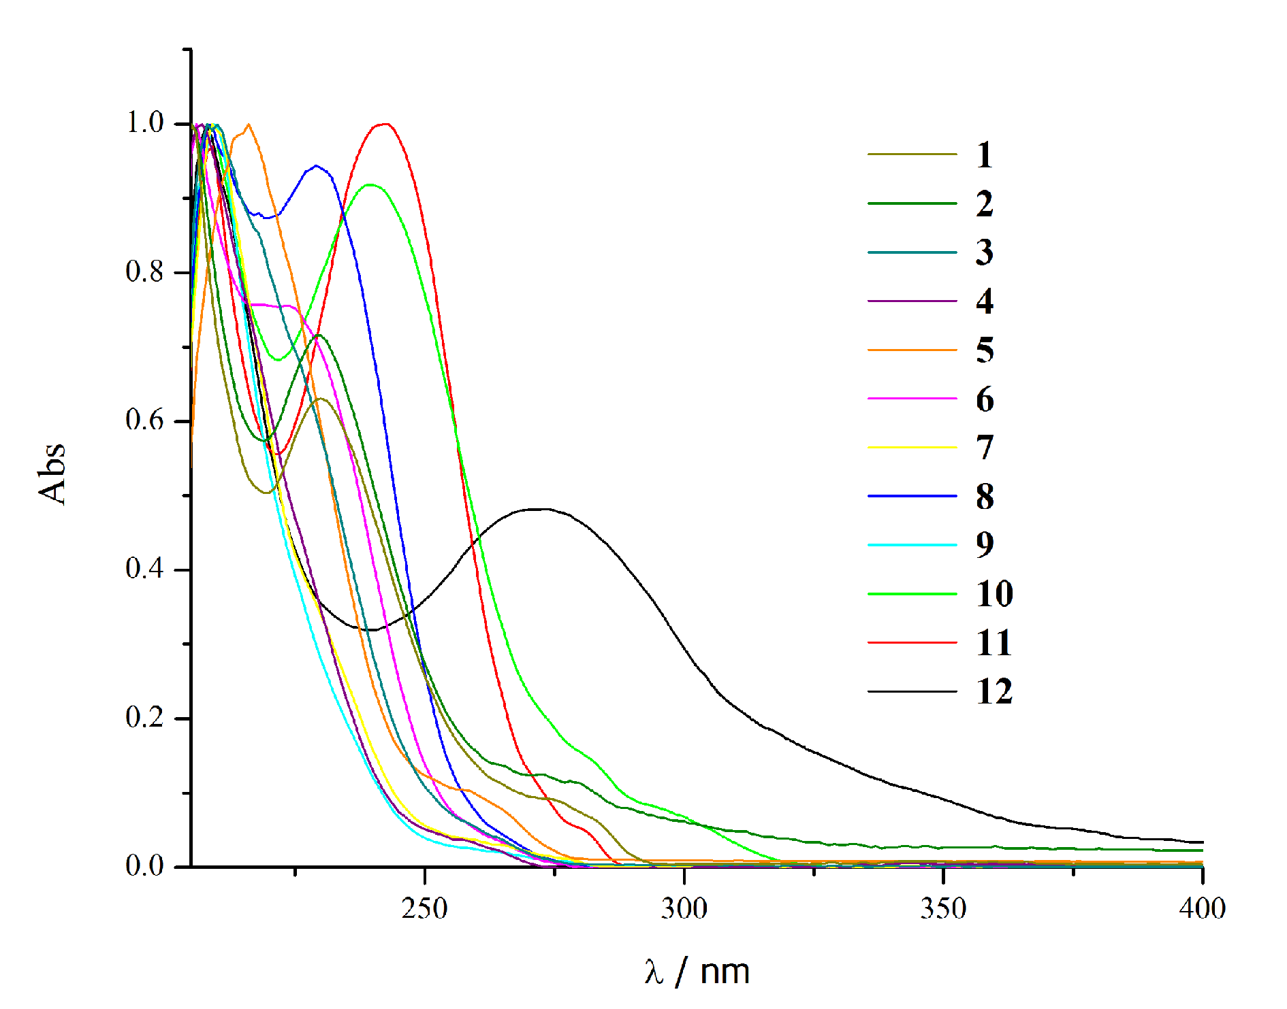

Figure S1. Normalized UV absorption spectra of the investigated compounds in ethanol.

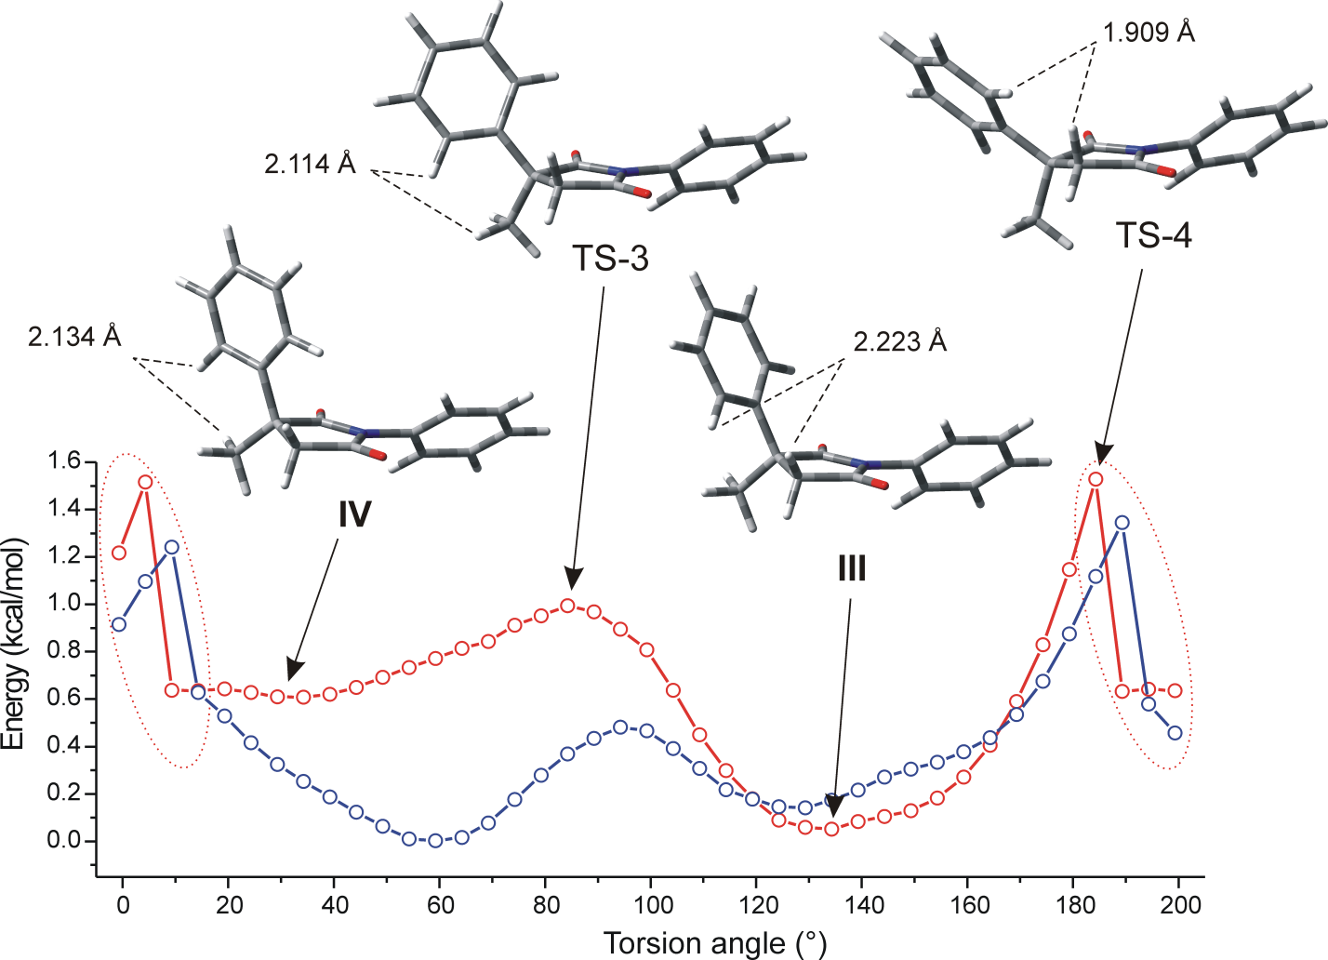

Figure S2. Potential energy scans for rotation of the 3-phenyl group, in vacuum (red) and ethanol (blue) carried out by the B3LYP/6-311G(d,p) method (N-phenyl group torsion angle of ~136°).

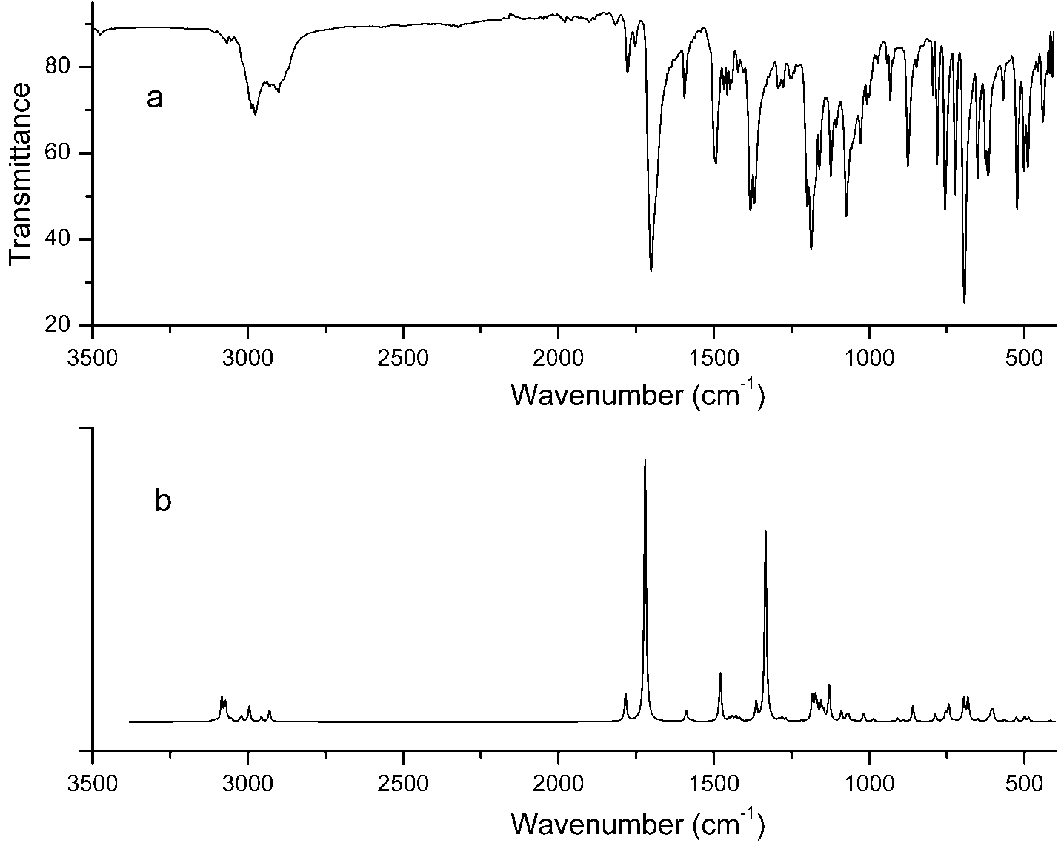

Figure S3. The experimental a) and calculated b) infrared spectrum of the compound 4.

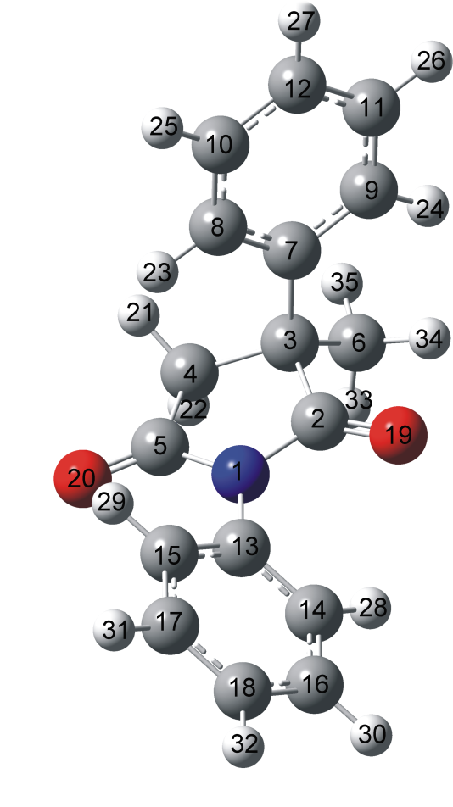

Figure S4. Atom numbering in the investigated succinimide 4.

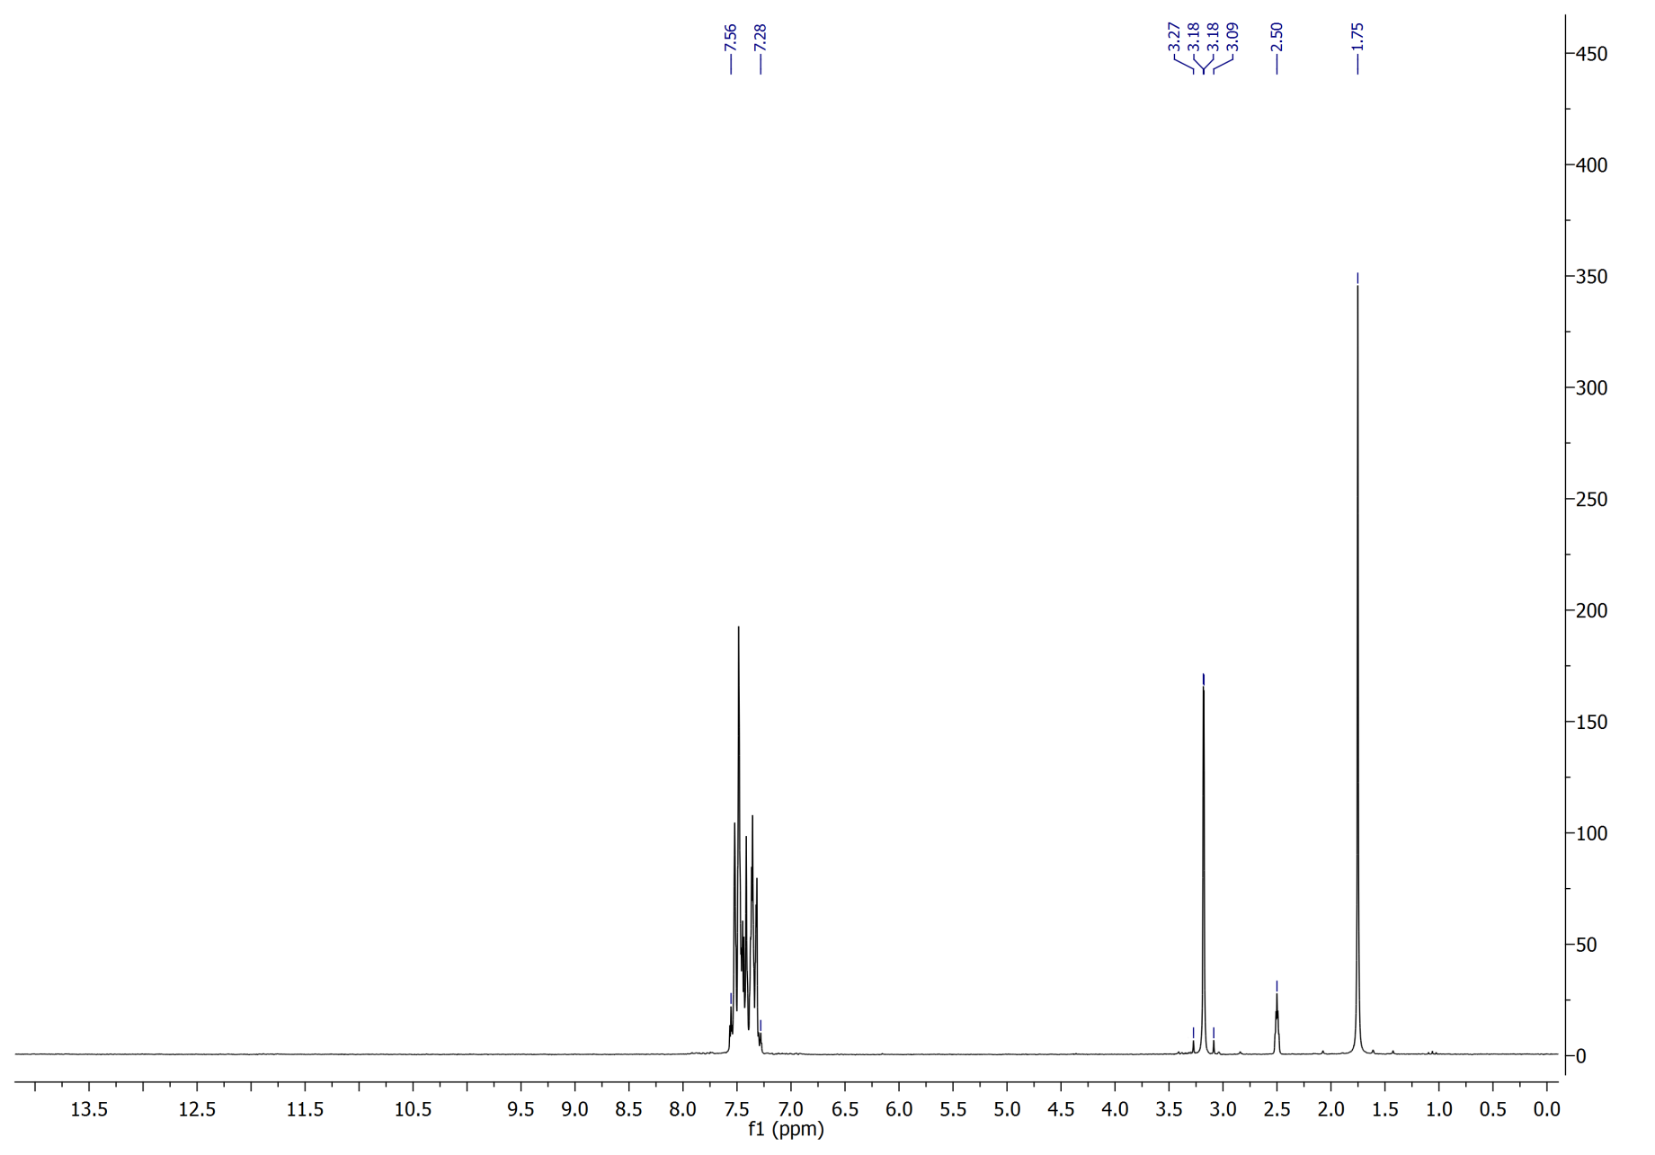

Figure S5. The ¹H NMR spectrum of the compound 4 recorded in DMSO-d₆.
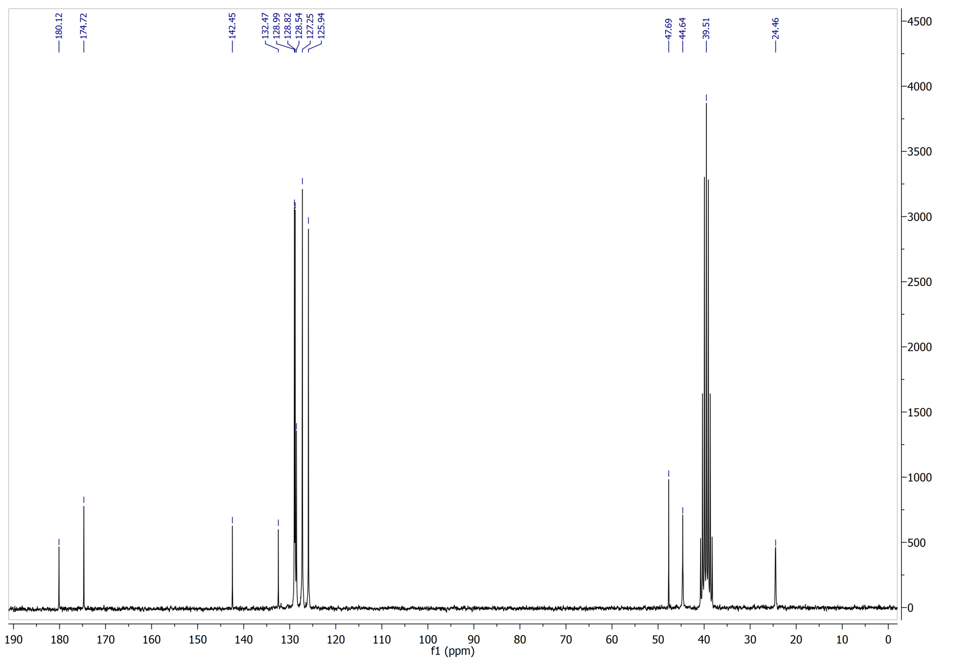
Figure S6. The ¹³C NMR spectrum of the compound 4 recorded in DMSO-d₆.

