Spectroscopic and quantum chemical elucidation of newly synthesized 1-aryl-3-methyl-3-phenylpyrrolidine-2,5-diones as potentional anticonvulsant agents
Jelena Petković Cvetković¹, Bojan Božić^{2,*}, Nebojša Banjac³, Jelena Lađarević¹, Vesna Vitnik⁴, Željko Vitnik⁴, Nataša Valentić¹, Gordana Ušćumlić¹
¹ Faculty of Technology and Metallurgy, University of Belgrade, Karnegijeva 4, P. O. Box 3503, 11120, Belgrade, Serbia
² Institute of Physiology and Biochemistry, Faculty of Biology, University of Belgrade, Studentski trg 16, 11000 Belgrade, Serbia
³ Faculty of Agriculture, Food Technology and Biochemistry, University of Belgrade, Nemanjina 6, 11080, Belgrade, Zemun, Serbia
⁴ Department of Chemistry, ICTM, University of Belgrade, Studentski trg 12-16, 11000 Belgrade, Serbia

*Correspondence: Bojan Božić
Institute of Physiology and Biochemistry, Faculty of Biology, University of Belgrade, Studentski trg 16, 11000 Belgrade, Serbia
E-mail address: bbozic@bio.bg.ac.rs (B. Božić)
Contents
Characterization of investigated compounds 2
Tables 6
Figures 17

Characterization of investigated compounds

1-(4-Hydroxyphenyl)-3-methyl-3-phenylpyrrolidine-2,5-dione (1, C₁₇H₁₅NO₃). White solid; Yield: 52%; mp: 173.2–174.9 ºC; FT-IR (KBr): |ν| cm^{–1} = 1774 (C=O), 1687 (C=O); ¹H NMR (200 MHz, DMSO): |δ| ppm = 9.78 (s, 1H, –OH), 7.50–7.27 (m, 5H, –C₆H₅), 7.12 (d, J = 8.0 Hz, 2H, –C₆H₄–), 6.87 (d, J = 8.0 Hz, 2H, –C₆H₄), 3.13 (s, 2H, –CH₂–), 1.73 (s, 3H, –CH₃); ¹³C NMR (50 MHz, DMSO): |δ| ppm = 180.42 (C2), 175.03 (C5), 157.49 (Ph), 142.59 (Ph), 128.81 (Ph), 128.44 (Ph), 127.24 (Ph), 125.90 (Ph), 123.52(Ph), 115.49 (Ph), 47.53 (C4), 44.60 (C3), 24.51 (C6). Anal. calcd. for C₁₇H₁₅NO₃: C, 72.58; H, 5.37; N, 4.98; Found: C, 72.44; H, 5.31; N, 4.89.
1-(4-Methoxyphenyl)-3-methyl-3-phenylpyrrolidine-2,5-dione (2, C₁₈H₁₇NO₃). Black solid; Yield: 62%; mp: 104.0–126.0 ºC; FT-IR (KBr): |ν| cm^{–1} = 1772 (C=O), 1710 (C=O); ¹H NMR (200 MHz, DMSO): |δ| ppm = 7.52–7.31 (m, 5H, –C₆H₅), 7.25 (d, J = 8.0 Hz, 2H, –C₆H₄–), 7.05 (d, J = 8.0 Hz, 2H, –C₆H₄–), 3.79 (s, 3H, –OCH₃), 3.14 (ABq, 2H, Δν_{AB} = 8.72 Hz, J = 18Hz, –CH₂–), 1.74 (s, 3H, –CH₃); ¹³C NMR (50 MHz, DMSO): |δ| ppm = 180.33 (C2), 174.94 (C5), 159.10 (Ph), 142.54 (Ph), 128.80 (Ph), 128.47 (Ph), 127.25 (Ph), 125.93 (Ph), 125.02 (Ph), 114.21 (Ph), 55.40 (–OCH₃), 47.58 (C4), 44.61 (C3), 24.45 (C6). Anal. calcd. for C₁₈H₁₇NO₃: C, 73.20; H, 5.80; N, 4.74; Found: C, 73.14; H, 5.71; N, 4.63.
1-(4-Methylphenyl)-3-methyl-3-phenylpyrrolidine-2,5-dione (3, C₁₈H₁₇NO₂). White solid; Yield: 55%; mp: 105.5–106.6 ºC; FT-IR (KBr): |ν| cm^{–1} = 1772 (C=O), 1707 (C=O); ¹H NMR (200 MHz, DMSO): |δ| ppm = 7.53–7.20 (m, 9H, –C₆H₅ and N–C₆H₄–), 3.17 (ABq, 2H, J = 18Hz, –CH₂–), 2.35 (s, 3H, Ph–CH₃), 1.75 (s, 3H, succ–CH₃); ¹³C NMR (50 MHz, DMSO): |δ| ppm = 180.17 (C2), 174.77 (C5), 142.79 (Ph), 138.05 (Ph), 129.88 (Ph), 129.44 (Ph), 128.80 (Ph), 127.24 (Ph), 126.99 (Ph), 125.90 (Ph), 47.63 (C4), 44.62 (C3), 24.45 (C6), 20.71 (–CH₃). Anal. calcd. for C₁₈H₁₇NO₂: C, 77.40; H, 6.13; N, 5.01; Found: C, 77.34; H, 6.01; N, 4.93.
1-phenyl-3-methyl-3-phenylpyrrolidine-2,5-dione (4, C₁₇H₁₅NO₂). White solid; Yield: 45%; mp: 105.5–106.6 ºC; FT-IR (KBr): |ν| cm^{–1} = 1784 (C=O), 1721 (C=O); ¹H NMR (200 MHz, DMSO): |δ| ppm = 7.56–7.28 (m, 10H, –C₆H₅ and N–C₆H₅), 3.18 (ABq, 2H, J = 18Hz, –CH₂–), 1.75 (s, 3H, –CH₃); ¹³C NMR (50 MHz, DMSO): |δ| ppm = 180.12 (C2), 174.72 (C5), 142.45 (Ph), 132.47 (Ph), 128.99 (Ph), 128.82 (Ph), 128.54 (Ph), 127.25 (Ph), 125.94 (Ph), 47.69 (C4), 44.64 (C3), 24.46 (C6). Anal. calcd. for C₁₇H₁₅NO₂: C, 76.96; H, 5.70; N, 5.28; Found: C, 76.87; H, 5.61; N, 5.30.
1-(4-Fluorophenyl)-3-methyl-3-phenylpyrrolidine-2,5-dione (5, C₁₇H₁₄NO₂F). White solid; Yield: 57%; mp: 119.8–121.1 ºC; FT-IR (KBr): |ν| cm^{–1} = 1782 (C=O), 1712 (C=O); ¹H NMR (200 MHz, DMSO): |δ| ppm = 7.54–7.28 (m, 9H, –C₆H₅ and N–C₆H₄–), 3.18 (s, 2H, –CH₂–), 1.76 (s, 3H, –CH₃); ¹³C NMR (50 MHz, DMSO): |δ| ppm = 180.10 (C2), 174.68 (C5), 161.62 (d, J = 244.0 Hz, Ph), 142.41 (Ph), 129.49 (d, J = 9.0 Hz, Ph), 128.80 (Ph), 128.69 (d, J = 3 Hz, Ph), 127.28 (Ph), 125.98 (Ph), 115.91 (d, J = 22.5 Hz, Ph), 47.67 (C4), 44.64 (C3), 24.54 (C6). Anal. calcd. for C₁₇H₁₄NO₂F: C, 72.07; H, 4.98; N, 4.94; Found: C, 72.00; H, 4.86; N, 4.30.
1-(4-Chlorophenyl)-3-methyl-3-phenylpyrrolidine-2,5-dione (6, C₁₇H₁₄NO₂Cl). White solid; Yield: 65%; mp: 120.2–122.2 ºC; FT-IR (KBr): |ν| cm^{–1} = 1778 (C=O), 1710 (C=O); ¹H NMR (200 MHz, DMSO): |δ| ppm = 7.63–7.27 (m, 9H, –C₆H₅ and N–C₆H₄–), 3.18 (ABq, 2H, Δν_{AB} = 12.65 Hz, J = 18Hz, –CH₂–), 1.75 (s, 3H, –CH₃); ¹³C NMR (50 MHz, DMSO): |δ| ppm = 179.90 (C2), 174.47 (C5), 142.32 (Ph), 133.02 (Ph), 131.29 (Ph), 129.03 (Ph), 128.78 (Ph), 127.28 (Ph), 125.96 (Ph), 47.70 (C4), 44.61 (C3), 24.58 (C6). Anal. calcd. for C₁₇H₁₄NO₂Cl: C, 68.12; H, 4.71; N, 4.67; Found: C, 68.04; H, 4.59; N, 4.59.
1-(3-Chlorophenyl)-3-methyl-3-phenylpyrrolidine-2,5-dione (7, C₁₇H₁₄NO₂Cl). White solid; Yield: 66%; mp: 128.6–130.3 ºC; FT-IR (KBr): |ν| cm^{–1} = 1774 (C=O), 1709 (C=O); ¹H NMR (200 MHz, DMSO): |δ| ppm = 7.56–7.28 (m, 9H, –C₆H₅ and N–C₆H₄–), 3.17 (ABq, 2H, Δν_{AB} = 12.65 Hz, J = 18Hz, –CH₂–), 1.76 (s, 3H, –CH₃); ¹³C NMR (50 MHz, DMSO): |δ| ppm = 179.82 (C2), 174.37 (C5), 142.28 (Ph), 133.79 (Ph), 133.04 (Ph), 130.60 (Ph), 128.77 (Ph), 128.55 (Ph), 127.27 (Ph), 126.11 (Ph), 126.01 (Ph), 47.71 (C4), 44.68 (C3), 24.56 (C6). Anal. calcd. for C₁₇H₁₄NO₂Cl: C, 68.12; H, 4.71; N, 4.67; Found: C, 68.07; H, 4.60; N, 4.59.
1-(4-Bromophenyl)-3-methyl-3-phenylpyrrolidine-2,5-dione (8, C₁₇H₁₃NO₂Br). White solid; Yield: 66%; mp: 112.3–114.4 ºC; FT-IR (KBr): |ν| cm^{–1} = 1776 (C=O), 1709 (C=O); ¹H NMR (200 MHz, DMSO): |δ| ppm = 7.73 (d, J = 8 Hz, 2H, –C₆H₄– ), 7.53–7.27 (m, 7H, –C₆H₅ and N–C₆H₄–), 3.18 (ABq, 2H, Δν_{AB} = 8.72 Hz, J = 18Hz, –CH₂–), 1.75 (s, 3H, –CH₃); ¹³C NMR (50 MHz, DMSO): |δ| ppm = 179.86 (C2), 174.44 (C5), 142.32 (Ph), 131.99 (Ph), 131.73 (Ph), 129.35 (Ph), 128.80 (Ph), 127.29 (Ph), 125.97 (Ph), 121.53 (Ph), 47.72 (C4), 44.62 (C3), 24.57 (C6). Anal. calcd. for C₁₇H₁₄NO₂Br: C, 59.32; H, 4.10; N, 4.07; Found: C, 59.25; H, 4.01; N, 3.99.
1-(3-Bromophenyl)-3-methyl-3-phenylpyrrolidine-2,5-dione (9, C₁₇H₁₃NO₂Br). White solid; Yield: 66%; mp: 118.8–121.1 ºC; FT-IR (KBr): |ν| cm^{–1} = 1772 (C=O), 1709 (C=O); ¹H NMR (200 MHz, DMSO): |δ| ppm = 7.69–7.28 (m, 9H, –C₆H₅ and N–C₆H₄–), 3.17 (ABq, 2H, Δν_{AB} = 12.65 Hz, J = 18Hz, –CH₂–), 1.76 (s, 3H, –CH₃); ¹³C NMR (50 MHz, DMSO): |δ| ppm = 179.82 (C2), 174.38 (C5), 142.27 (Ph), 133.91 (Ph), 131.42 (Ph), 130.86 (Ph), 130.06 (Ph), 128.76 (Ph), 127.26 (Ph), 126.50 (Ph), 126.01 (Ph), 121.22 (Ph), 47.70 (C4), 44.68 (C3), 24.56 (C6). Anal. calcd. for C₁₇H₁₄NO₂Br: C, 59.32; H, 4.10; N, 4.07; Found: C, 59.22; H, 4.03; N, 3.97.
1-(4-Carboxyphenyl)-3-methyl-3-phenylpyrrolidine-2,5-dione (10, C₁₈H₁₅NO₄). White solid; Yield: 61%; mp: 173.5–174.7 ºC; FT-IR (KBr): |ν| cm^{–1} = 1783 (C=O), 1710 (C=O); ¹H NMR (200 MHz, DMSO): |δ| ppm = 13.15 (bs, 1H,–COOH), 8.09 (d, J = 10 Hz, 2H, –C₆H₄– ), 7.54–7.28 (m, 7H, –C₆H₅ and N–C₆H₄–), 3.21 (ABq, 2H, Δν_{AB} = 12.65 Hz, J = 18Hz, –CH₂–), 1.76 (s, 3H, –CH₃); ¹³C NMR (50 MHz, DMSO): |δ| ppm = 179.85 (C2), 174.44 (C5), 166.76 (–COOH), 142.31 (Ph), 136.27 (Ph), 130.68 (Ph), 130.02 (Ph), 128.85 (Ph), 127.36 (Ph), 127.25 (Ph), 125.99 (Ph), 47.81 (C4), 44.65 (C3), 24.58 (C6). Anal. calcd. for C₁₈H₁₅NO₄: C, 69.89; H, 4.89; N, 4.53; Found: C, 69.72; H, 4.73; N, 4.46.
1-(4-Cyanophenyl)-3-methyl-3-phenylpyrrolidine-2,5-dione (11, C₁₈H₁₄N₂O₂). White solid; Yield: 58%; mp: 93.9–95.3 ºC; FT-IR (KBr): |ν| cm^{–1} = 1784 (C=O), 1713 (C=O); ¹H NMR (200 MHz, DMSO): |δ| ppm = 8.01 (d, J = 8 Hz, 2H, –C₆H₄– ), 7.63 (d, J = 10 Hz, 2H, –C₆H₄– ), 7.55–7.28 (m, 5H, –C₆H₅), 3.21 (ABq, 2H, Δν_{AB} = 12.65 Hz, J = 18Hz, –CH₂–), 1.77 (s, 3H, –CH₃); ¹³C NMR (50 MHz, DMSO): |δ| ppm = 179.61 (C2), 174.17 (C5), 142.18 (Ph), 136.51 (Ph), 133.08 (Ph), 128.80 (Ph), 127.34 (Ph), 128.05 (Ph), 126.01 (Ph), 118.35 (–CN), 111.09 (Ph), 47.81 (C4), 44.62 (C3), 24.61 (C6). Anal. calcd. for C₁₈H₁₄N₂O₂: C, 74.47; H, 4.86; N, 9.65; Found: C, 74.39; H, 4.79; N, 9.67.
1-(4-Nitrophenyl)-3-methyl-3-phenylpyrrolidine-2,5-dione (12, C₁₇H₁₃N₂O₄). White solid; Yield: 60%; mp: 106.9–108.1 ºC; FT-IR (KBr): |ν| cm^{–1} = 1773 (C=O), 1705 (C=O); ¹H NMR (200 MHz, DMSO): |δ| ppm = 7.95 (d, J = 8 Hz, 2H, –C₆H₄– ), 7.71 (d, J = 10 Hz, 2H, –C₆H₄– ), 7.55–7.27 (m, 5H, –C₆H₅), 3.23 (ABq, 2H, Δν_{AB} = 12.65 Hz, J = 18Hz, –CH₂–), 1.85 (s, 3H, –CH₃); ¹³C NMR (50 MHz, DMSO): |δ| ppm = 179.61 (C2), 174.17 (C5), 142.15 (Ph), 138.05 (Ph), 128.82 (Ph), 128.21 (Ph), 127.37 (Ph), 128.05 (Ph), 126.03 (Ph), 112.42 (Ph), 47.86 (C4), 44.61 (C3), 24.60 (C6). Anal. calcd. for C₁₇H₁₃N₂O₄: C, 66.00; H, 4.24; N, 9.06; Found: C, 59.94; H, 4.26; N, 9.09.

Tables
Table S1. Long-frequencies UV absorption maxima of 1-aryl-3-methyl-3-pheylpyrrolidine-2,5-diones 1–12 in ethanol and Hammett constants for corresponding substituents.

Comp. No. | 1 | 2 | 3 | 4 | 5 | 6 | 7 | 8 | 9 | 10 | 11 | 12
ν_{max} × 10⁻³ | 43.48 | 43.48 | 45.87 | 48.31 | 46.30 | 44.44 | 47.62 | 43.48 | 47.62 | 41.67 | 41.32 | 36.63
σ_{p/m} | -0.37 | -0.27 | -0.17 | 0.00 | 0.06 | 0.23 | 0.37 | 0.23 | 0.39 | 0.45 | 0.66 | 0.78

Table S2. ¹³C NMR chemical shifts (δ/ppm) of the investigated succinimides.
No. | Substituents | SCS in δ/ppm
 |  | C2 | C5
1 | 4-OH | 0.30 | 0.31
2 | 4-OCH₃ | 0.21 | 0.22
3 | 4-CH₃ | 0.05 | 0.05
4 | H | 180.12 | 174.72
5 | 4-F | -0.02 | -0.04
6 | 4-Cl | -0.22 | -0.25
7 | 3-Cl | -0.30 | -0.35
8 | 4-Br | -0.11 | -0.15
9 | 3-Br | -0.30 | -0.34
10 | 4-COOH | -0.27 | -0.28
11 | 4-CN | -0.51 | -0.55
12 | 4-NO₂ | -0.51 | -0.55

Table S3. Electronic energies (E_{HF}) and ZPE corrected energies (E_{ZPE}) in a.u., relative energies (E_{R}) in kcal/mol and the statistical Boltzmann distribution weighted values (ω) of all isomers for compound 4 obtained with B3LYP and M06-2X methods and 6-311G(d,p) basis set.

Conf. | B3LYP
 | Vacuum |  |  |  | Ethanol |  |  |  | DMSO
 | E_{HF} | E_{ZPE} | E_{R} | ω | E_{HF} | E_{ZPE} | E_{R} | ω | E_{HF} | E_{ZPE} | E_{R} | ω
I | -862.292747 | -862.012164 | 0.02 | 35.3 | -862.305019 | -862.024885 | 0.15 | 22.2 | -862.305319 | -862.025215 | 0.15 | 22.2
II | -862.292075 | -862.011389 | 0.51 | 15.6 | -862.305248 | -862.025033 | 0.05 | 25.9 | -862.305575 | -862.025370 | 0.05 | 26.2
III | -862.292670 | -862.012202 | 0 | 36.7 | -862.305021 | -862.024943 | 0.11 | 23.6 | -862.305319 | -862.025249 | 0.13 | 23.1
IV | -862.291781 | -862.011169 | 0.65 | 12.4 | -862.305242 | -862.025118 | 0 | 28.3 | -862.305575 | -862.025450 | 0 | 28.5
 | M06-2X
I | -861.944531 | -861.660608 | 0.16 | 23.9 | -861.957569 | -861.674089 | 0.49 | 16.2 | -861.957887 | -861.674422 | 0.48 | 16.2
II | -861.944911 | -861.660861 | 0 | 31.1 | -861.958511 | -861.674864 | 0 | 36.5 | -861.958832 | -861.675192 | 0 | 36.4
III | -861.944588 | -861.660724 | 0.09 | 27.0 | -861.957522 | -861.674065 | 0.50 | 15.7 | -861.957828 | -861.674373 | 0.51 | 15.3
IV | -861.944568 | -861.660342 | 0.33 | 18.0 | -861.958265 | -861.674728 | 0.09 | 31.6 | -861.958595 | -861.675074 | 0.07 | 32.1
E_{R} = E_{ZPE} (i) - E_{ZPE} (0); E_{ZPE} (0) - ZPE corrected energy of most stable conformer

Table S4. Energy of HOMO and LUMO orbitals, and HOMO-LUMO energy gaps (eV) obtained with B3LYP and M06-2X calculation for the investigated succinimides in vacuum, ethanol and DMSO

 | B3LYP
 | Vakuum |  |  | Etanol |  |  | DMSO
 | E_{HOMO} | E_{LUMO} | ΔE | E_{HOMO} | E_{LUMO} | ΔE | E_{HOMO} | E_{LUMO} | ΔE
 | eV | eV | eV | eV | eV | eV | eV | eV | eV
1 | -6.24 | -0.83 | -5.40 | -6.52 | -0.89 | -5.63 | -6.54 | -0.90 | -5.65
2 | -6.14 | -0.79 | -5.34 | -6.43 | -0.88 | -5.55 | -6.44 | -0.89 | -5.55
3 | -6.57 | -0.84 | -5.74 | -6.90 | -0.91 | -5.99 | -6.88 | -0.89 | -5.98
4 | -6.82 | -0.89 | -5.93 | -7.01 | -0.91 | -6.09 | -7.01 | -0.92 | -6.09
5 | -6.79 | -0.98 | -5.81 | -7.00 | -0.94 | -6.06 | -7.00 | -0.94 | -6.06
6 | -6.80 | -1.11 | -5.69 | -7.00 | -1.13 | -5.86 | -7.00 | -1.13 | -5.87
7 | -6.94 | -1.13 | -5.81 | -7.02 | -1.16 | -5.87 | -7.03 | -1.15 | -5.88
8 | -6.74 | -1.11 | -5.63 | -6.95 | -1.14 | -5.81 | -6.94 | -1.15 | -5.78
9 | -6.84 | -1.12 | -5.72 | -7.01 | -1.15 | -5.86 | -7.01 | -1.15 | -5.86
10 | -7.10 | -1.76 | -5.34 | -7.04 | -1.90 | -5.14 | -7.04 | -1.91 | -5.13
11 | -7.22 | -1.87 | -5.35 | -7.05 | -1.94 | -5.12 | -7.05 | -1.94 | -5.11
12 | -7.27 | -2.67 | -4.60 | -7.06 | -2.89 | -4.17 | -7.06 | -2.90 | -4.16
 | M06-2X
1 | -7.49 | 0.12 | -7.61 | -7.78 | 0.14 | -7.92 | -7.79 | 0.14 | -7.93
2 | -7.39 | 0.16 | -7.56 | -7.71 | 0.10 | -7.81 | -7.71 | 0.08 | -7.79
3 | -7.80 | 0.08 | -7.88 | -8.10 | 0.01 | -8.11 | -8.11 | 0.01 | -8.13
4 | -8.05 | 0.02 | -8.07 | -8.35 | -0.04 | -8.30 | -8.35 | -0.04 | -8.31
5 | -8.04 | -0.03 | -8.01 | -8.30 | 0.01 | -8.31 | -8.31 | 0.01 | -8.32
6 | -8.04 | -0.20 | -7.84 | -8.27 | -0.25 | -8.02 | -8.31 | -0.16 | -8.15
7 | -8.19 | -0.21 | -7.98 | -8.42 | -0.26 | -8.16 | -8.43 | -0.26 | -8.16
8 | -7.98 | -0.11 | -7.87 | -8.20 | -0.27 | -7.93 | -8.21 | -0.27 | -7.93
9 | -8.11 | -0.23 | -7.88 | -8.35 | -0.27 | -8.08 | -8.36 | -0.28 | -8.08
10 | -8.32 | -0.76 | -7.56 | -8.44 | -0.93 | -7.51 | -8.44 | -0.94 | -7.50
11 | -8.46 | -0.92 | -7.54 | -8.46 | -0.99 | -7.47 | -8.47 | -0.96 | -7.51
12 | -8.63 | -1.51 | -7.12 | -8.48 | -1.73 | -6.75 | -8.47 | -1.73 | -6.74

Table S5. Evaluation of drug candidates.
No. | Molecular weight | log P^{c} | Hydrogen bonds |  | Rotatable bonds | Polar surface area/Å^{2c}
 |  |  | Donorsª | Acceptors^{b}
1 | 281.31 | 2.09 | 1 | 4 | 2 | 57.61
2 | 295.34 | 2.63 | 0 | 4 | 3 | 46.61
3 | 279.34 | 3.02 | 0 | 3 | 2 | 37.38
4 | 265.31 | 2.57 | 0 | 3 | 2 | 37.38
5 | 283.30 | 2.73 | 0 | 3 | 2 | 37.38
6 | 299.76 | 3.25 | 0 | 3 | 2 | 37.38
7 | 299.76 | 3.23 | 0 | 3 | 2 | 37.38
8 | 344.21 | 3.38 | 0 | 3 | 2 | 37.38
9 | 344.21 | 3.36 | 0 | 3 | 2 | 37.38
10 | 309.32 | 2.48 | 1 | 5 | 3 | 74.68
11 | 290.32 | 2.33 | 0 | 4 | 2 | 61.17
12 | 310.31 | 2.53 | 0 | 6 | 3 | 83.20
Methsuximide | 203.24 | 1.34 | 0 | 3 | 1 | 37.38
Ideal compound | <500 | <5 | <5 | <10 | <8 | <140
ª A donor indicates any O–H or N–H group.
^{b} An acceptor indicates any O or N including those in donor groups.
^{c} Parameters calculated from program Molinspiration.

Table S6. PASS prediction of the investigated succinimides (1–12). Pa and Pi represent probabilities that investigated molecule can be active and inactive, respectively.
Note: Only the results with Pa > 0.7 are presented
1-(4-Hydroxyphenyl)-3-methyl-3-phenylpyrrolidine-2,5-dione (1)
Pa | Pi | Receptors
0.853 | 0.023 | CYP2C12 substrate
0.796 | 0.020 | Antiseborrheic
0.788 | 0.028 | Testosterone 17beta-dehydrogenase (NADP+) inhibitor
0.733 | 0.004 | Tetrahydroxynaphthalene reductase inhibitor
0.730 | 0.010 | 27-Hydroxycholesterol 7alpha-monooxygenase inhibitor
0.718 | 0.016 | Glutathione thiolesterase inhibitor
0.731 | 0.054 | Aspulvinone dimethylallyltransferase inhibitor
0.721 | 0.061 | Ubiquinol-cytochrome-c reductase inhibitor

1-(4-Methoxyphenyl)-3-methyl-3-phenylpyrrolidine-2,5-dione (2)
Pa | Pi | Receptors
0.764 | 0.044 | Aspulvinone dimethylallyltransferase inhibitor
0.735 | 0.038 | Gluconate 2-dehydrogenase (acceptor) inhibitor
0.721 | 0.053 | CYP2C12 substrate

1-(4-Methylphenyl)-3-methyl-3-phenylpyrrolidine-2,5-dione (3)
Pa | Pi | Receptors
0.783 | 0.030 | Testosterone 17beta-dehydrogenase (NADP+) inhibitor
0.735 | 0.010 | 27-Hydroxycholesterol 7alpha-monooxygenase inhibitor
0.712 | 0.046 | CYP2J substrate
0.717 | 0.054 | CYP2C12 substrate

1-phenyl-3-methyl-3-phenylpyrrolidine-2,5-dione (4)
Pa | Pi | Receptors
0.823 | 0.020 | Testosterone 17beta-dehydrogenase (NADP+) inhibitor
0.806 | 0.005 | 27-Hydroxycholesterol 7alpha-monooxygenase inhibitor
0.746 | 0.008 | Anticonvulsant
0.731 | 0.005 | CYP2A8 substrate
0.740 | 0.050 | CYP2C12 substrate
0.703 | 0.015 | Phosphatidylcholine-retinol O-acyltransferase inhibitor
0.727 | 0.042 | CYP2J substrate
0.705 | 0.022 | Lysase inhibitor

1-(4-Fluorophenyl)-3-methyl-3-phenylpyrrolidine-2,5-dione (5)
Pa | Pi | Receptors
0.748 | 0.008 | Anticonvulsant

1-(4-Chlorophenyl)-3-methyl-3-phenylpyrrolidine-2,5-dione (6)
Pa | Pi | Receptors
0.830 | 0.003 | CYP2A8 substrate
0.809 | 0.005 | Anticonvulsant
0.803 | 0.005 | 27-Hydroxycholesterol 7alpha-monooxygenase inhibitor
0.764 | 0.048 | Phobic disorders treatment
0.734 | 0.039 | CYP2J substrate
0.709 | 0.021 | 5-O-(4-coumaroyl)-D-quinate 3'-monooxygenase inhibitor
0.704 | 0.034 | Glycosylphosphatidylinositol phospholipase D inhibitor
1-(3- Chlorophenyl)-3-methyl-3-phenylpyrrolidine-2,5-dione (7)
Pa | Pi | Receptors
0.835 | 0.005 | Anticonvulsant
0.809 | 0.004 | CYP2A8 substrate
0.774 | 0.007 | 27-Hydroxycholesterol 7alpha-monooxygenase inhibitor
0.734 | 0.027 | Glycosylphosphatidylinositol phospholipase D inhibitor
0.731 | 0.062 | Phobic disorders treatment
0.706 | 0.048 | CYP2J substrate

1-(4-Bromophenyl)-3-methyl-3-phenylpyrrolidine-2,5-dione (8)
Pa | Pi | Receptors
0.778 | 0.006 | Anticonvulsant

1-(3- Bromophenyl)-3-methyl-3-phenylpyrrolidine-2,5-dione (9)
Pa | Pi | Receptors
0.807 | 0.005 | Anticonvulsant

1-(4-Carboxyphenyl)-3-methyl-3-phenylpyrrolidine-2,5-dione (10)
Pa | Pi | Receptors
0.909 | 0.005 | Testosterone 17beta-dehydrogenase (NADP+) inhibitor
0.848 | 0.004 | Phosphatidylcholine-retinol O-acyltransferase inhibitor
0.825 | 0.006 | Pullulanase inhibitor
0.823 | 0.005 | Glutathione thiolesterase inhibitor
0.823 | 0.005 | Ribulose-phosphate 3-epimerase inhibitor
0.803 | 0.004 | Electron-transferring-flavoprotein dehydrogenase inhibitor
0.798 | 0.004 | Cholestanetriol 26-monooxygenase inhibitor
0.799 | 0.006 | Creatininase inhibitor
0.806 | 0.017 | Alkenylglycerophosphocholine hydrolase inhibitor
0.798 | 0.019 | Antieczematic
0.787 | 0.009 | Fusarinine-C ornithinesterase inhibitor
0.781 | 0.004 | Arylalkyl acylamidase inhibitor
0.772 | 0.004 | Phenol O-methyltransferase inhibitor
0.767 | 0.005 | 1,4-Lactonase inhibitor
0.772 | 0.011 | 5-O-(4-coumaroyl)-D-quinate 3'-monooxygenase inhibitor
0.763 | 0.004 | Ferredoxin-NAD+ reductase inhibitor
0.763 | 0.004 | Naphthalene 1,2-dioxygenase inhibitor
0.775 | 0.017 | Taurine dehydrogenase inhibitor
0.768 | 0.011 | Glucan endo-1,6-beta-glucosidase inhibitor
0.761 | 0.007 | 3-Hydroxybenzoate 6-monooxygenase inhibitor
0.760 | 0.009 | UDP-N-acetylglucosamine 4-epimerase inhibitor
0.756 | 0.006 | L-glutamate oxidase inhibitor
0.773 | 0.025 | Chlordecone reductase inhibitor
0.757 | 0.010 | NADPH-cytochrome-c2 reductase inhibitor
0.751 | 0.007 | Gluconate 5-dehydrogenase inhibitor
0.756 | 0.016 | Glutamyl endopeptidase II inhibitor
0.750 | 0.010 | Bisphosphoglycerate phosphatase inhibitor
0.748 | 0.008 | Polyamine-transporting ATPase inhibitor
0.744 | 0.005 | Chenodeoxycholoyltaurine hydrolase inhibitor
0.740 | 0.005 | Tryptophanamidase inhibitor
0.741 | 0.008 | Methylamine-glutamate N-methyltransferase inhibitor
0.743 | 0.010 | Dimethylargininase inhibitor
0.740 | 0.008 | Pterin deaminase inhibitor
0.735 | 0.004 | Cyclohexyl-isocyanide hydratase inhibitor
0.736 | 0.012 | Alkane 1-monooxygenase inhibitor
0.727 | 0.004 | Mannan endo-1,4-beta-mannosidase inhibitor
0.735 | 0.018 | Dehydro-L-gulonate decarboxylase inhibitor
0.724 | 0.007 | Spermidine dehydrogenase inhibitor
0.719 | 0.008 | Poly(alpha-L-guluronate) lyase inhibitor
0.715 | 0.005 | (R)-Pantolactone dehydrogenase (flavin) inhibitor
0.717 | 0.012 | 2-Hydroxymuconate-semialdehyde hydrolase inhibitor
0.709 | 0.004 | N-acetylneuraminate synthase inhibitor
0.708 | 0.005 | Opheline kinase inhibitor
0.708 | 0.005 | Taurocyamine kinase inhibitor
0.708 | 0.006 | Aminobutyraldehyde dehydrogenase inhibitor
0.707 | 0.005 | Long-chain-aldehyde dehydrogenase inhibitor
0.713 | 0.013 | 2-Hydroxyquinoline 8-monooxygenase inhibitor
0.728 | 0.028 | Sugar-phosphatase inhibitor
0.712 | 0.012 | N-acetylneuraminate 7-O(or 9-O)-acetyltransferase inhibitor
0.705 | 0.007 | NADH kinase inhibitor
0.704 | 0.008 | Gamma-guanidinobutyraldehyde dehydrogenase inhibitor
0.706 | 0.009 | Mitochondrial processing peptidase inhibitor
0.702 | 0.007 | Peptide alpha-N-acetyltransferase inhibitor
0.713 | 0.022 | Sphinganine kinase inhibitor
0.713 | 0.026 | Glutamate-5-semialdehyde dehydrogenase inhibitor
0.715 | 0.063 | Ubiquinol-cytochrome-c reductase inhibitor

1-(4-Cyanophenyl)-3-methyl-3-phenylpyrrolidine-2,5-dione (11)
Pa | Pi | Receptors
0.864 | 0.020 | CYP2C12 substrate
0.770 | 0.005 | Neurotransmitter uptake inhibitor

1-(4-Nitrophenyl)-3-methyl-3-phenylpyrrolidine-2,5-dione (12)
Pa | Pi | Receptors
0.770 | 0.013 | Lysase inhibitor
0.792 | 0.036 | Ubiquinol-cytochrome-c reductase inhibitor
0.766 | 0.011 | Fusarinine-C ornithinesterase inhibitor
0.759 | 0.012 | Glucan endo-1,6-beta-glucosidase inhibitor
0.721 | 0.009 | Anticonvulsant
0.701 | 0.044 | Acrocylindropepsin inhibitor
0.701 | 0.044 | Chymosin inhibitor
0.701 | 0.044 | Saccharopepsin inhibitor

Parent compound: Methsuximide
Pa | Pi | Receptors
0.909 | 0.004 | Anticonvulsant
0.847 | 0.003 | CYP2A8 substrate
0.823 | 0.020 | Testosterone 17beta-dehydrogenase (NADP+) inhibitor
0.772 | 0.014 | Nicotinic alpha2beta2 receptor antagonist
0.745 | 0.005 | 4-Nitrophenol 2-monooxygenase inhibitor
0.738 | 0.005 | CYP2A2 substrate
0.767 | 0.044 | CYP2C12 substrate
0.740 | 0.023 | Nicotinic alpha6beta3beta4alpha5 receptor antagonist
0.727 | 0.010 | 27-Hydroxycholesterol 7alpha-monooxygenase inhibitor
0.703 | 0.015 | Phosphatidylcholine-retinol O-acyltransferase inhibitor
0.709 | 0.047 | CYP2J substrate

Figures
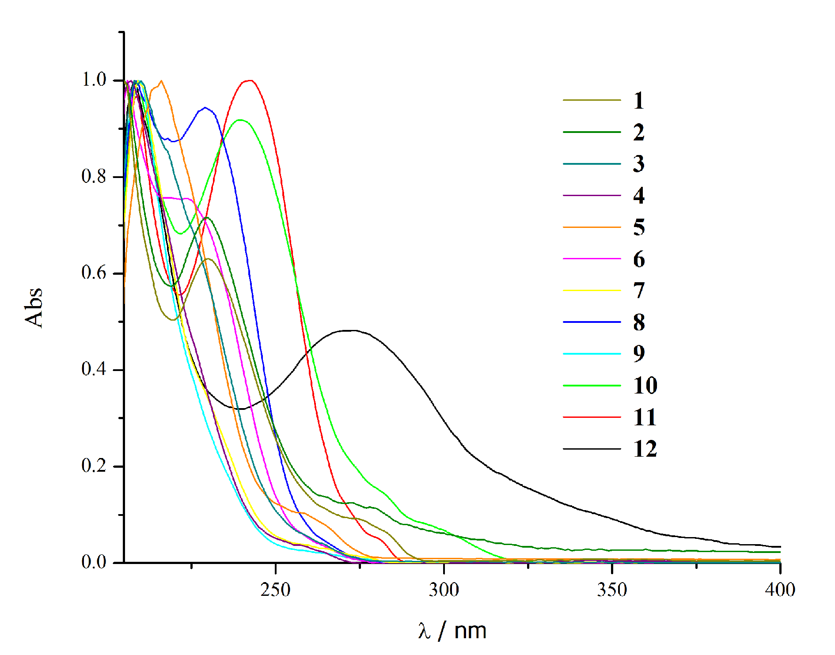

Figure S1. Normalized UV absorption spectra of investigated compounds in ethanol.

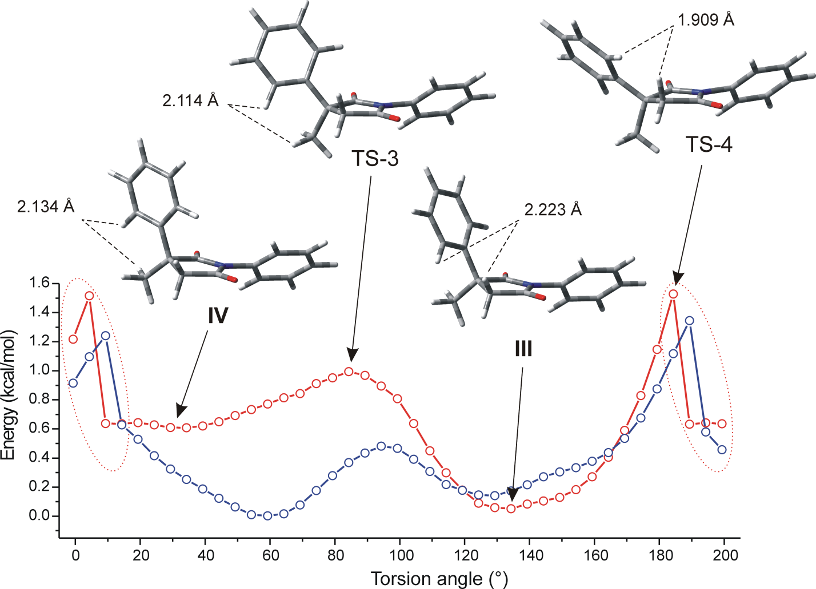

Figure S2. The potential energy scans for rotation of 3-phenyl group, in the vacuum (red) and ethanol (blue) done by B3LYP/6-311G(d,p) method (N-phenyl group torsion angle of ~ 136°).

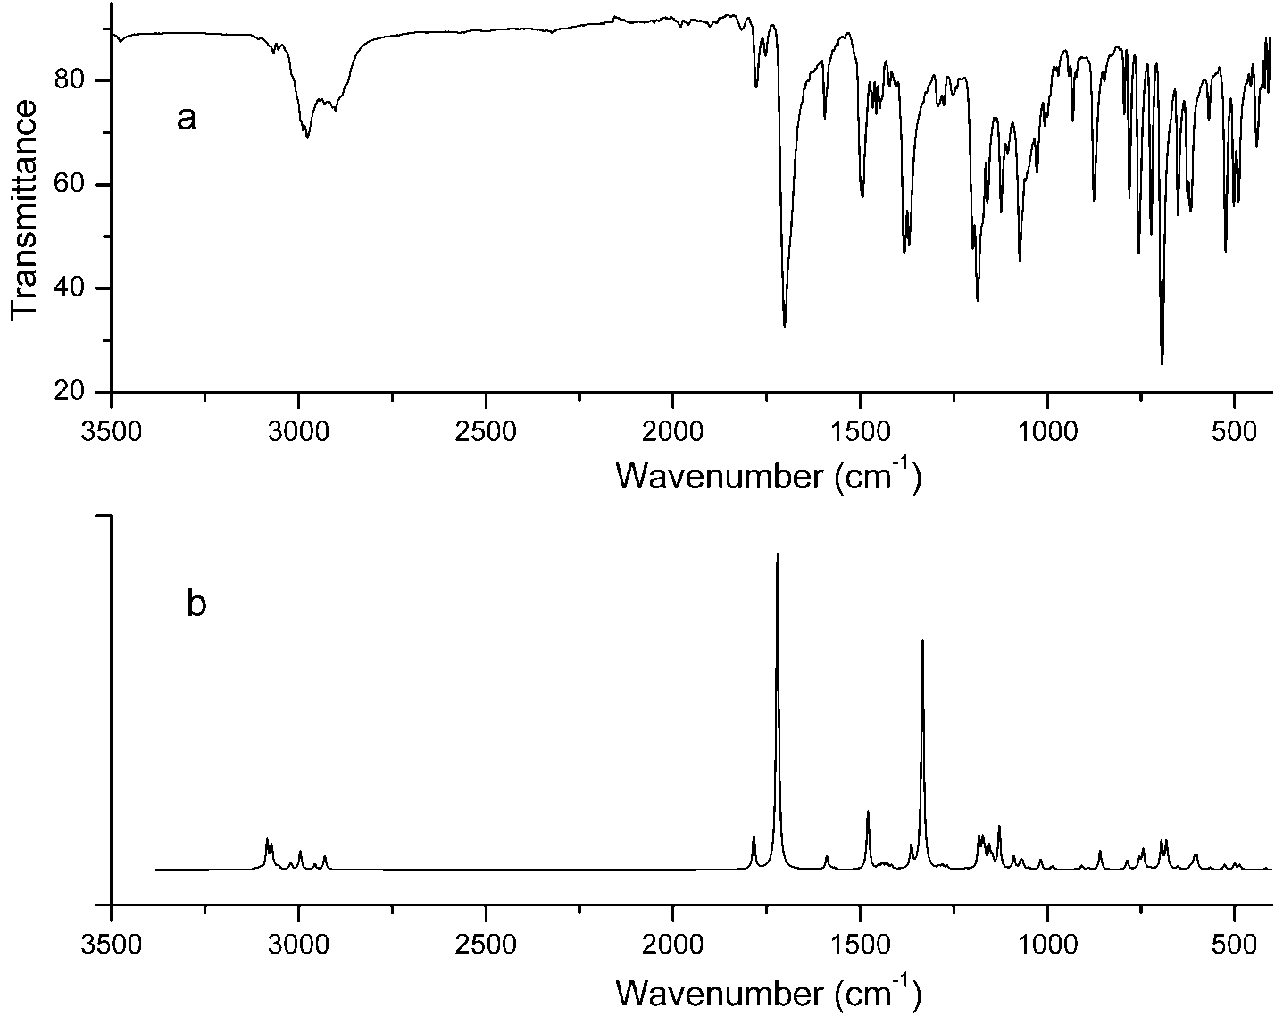

Figure S3. The experimental a) and calculated b) infrared spectrum of 4.

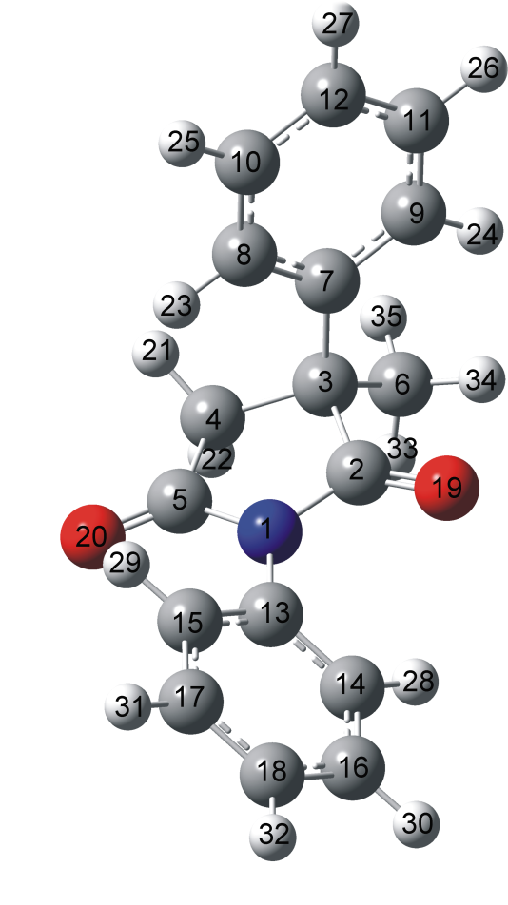

Figure S4. Atom numbering of investigated succinimide 4.

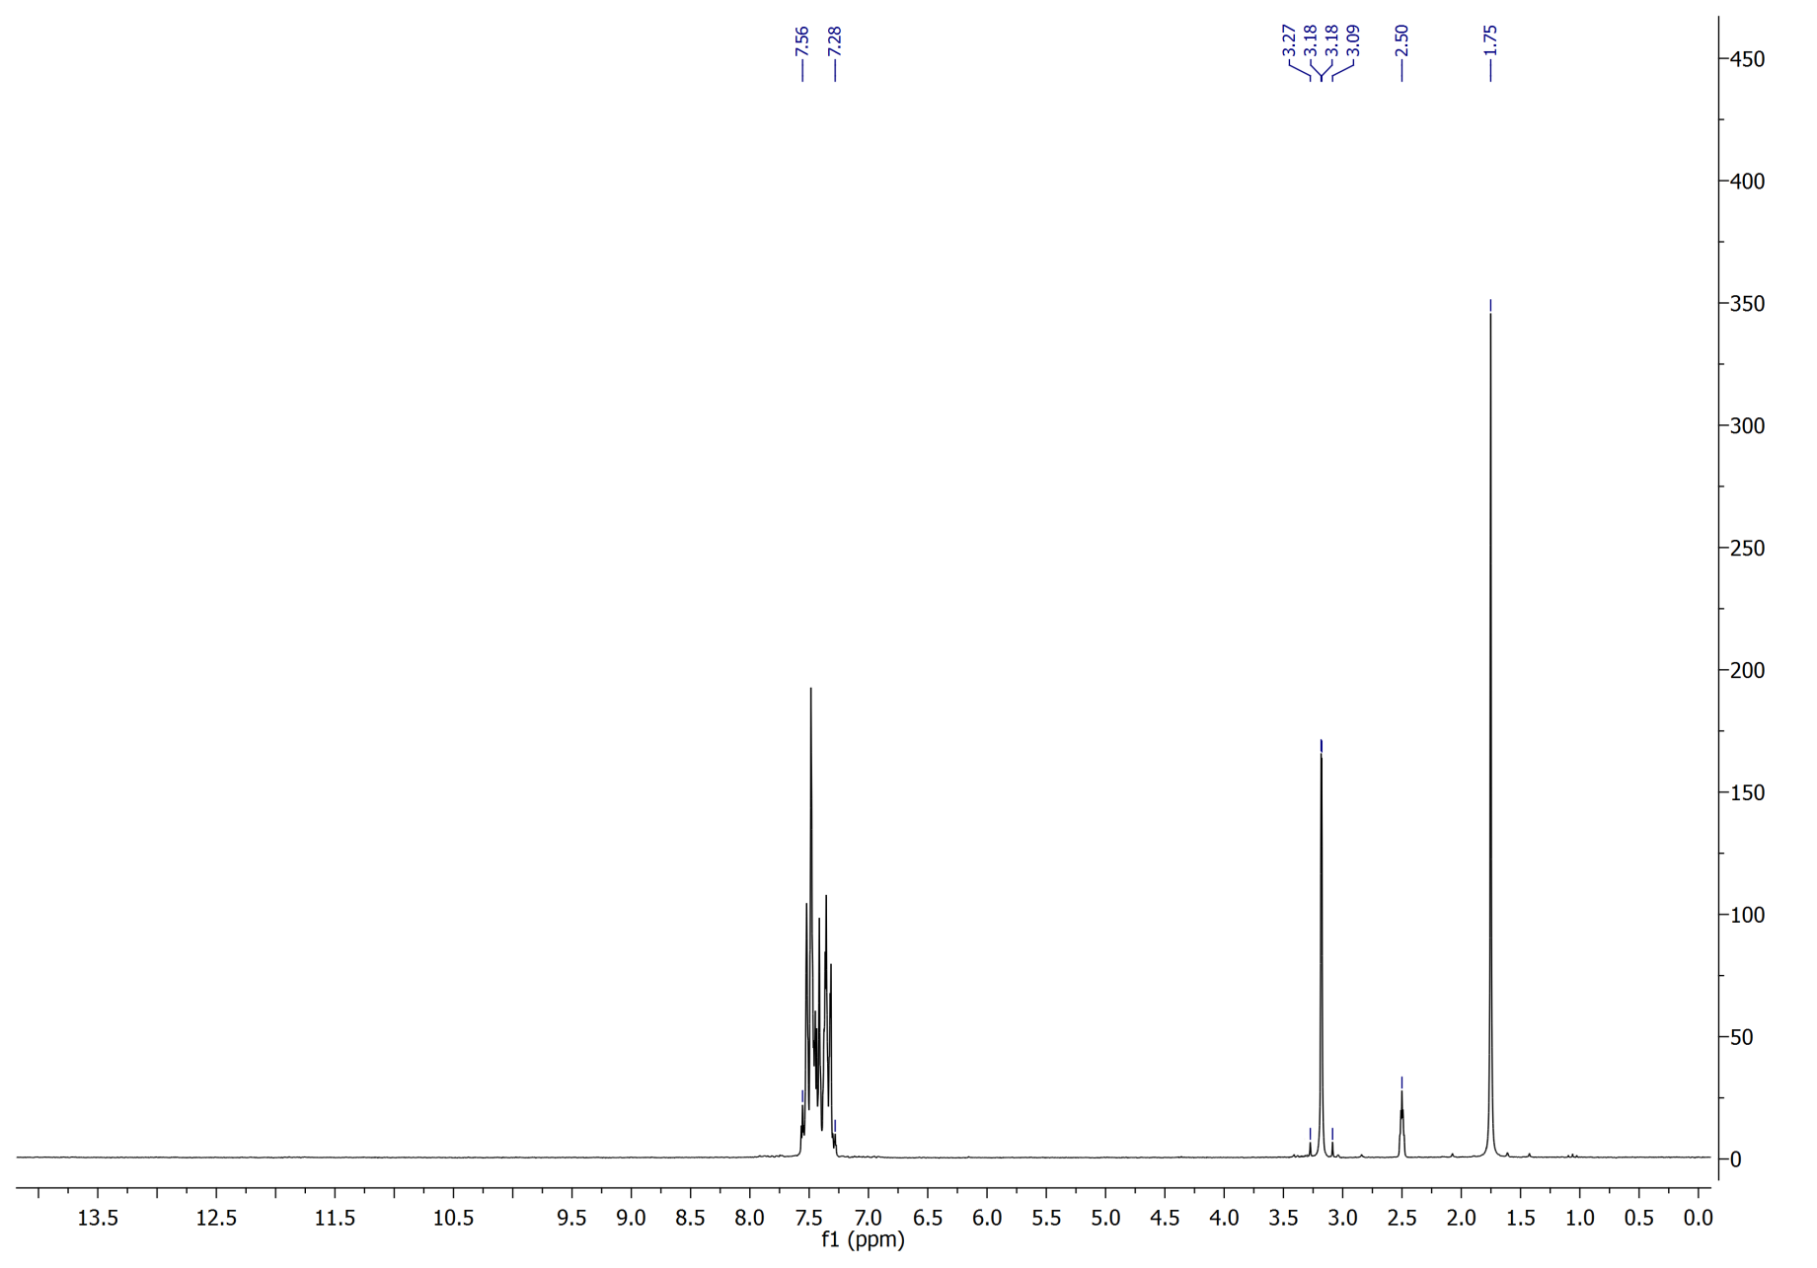

Figure S5. The ¹H NMR spectrum of 4 recorded in DMSO-d₆.
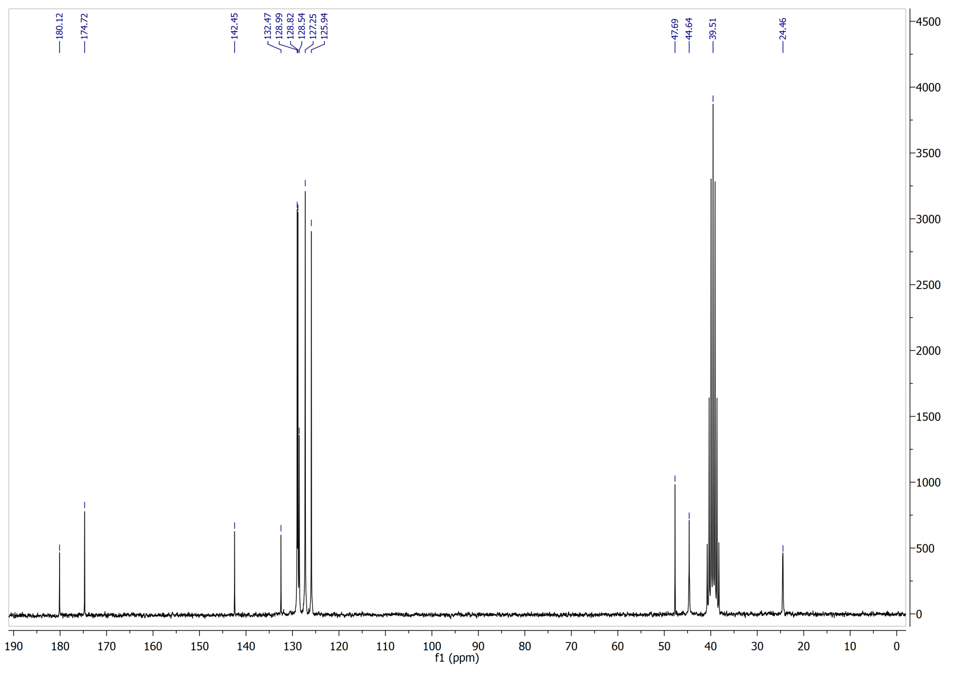
Figure S6. The ¹³C NMR spectrum of 4 recorded in DMSO-d₆.

