**Supporting information**

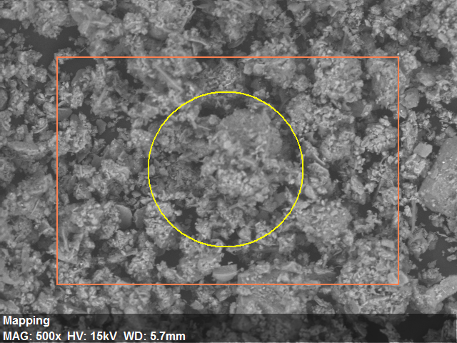

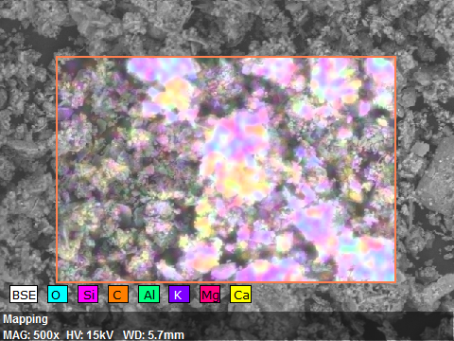

Figure S1. The structural and surface characterization of sediment

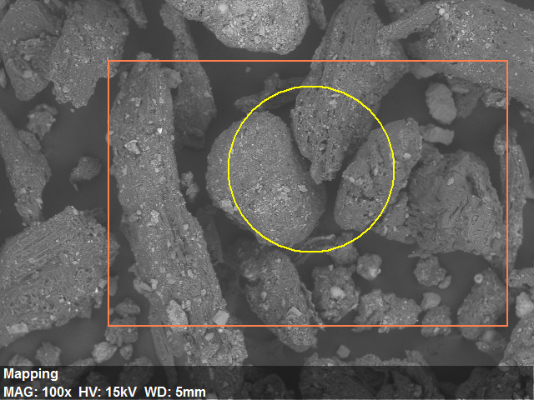

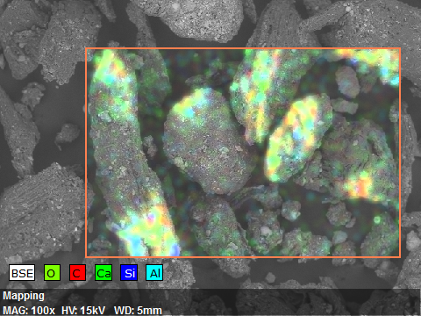

Figure S2. The structural and surface characterization of humus

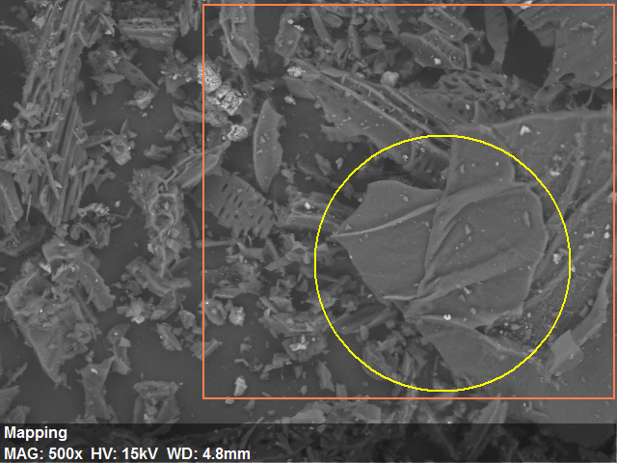



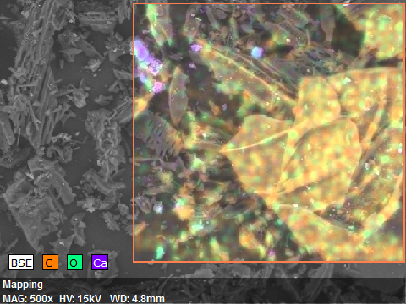

Figure S3. The structural and surface characterization of biochar

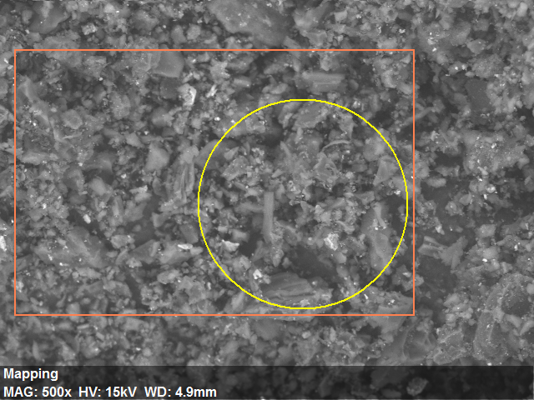

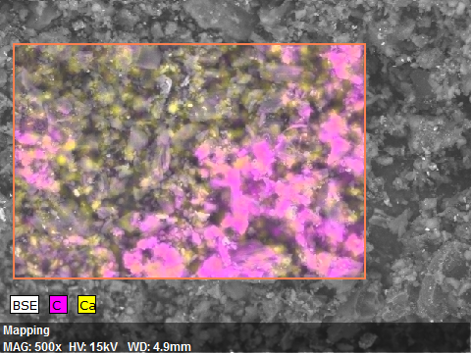

AMImage size:480 x 360Mag:500xHV:15.0kV

Figure S4. The structural and surface characterization of activated carbon

|  |  |  |  |  |  |  |  |  |  |  |  |  |  |  |  |  |  |  |  |
| --- | --- | --- | --- | --- | --- | --- | --- | --- | --- | --- | --- | --- | --- | --- | --- | --- | --- | --- | --- |
| Table S1. | Desorption parameters for the PeCB contaminated sediment amended with carbon rich sorbent | | | | | | | | | | | | | | | | | | |
|  | **Activated carbon** | | | | | | | | | | | | | | | | | | |
|  | **0.50%** | | | |  | **1.00%** | | | |  | **5.00%** | | | |  | **10.00%** | | | |
|  | **14 day** | **30 day** | **90 day** | **180 day** |  | **14 day** | **30 day** | **90 day** | **180 day** |  | **14 day** | **30 day** | **90 day** | **180 day** |  | **14 day** | **30 day** | **90 day** | **180 day** |
| **Ffast** | 6.55% | 1.27% | 100% | 2.52% |  | 3.49% | 0.05% | 2.09% | 0.00% |  | 0.09% | 4.21% | 0.00% | 0.68% |  | 0.44% | 1.34% | 0.00% | 0.10% |
| **Fslow** | 92.9% | 98.9% | 0.00% | 97.5% |  | 96.5% | 100% | 98.1% | 100% |  | 99.9% | 96.3% | 100% | 99.3% |  | 99.6% | 98.7% | 100% | 99.9% |
| **kfast (h-1)** | 0.11825 | 0.0897 | 0.00012 | 0.0066 |  | 0.17166 | 0.04267 | 0.000143 | 0.05746 |  | 0.0628 | 0.15109 | 0.06318 | 0.0048 |  | 0.30658 | 0.03223 | 0.03774 | 0.01992 |
| **kslow (h-1)** | 0.00004 | 0.00004 | 0.00009 | 0.00018 |  | 0.00002 | 0.00010 | 0.00014 | 0.000082 |  | 0.00002 | 0.00008 | 0.000012 | 0.000005 |  | 0.000215 | 0.00062 | 0.000037 | 0.00021 |
| **R2** | 0.934 | 0.872 | 0.368 | 0.941 |  | 0.980 | 0.946 | 0.693 | 0.948 |  | 0.879 | 0.638 | 0.742 | 0.882 |  | 0.918 | 0.880 | 0.742 | 0.747 |
|  | **Biochar** | | | | | | | | | | | | | | | | | | |
|  | **0.50%** | | | |  | **1.00%** | | | |  | **5.00%** | | | |  | **10.00%** | | | |
|  | **14 day** | **30 day** | **90 day** | **180 day** |  | **14 day** | **30 day** | **90 day** | **180 day** |  | **14 day** | **30 day** | **90 day** | **180 day** |  | **14 day** | **30 day** | **90 day** | **180 day** |
| **Ffast** | 72.1% | 1.76% | 0.01% | 14.4% |  | 7.97% | 0.89% | 42.3% | 4.45% |  | 46.0% | 0.72% | 29.4% | 18.0% |  | 20.9% | 0.60% | 71.9% | 7.92% |
| **Fslow** | 21.2% | 98.3% | 100% | 85.4% |  | 92.5% | 99.1% | 58.1% | 95.6% |  | 50.9% | 99.3% | 71.1% | 83.0% |  | 78.4% | 99.4% | 28.8% | 92.3% |
| **kfast (h-1)** | 0.16324 | 0.16694 | 0.00034 | 0.00203 |  | 0.10801 | 0.38981 | 0.00047 | 0.01637 |  | 0.10245 | 5.23059 | 0.000416 | 0.01518 |  | 0.000184 | 0.02002 | 0.00056 | 0.0067 |
| **kslow (h-1)** | 0.00071 | 0.00003 | 0.00034 | 0.00045 |  | 0.00002 | 0.00001 | 0.00047 | 0.00025 |  | 0.00003 | 0.0005 | 0.00041 | 0.000074 |  | 0.000184 | 0.00012 | 0.0006 | 0.0005 |
| **R2** | 0.905 | 0.880 | 0.842 | 0.974 |  | 0.952 | 0.933 | 0.904 | 0.974 |  | 0.938 | 0.998 | 0.813 | 0.831 |  | 0.611 | 0.749 | 0.801 | 0.910 |
|  | **Hummus** | | | | | | | | | | | | | | | | | | |
|  | **0.50%** | | | |  | **1.00%** | | | |  | **5.00%** | | | |  | **10.00%** | | | |
|  | **14 day** | **30 day** | **90 day** | **180 day** |  | **14 day** | **30 day** | **90 day** | **180 day** |  | **14 day** | **30 day** | **90 day** | **180 day** |  | **14 day** | **30 day** | **90 day** | **180 day** |
| **Ffast** | 54.0% | 3.91% | 49.9% | 1.35% |  | 56.8% | 2.07% | 100% | 2.30% |  | 32.7% | 9.80% | 100% | 2.22% |  | 12.6% | 1.59% | 100% | 5.54% |
| **Fslow** | 42.1% | 96.4% | 50.6% | 98.8% |  | 44.8% | 98.0% | 0.00% | 97.9% |  | 68.1% | 91.4% | 0.00% | 97.9% |  | 87.5% | 98.6% | 0.00% | 94.7% |
| **kfast (h-1)** | 0.26549 | 0.14583 | 0.00039 | 0.22443 |  | 0.2224 | 0.10948 | 0.00025 | 0.15288 |  | 0.39457 | 0.15556 | 0.000332 | 0.11573 |  | 0.75763 | 0.12568 | 0.000313 | 0.01422 |
| **kslow (h-1)** | 0.000729 | 0.000026 | 0.000393 | 0.000152 |  | 0.000038 | 0.00011 | 0.000024 | 0.00017555 |  | 0.000087 | 0.000215 | 0.0005121 | 0.0001569 |  | 0.0000007 | 0.000066 | 0.000521 | 0.00036 |
| **R2** | 0.884 | 0.795 | 0.839 | 0.919 |  | 0.956 | 0.888 | 0.841 | 0.929 |  | 0.950 | 0.653 | 0.836 | 0.964 |  | 0.996 | 0.720 | 0.808 | 0.982 |