We appreciate the time invested by the editor and reviewer in analyzing the manuscript and the useful and constructive suggestions given by the reviewer. We addressed all reviewer’s suggestions in order to improve the quality and the clarity of the manuscript text. Below are given the comments and description of changes done to manuscript in order to respond to reviewer’s questions and improve the manuscript.
- All presented reactions should have clearly described physical quantities used, as well as reaction constants to avoid any misinterpretation.

Physical quantities used and units description is added to the manuscript.

- The authors have to ask an English native speaker to copy edit and proofread the manuscript to improve readability and correct the existing errors.

The manuscript was proofread, and the text was improved for better readability, with errors corrected.

- It can be useful if authors can present a schematic description of Ca-based sorbent implementation for described purposes.

A figure 1 detailing the possible implementations of direct sorbent injection technology on the boiler furnace, with following paragraph better describing the figure is added to the manuscript text, starting at the line 58: “Figure 1 shows the possibilities for sorbent injection in flue gas desulfurization technologies, with focus on sorbent injection in boiler furnace. Depending on the local conditions, especially temperature field, sorbent can be injected through one or more burner tiers [1] or above the burner tiers [1-6]. This application of the sorbent is commonly called FSI (Furnace Sorbent Injection). Other technologies consider the use of the sorbent by injecting it in duct further down the gas canal (ESI, DSI), [6-7] where the local temperatures are lower.

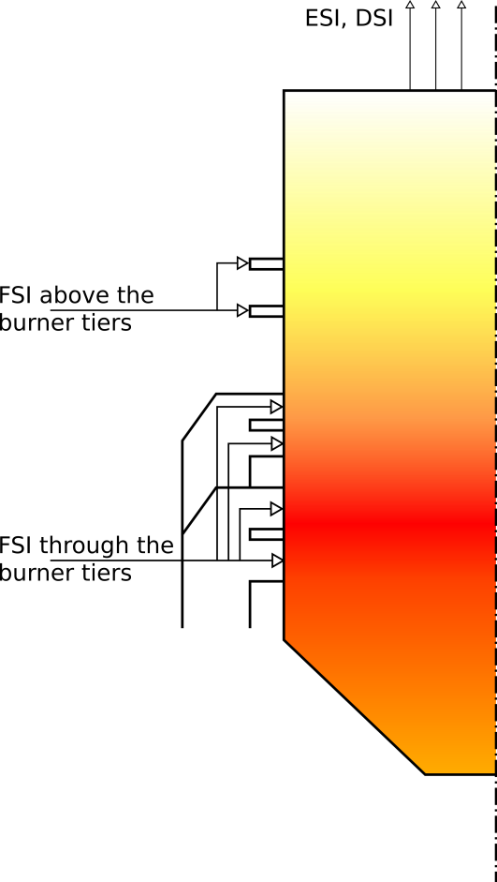
Figure 1 Schematic display of possible implementation of direct furnace sorbent on utility boiler”

- It is stated that different models were used for calcinations, sintering, and sulfation. However, it is necessary to bring all these particular to the same point(s) and to present what are the outcomes of these models on real examples of different processes. In that way, the readers should have a clear input how does the specific model predict specific process (calcinations, sintering, or sulfation). If it is not possible to plot them together on a single graph, then tables (one for every part of the process: calcination, sintering, and sulfation ) should be created, and also please provide us with the description of other powder properties, e.g. particle size, specific surface area, temperature range, SO2 concentration, etc. In that way, the review you have presented would be fully usable for audiences both from the industrial and scientific community.

In this paper we attempt to give an overview of several models that are commonly met in literature. While the differences in model application range and usability in certain cases do exist, the models themselves are well suited for application in ranges they were developed for – the temperature ranges or specific sorbent types. This can be seen by examining the original papers about the models. In order to give the comparable overview of several specific models the Table 1 is added to the paper, containing the parallel view of major equations for calcination, sintering and sulfation rates specific models. Starting at line 267 following text and table are added:

“To better illustrate the major equation, and the way different authors model the sorbent, overview of major equations is given in Table 1.

Table 1 Overview of major equations governing the calcination, sintering and sulfation rates in models by different authors
 | Calcination | Sintering | Sulfation
Borgwardt (large sorbent particles) | Calcination rate, sorbent usually precalcined before use  $$R_{c}=R_{c,0}e^{\frac{-E_{a}}{RT}}$$ | Sintering is taken into account through the changes in efficiency coefficient $η_{ef}$ | Sulfation reaction rate  $$r=\frac{1}{W}\frac{dn'}{dt}=\frac{η}{ρ}k_{sulf}C^{m}$$  Efficiency coefficient correction by Punbusayakul  $${η_{ef}=e}^{-\frac{β\dot{n}}{w}}e^{\left(-\frac{E}{RT}\right)+\left(\frac{E}{RT_{ref}}\right)}∙\frac{c^{m}}{c_{ref}^{m}} \left[-\right]$$
Borgwardt (small sorbent particles) | Calcination extent  $$X_{c}\left(t\right)=1-e^{-k_{c}M_{M,Ca{CO}_{3}}S_{Ca{CO}_{3}}t}$$  Calcium oxide surface development  $$S_{CaO}^{n}=\sum_{k=1}^{n}{S^{n,k}\left(X_{c}{\left(t_{k}\right)-X}_{c}\left(t_{k-1}\right)\right)}$$ | Sintered calcium oxide surface at time step k  $$S^{n,k}=S_{0,CaO}\left(1-{\left(K_{s}\left(T_{k}\right)t_{n}\right)}^{\frac{1}{γ\left(t_{k}\right)}}\right)$$ | Conversion when the diffusion resistance can be neglected  $$1-3{\left(1-X_{s}\right)}^{\frac{2}{3}}+2\left(1-X_{s}\right)=k_{d}t$$  Sulfation reaction rate  $k_{d}=2,65S_{B}^{2}P_{{SO}_{2}}^{0,64}exp⁡(-\frac{36600}{RT})$
Hu and Scaroni | Calcination rate  $$R_{c}=k_{c}A_{Ca{CO}_{3}}$$  Reaction rate coefficient  $${k'}_{c}=6.078×{10}^{7}exp⁡\left(-205000/RT\right)$$  Reaction rate coefficient correction  $$k_{c}={k^{'}}_{c}A$$  $$A=\left\{\begin{matrix}{\left(P_{eq}-P_{i}\right)}/{P_{eq}} & | & P_{eq}∙{10}^{-2}<P_{i}<P_{eq}, \\ 1 & | & P_{i}{≤P}_{eq}∙{10}^{-2}\end{matrix}\right.$$
Silcox | Calcination rate  $$R_{c}=k_{D}\left(P_{eq}-P_{i}\right)$$  Reaction rate coefficient  $$k_{D}=1,22exp⁡(-{4026}/T)$$ | $$\frac{dS}{dt}=-k_{s}{\left(S-S_{as}\right)}^{2}$$  $$k_{s}=A\exp\left(-\frac{E}{RT}\right)\exp\left(\frac{BP^{m}}{RT}\right)$$
Khinast | Calcination rate  $$R_{c}=k_{c}e^{-coef\frac{P_{i}}{P_{eq}}}$$
Alvfors | Calcination extent  $$X_{c}\left(t\right)=1-e^{-k_{c}M_{M,Ca{CO}_{3}}S_{Ca{CO}_{3}}t}$$  Calcium oxide surface development  $$S_{CaO}^{n}=\sum_{k=1}^{n}{S^{n,k}\left(X_{c}{\left(t_{k}\right)-X}_{c}\left(t_{k-1}\right)\right)}$$ | Sintered calcium oxide surface at time step k  $$S^{n,k}=S_{0,CaO}\left(1-{\left(K_{s}\left(T_{k}\right)t_{n}\right)}^{\frac{1}{γ\left(t_{k}\right)}}\right)$$ | Reaction rate  $$r_{{SO}_{2}}=\frac{C_{{SO}_{2}}}{\frac{1}{kυS_{2}}+\frac{L}{D_{s}S_{avg}}}$$  Dimensionless surfaces  $$S_{i}=\frac{3\left(1-ε\right)\left(2g_{i}^{2}-n_{cp}f\left(g_{i},λ\right)\right)}{r_{0}\left(2-n_{cp}\left(1+\frac{1}{2}λ\right){\left(1-λ\right)}^{2}\right)}$$
Adánez | Calcination  $$\frac{dR_{c}}{dt}={\frac{M}{ρ}k}_{c}∙A$$  $$A=\left\{\begin{matrix}{\left(P_{eq}-P_{i}\right)}/{P_{eq}} & | & P_{eq}∙{10}^{-2}<P_{i}<P_{eq}, \\ 1 & | & P_{i}{≤P}_{eq}∙{10}^{-2}\end{matrix}\right.$$ | Generation rate of new pores due to sintering and sulfation:  - cylindrical pores  $$\frac{{dφ}_{ij}}{dt}=K_{s}φ_{i}φ_{j}$$  - plate-like pores  $$\frac{{dΩ}_{ij}}{dt}=K_{s}Ω_{i}Ω_{j}$$ | Sulfation model for two assumed pore geometry models:  - cylindrical pores  $$X_{sk}=\frac{M_{CaO}}{V_{Ca{SO}_{4}}}π\sum_{i}{\left(r_{2,K,i}^{2}-r_{1,K,i}^{2}\right)φ_{K,i}}$$  - plate-like pores  $$X_{sk}=\frac{M_{CaO}}{V_{Ca{SO}_{4}}}π\sum_{i}{\left(z_{2,K,i}-z_{2,K,i}\right)Ω_{K,i}}$$
Milne | Calcination extent  $$X=1-{\left(1-\frac{k}{d_{o}^{0,6}}t\right)}^{3}$$  CaCO₃ rate constant  $$k=10.303exp⁡(-{10980}/T)$$  Ca(OH)₂ rate constant  $$k=53.87exp⁡(-{8300}/T)$$ | Surface area loss  $$\frac{dS_{m}}{dt}=-2450\left(1+50.7p_{H_{2}O}^{0.17}+10.3p_{{CO}_{2}}^{0.67}\right)\exp\left({-29600}/T\right){\left(S_{m}-5000\right)}^{2}$$

”

- What you call “particle” seems to correspond with an agglomerate of particles, and in that way “particle internal structure” would correspond to the microstructure of agglomerate or internal agglomerate structure. That would be more acceptable terminology in materials science. In that way, when you speak on particle sintering models, eq. 12, “internal particle surface S” corresponds to the specific surface area of the powder as a physical and measurable quantity? If there are any distinctions, please explain it to avoid any confusion of the readers.

In nature the structure of sorbent is mostly random structure with noticeable patterns, built of solid material and pore canals, but in order to be able to model the structure, in relatively simple manner, assumptions and simplifications are made. Depending on the model complexity it can vary from the assumption that the particle is homogenous structure with core built from unreacted material and surface covered in reaction products. Several authors, focusing on more complex models of particle structure use the assumption that the particle consists of spherical grains, as the close approximation, in order to efficiently apply the model to the internal structure. Also, another group of authors focus efforts on modeling the pore structure. The term particle is used to describe the single particle that is obtained by sorbent pulverization. As said, the models that do not go further into analysis of particles structure stay at the use of the term particle to refer to the single pulverized sorbent particle. The more complex models which try to analyze the particle structure usually assume some regular form for internal structure of particle and refer to the basic building elements of those internal structures as grains. The most commonly assumed is spherical grain shape. Neighboring grains, depending on model may have no contact, or overlapping up to certain extent, depending on particle porosity and other influencing factors.
The sintering in described models is high temperature particle sintering which can’t be avoided, and leads to the loss of the internal reactive surface of the particle. The internal particle surface is measurable quantity in models, and the coefficients in models that focus on surface development and sintering are derived from experimentally obtained data. Depending on the model some authors express the specific surface per unit of particle mass, while others use surface units per unit of particle volume.
Following sentence is added 107 to the paper to better clarify this: “The internal particle surface corresponds to the specific surface area of powder, and the coefficients used in equations for particle surface development or sintering in models are determined by the authors based on the experimental data for the case-study sorbents.”

