**Novel composite zinc-alginate hydrogels with activated charcoal aimed for potential applications in multifunctional primary wound dressings**

Andrea Osmokrovica*, Ivan Jancicb, Ivona Jankovic- Castvana, Predrag Petrovicc, Marina Milenkovicb, Bojana Obradovica

aFaculty of Technology and Metallurgy, University of Belgrade, Karnegijeva 4, 11000 Belgrade, Serbia

bFaculty of Pharmacy, University of Belgrade, Vojvode Stepe 450, 11000 Belgrade, Serbia

cInnovation Center of the Faculty of Technology and Metallurgy, Karnegijeva 4, 11000 Belgrade, Serbia

**Supplementary material**



Fig.1S. Calibration curve for detection of AC

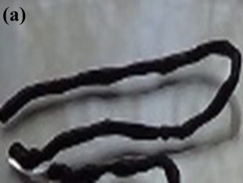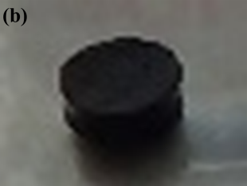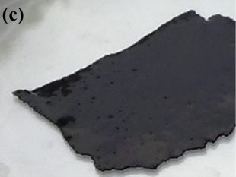

Fig.2S. Composite ZnA/AC hydrogel in the form of(a) fibre; (b) sheet; (c) film



Figure 3S. Release profiles of Zn2+ from ZnA and ZnA/AC in physiological saline solution at 37 °C during the overall period of 5 days and during the initial period of 8 h (inset)



Figure 4S. Optical micrographs of the surface of ZnA beads immersed in saline solution at: (a)the initial time point; (b) after 24 h; (c) after 48 h; (d) after 5 days; (scale bar = 0.5 mm)