Supplementary material

Fig. 1S. Calibration curve for detection of AC

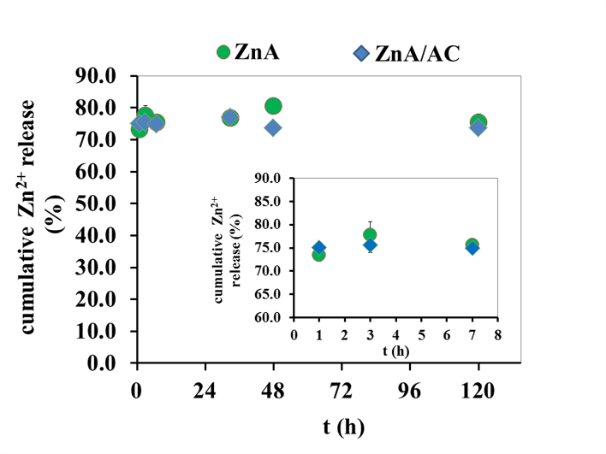
Figure 2S. Release profiles of Zn²⁺ from ZnA and ZnA/AC in physiological saline solution at 37 °C during the overall period of 5 days and during the initial period of 8 h (inset)

