How mass of filter bed samples for similar permeability was identified

We measured permeability of different mass of used polymer fibers and calculated
porosity for these samples using relation:

= 1 - _{n} /
- porosity
_{n –} bulk density
- density of used material.

On this way we obtained experimental relation between permeability and bed porosity. All investigated fibers follow this relation.

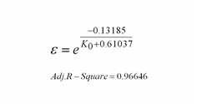

When we want to prepare bed with some exact permeability we have information what porosity is for this permeability. From the bulk density is possible to calculate mass of the material for wanted permeability:

_{n} = (1- )

m= ρ V_{bed}

V_{bed} – bed volume

Note: Bed volume is known from bed length and inner diameter of experimental pipe

