AN INVESTIGATION INTO THE EFFECTS OF EXCIPIENTS ON THE CRITICAL QUALITY ATTRIBUTES OF A DRY HERBAL EXTRACT CONTAINING CAPSULE

Branka Grujic¹*, Zdenka Vukovic¹, Jelena Veljkovic-Giga¹, Svetlana Ibric²
Dragana Dekanski¹

¹Galenika a.d., R&D Institute, Batajnicki drum bb, 11080 Belgrade, Serbia
²Faculty of Pharmacy, Vojvode Stepe 350, 11000, Belgrade, Serbia

*Corresponding author:
Branka Grujic
Galenika a.d., R&D Institute, Batajnicki drum bb, 11080 Belgrade, Serbia
E-mail address bivic.galenika@gmail.com

Abstract
Nutrition and dietary supplements have significant role in the prevention and treatment of cardiovascular disease. Olive leaf and vine leaf, thanks to their constituents, represent the powerful natural antioxidants and have cardioprotective activity. By their extraction, a higher concentration of active ingredients is provided. Dry herbal extracts are highly sensitive to moisture and elevated temperature and from the pharmaceutical and technological point of view these are raw materials with inadequate technological properties. The aim of this study was to investigate and compare the influence of different excipients in these two dry extracts capsule formulation i.e. the selection of excipients that will ensure appropriate critical process parameters in the manufacturing procedure. The monitored critical quality attributes include flowability, bulk density and tapped density, that are critical for technological feasibility of the capsule-filling operation. The effects of excipients on the above parameters have been experimentally studied and based on the obtained results, the appropriate capsule formulations which will ensure homogeneity and stability of the preparation have been developed,

Key words: dry herbal extracts, olive leaf, vine leaf, capsules, critical quality attributes

1.Introduction

Noncommunicable diseases, such as cardiovascular disease (CVD) and cancer, are the leading causes of death worldwide [1]. Dietary habits, such as the Mediterranean diet, can be involved in the regulation of blood pressure, decrease of oxidative stress, improvement of lipid profile and reduction of mortality rates due to cardiovascular diseases [2]. The rationale for taking dietary supplements including herbal extracts has been suggested by many in vitro and experimental animal studies that showed protection against inflammation and oxidative stress, both of which are suggested to be involved in the onset and progression of CVD [3]. Among the intensively studied plants, which are highly represented in the Mediterranean diet, are olive (Olea europaea L.) and grapevine (Vitis vinifera L.).
The olive leaf extract (OLE) contains oleuropein as an active ingredient, along with triterpens, flavonoids, chalcones and tannins. Owing to its composition, olive leaf is rated one of the most powerful natural antioxidants. The results of recent research have suggested beneficial effects of phenolic-rich olive leaf extracts as dietary supplement in modifying cardiovascular risk biomarkers such as blood pressure, hyperglycemia, oxidative stress and inflammation, as well as in improving vascular function and lipid profiles [4-7]. The vine leaf extract (VLE) was found to contain high amount of polyphenols, i.e. resveratrol, quercetin, catechin, flavone, flavonols, anthocyanin, gallic acid and epicatechin which have a high antioxidant potential and act protectively on cardiovascular system [8]. It is the herbal medicinal product for treatment of chronic venous insufficiency, which is characterised by swollen legs, varicose veins, a feeling of heaviness, pain, tiredness, itching, tension and cramps in the calves [9].
In line with the leading world trends in pharmaceutical industry, the use of dry herbal extracts standardised on a specific active substance, instead of raw herbal drugs, is quite a widespread practice [10]. This ensures precise dosing during administration, which is not the case when using raw herbal drugs. Herbal extracts are highly sensitive to moisture and elevated temperature and from the pharmaceutical and technological point of view these are raw materials with inadequate technological properties, homogeneity and stability of the drug. Dry herbal extracts may be administered as dosage forms, such as capsules, tablets and instant mixtures. In formulating such preparations it is necessary to select such excipients which will ensure attaining of appropriate technological parameters in the manufacturing process. The monitored critical material attributes include flowability, bulk density and tapped density, these being the critical parameters for technological feasibility of the capsule-filling operation, tabletting or filling of instant mixture into an appropriate container [11].
The purpose of this work was evaluation of the formulation factors in capsules with two selected dry herbal extracts described above. The effects of excipients on the critical quality attributes have been experimentally studied and based on the results obtained the appropriate capsule formulations have been developed, resulting in two new products on the market.

2.Materials and methods
2.1 Materials

Olive leaf extract EFLA® 943 and red vine leaf extract, EFLA®945 were purchased from Frutarom Switzerland Ltd. (Wadenswil, Switzerland). The olive leaf extract was manufactured from the dried leaves of Olea europaea L., applying an ethanol (80 % m/m) extraction procedure and standardised to 18-26 % of oleuropein. Grapevine (Vitis vinifera L) leaf extract is standardized to total polyphenols, anthocyanins and trans-resveratrol. After a patented filtration process (EFLA® Hyperpure), the crude extracts were dried. Stability and microbiological purity were confirmed by the manufacturer.
Other materials that were used in this study are: corn starch (Amylum, Bulgaria), calcium hydrogen phosphate dihydrate (JRS Pharma, USA), colloid silicon dioxide–(Evonik, Germany), lactose monohydrate (Meggle, Germany), talk (Luzenac, France) and magnesium stearate (Galenika ad, Serbia).

2.2 Characterization of starting materials, extracts and excipients
2.2.1 Particle size
The average particle size was determined by Malvern, Mastersizer X, (Worcestershire, UK). The measurements were carried out at least 3 times for each sample. The average and the median particle size of all samples were measured using MS 64-Dry powder feeder (Model MSX 64, Malvern Instruments, Worcestershire, UK).
The following instrument settings had been done: the air pressure was set between 1-3 bars, the number of sweeps was set to 30000 in a time frame of 60s; the active beam length was set to 10 mm with a range lens of 1000mm; a minimum obscuration value of 1-10% was obtained in all measurements. The particle size distribution of the samples including mean and medium particle size was calculated from the raw data using the software (Malvern).
2.2.2 Flowability
The values of fowability, using flowability tester Erweka tip GTB (Germany), were determined with a hopper made of plexiglass (centre angle: 37.5 ºC, orifice diameter: 9 mm), which was connected to a balance (PC 8000 Mettler Toledo Gmbh, Greifensee, Switzerland). The increase in weight could be measured 375 times per minute. The data were transferred to a computer and automatically put in an excel sheet with the software Balance link (Mettler Toledo, Balance link V 3.01, Greifensee, Switzerland). The flowability of all materials was determined with approximately 100g of sample. By division of the mass through the flowing time, the fowability of different samples was calculated (equation 1). The measurement was carried out 5 times for each sample.

Flowability = mass / flowing time Equation 1

2.2.3 Bulk and tapping density
Different measurements were performed; bulk and tapped density and finally, Hausner Ratio was calculated. The bulk and tap density were determined using an apparatus Erweka Type STAV 2003 (Engelsmann AG, Germany). Sample in quantity of 100g was placed into a graduated cylinder. The volumes at the beginning (bulk volume V_{O} ) and after tapping 1250 times (tap volume V₁₂₅₀ ) were noted. The bulk density (ρ_{b} ) was calculated as a ratio of mass and initial volume V_{O,} while the tapped density (ρ_{t} ) was calculated as a ratio of mass and tapped volume V_{1250.} The Hausner ratio (HF) was calculated according to following equation:

HF= ρ_{t} / ρ_{b} Equation 2

HR values less than 1.25 indicate good flow, whereas values greater than 1.25 indicate poor flow. For values between 1.25 and 1.5 added glidant normally would improve flowability.

2.2.4 Residual moisture
The residual moisture content was determined by an infrared drying unit, Mettler Toledo Type LP 16 M (Mettler Instruments, Nanikon-Üster, Switzerland). Samples of approximately 1g were prepared. Samples were heated up to 20 minutes to 110 ºC giving the loss of moisture in percent by weight.

2.2.5 Morphology examination
A suspension of the powder in the single drop of paraffin oil was made on a microscopic plate. Then a drop of xylene was added, with the aim of brightening and a clearer the picture. The sample was covered with the cover plate and observed under a microscope at 10x and 15x magnification. Then the representative images were photographed (ZEISS Axiophot-Option with integrated camera (Germany)).

2.3 Analysis of the product
2.3.1 Content of extracts
For olive leaf extract standardized to oleuropein, content of oleuropein was determined on HPLC apparatus with DAD detection at wavelength 254 nm, using Zorbax RX C18 150x4.6mm, 5µm column, both by Agilent Technologies (USA). Gradient elution at 1ml/min was used, with 1%V/V acetic acid as eluent A and methanol as eluent B, starting with 15% B, reaching 50% B in 5 minutes and keeping isocratic conditions for 7 minutes, followed by a 5 minutes postrun. Injection volume was 10µl and the column temperature 25ºC. Retention time of oleuropein was around 9 minutes.
For vine leaf extract standardized to trans-resveratrol, content of trans-resveratrol was determined on HPLC apparatus with DAD detection at wavelength 306 nm, using Zorbax RX C18 150x4.6mm, 5µm column, both by Agilent Technologies (USA). Mobile phase consisting of 83% of 0.1%V/V phosphoric acid and 17% acetonitrile was used, with flow rate 1ml/min for 30 minutes, followed by 10 minutes at 3 ml/min, and 5 minutes postrun. Injection volume was 20µl and the column temperature 25ºC. Retention time of trans-resveratrol was around 25 minutes.
Colorimetric determination of total polyphenoles at wavelength 715 nm, with pyrogallol as a standard, using Folin-Ciocalteu`s reagent in a 15% m/V sodium carbonate solution, was performed on UV/Vis 8453 spectrophotometer by Agilent Technologies (USA).
Colorimetric determination of total antocyanines in 0.1% V/V methanolic hydrochloric acid at wavelength 528 nm , based on specific absorbance of cyanidol 3-glucoside was performed on UV/Vis 8453 spectrophotometer by Agilent Technologies (USA).

2.3.2 Disintegration of capsules
The disintegration study of the capsules was performed using Erweka disintegration tester type ZT-322. The test was performed in following conditions: 800 ml of media water during 15min. of examination at temperature 37 ±5ºC using discs. Six capsules are placed into basket with device for raising and lowering the basket in the immersion fluid –water, with constant frequency rate 29-32 rpm. During 15 min. in water all capsules should be disintegrated.

2.3.3 Loss on drying
The loss of drying was determined using the apparatus Sartorius type MA 40 (Germany). The residual moisture content was determined by an infrared drying unit. Mettler Toledo Type LP 16 M (Mettler Instruments, Nanikon-Üster, Switzerland). Samples of approximately 1g were prepared. They were heated up to 2h minutes to 105 ºC giving the loss of moisture in percent by weight.

2.4 Dry extracts capsule preparation
The Active Pharmaceutical Ingredient (API) (vine leaf dry extract or olive leaf dry extract) is mixing with excipients on granulator mixer Lődige MGT 250G (Germany) and then homogenous mass is capsulated on capsuling machine Zanasi nigris S.p.A, AZ/60-R (Italy) in capsules No 1.with a target mass 350mg for olive leaf and target mass for vine leaf 300mg.

2.5 Stability study
During formulation development, long-term stability study was performed for both products during the shelf life on the following terms 25ºC/60% RH during 36 months and intermediate stability study in terms of 30ºC/65% RH during 12 months. The both products during stability study were tested on organoleptic appearance, API content, capsule disintegration in media which imitates GIT conditions.

3. Results and discussion

A recent increase in the popularity of natural products has revitalized interest in traditional remedies that have been used for the treatment of CVDs through centuries [12]. The use of dried extracts has received special attention for the development and production of solid forms because of higher stability, homogeneity of constituents and easy in handling. On the other hand it is a complex task because they don’t have the necesarry properties of rheology and compressability [13]. Both olive leaf extract and vine leaf extract as standardised herbal extracts are open for a broad range of uses in the food and functional food industry. In this study, optimal capsule formulation with these two dry herbal extracts was developed and confirmed during stability study testing.
Dry herbal extracts are showing significantly more stability in parameters as relative moisture and high temperature, comparing to classical herbal extracts. Characterization of the dry herbal extracts was performed in order to evaluate the excipients influence on their stability. Based on the results for relative moisture, dry extracts are most stable in mixture with lubricants talc or magnesium stearate and least stable with maize starch and calcium phosphate dihydrate. As shown in table 1. maize starch and calcium phosphate dihydrate are hygroscopic and tend to increase the level of moisture which can cause degradation of the API and therefore decrease therapeutic effect. Based on the results of the characterization and evaluation of critical quality parameters, optimal excipients for the formulation were chosen which can provide optimal filling and capsulating process, as shown in Table 2. The most important parameters for capsulating process are flowability, bulk and tapped density of the powders. Formulation with lubricants and glidants colloid silicon dioxide, talc and magnesium stearate had optimal flowability properties and with lactose monohydrate as a filler. Formulation with starch and calcium hidrogen phosphate as a filler had poor flowability and powder could not enter in the capsule volume, capsulating process was difficult, with sticking of powder to the machine, process was often stopped, without continuity and with losses. Hausner ratio less than 1.25 for the optimal formulation shows good flowability for both products Olive leaf and Vine leaf.

Table 1: Relative moisture values for extract mixtures with different excipients
Relative moisture (%)
Excipient | Olive leaf | Vine leaf
Colloid silicon dioxide | 3,91 | 3,65
Magnesium stearate | 2,01 | 3,69
Talc | 3,20 | 3,46
Lactose monohidrate | 5,92 | 5,86
Calcium hydrogen phosphate dyhidrate | 6,13 | 5,72
Maize starch | 6,55 | 6,70

Table 2. Critical quality attributes for optimal formulation
Tests units | Olive leaf | Vine leaf
Particle size µm | 850 | 760
Flowability s/100g | 10 | 8
Bulk density g/ml | 0,59 | 0,69
Tapped density g/ml | 0,73 | 0,80
Hausner ratio % | 1.23 | 1.16

Digital photoshoot of optimal formulation powder in magnitude 10x and 15x magnification in figure 1a shows uniform, spheric particles with narrow particle size distribution which is essential for good powder flowing and also for uniform capsule filling. Figure 1b shows powder formulation with irregular shaped particles with sharp edges wich tend to agglomerate and also with broad particle size distribution.

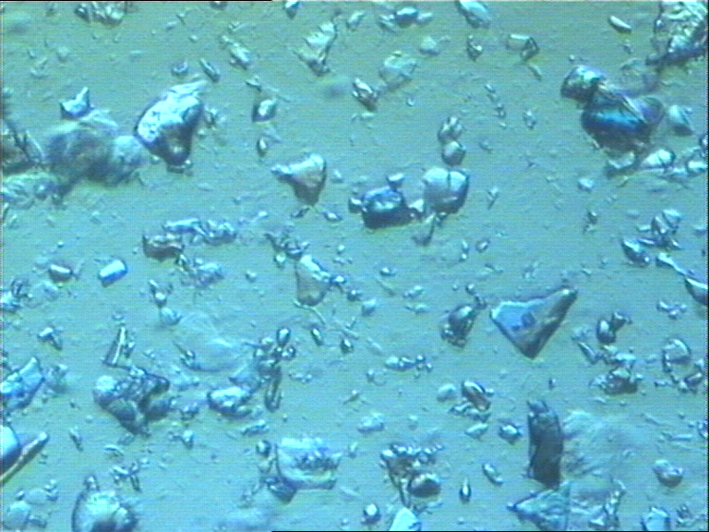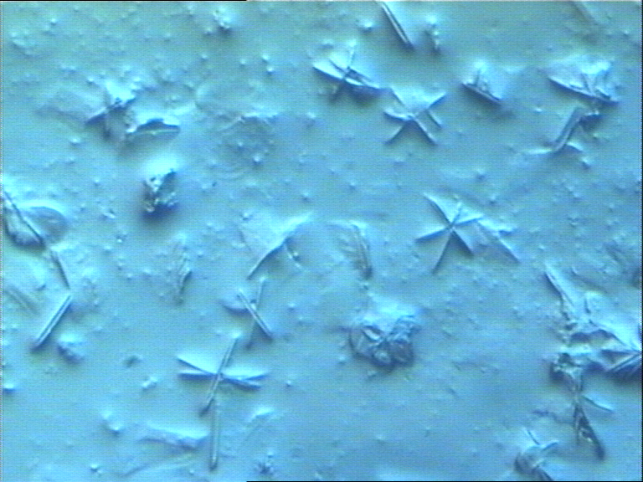
Figure 1, a - Representative microphotograph of a - "optimal" formulation and b - "incorrect" formulation

Result of this parameters is very difficult process of capsulating, and non homogenous dosing. Optimal formulation was submitted to long term stability study testing and intermedite study during shelf life of the product as shown in table 3 and table 4. Long term study during 36 months in conditions 25 ºC/60%RH showed results of the content of oleuropein in the product Olive leaf according to Specification during the whole study, figure 2. During intermediar study, figure 3. it is observed significant decrease in oleuropein content after six months but still in requirements of the Specification. Results of the vine leaf capsules on long term and intermediar study in all test terms show stable results for antocyans and trans resveratrol while content for poliphenol during long term study showed signifigant decrease after 9 and 18 months but still within Specification limits. During intermediate study poliphenol content decreased after six and twelvth months figure 3. but in the Specification limits. Based on the given results optimal formulations for both products is very stable during shelf life in conditions of increased relative humidity and temperature.

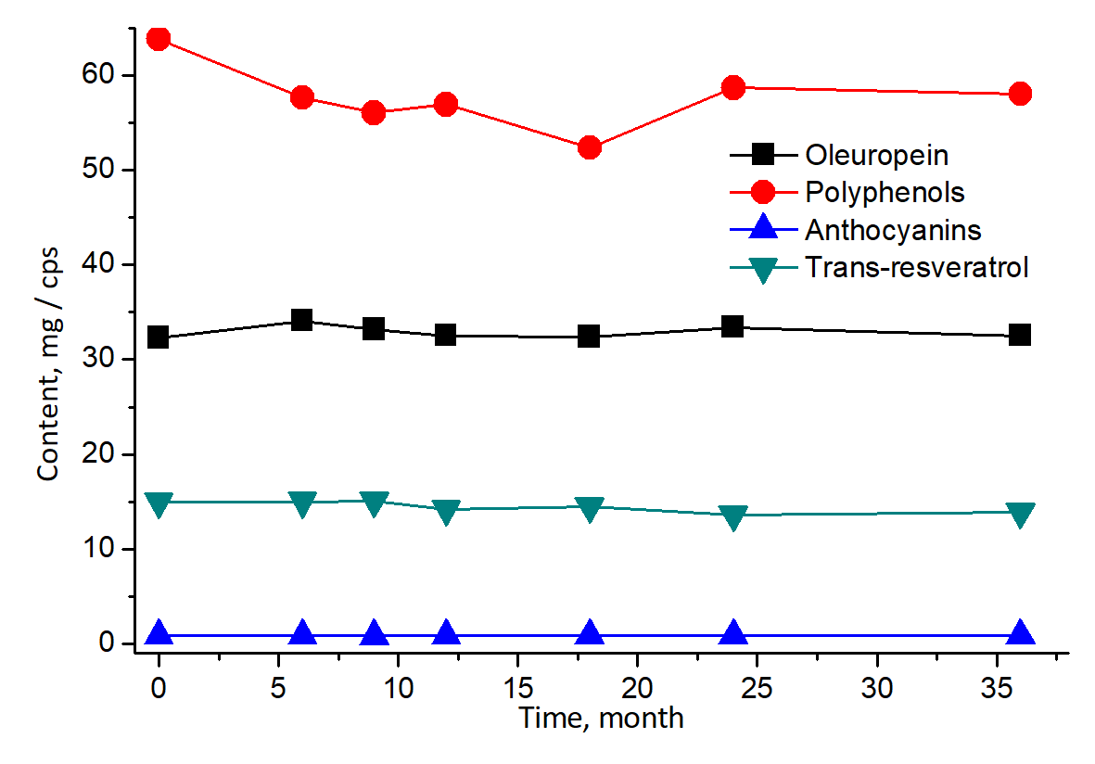
Figure 2. Content of active ingredients in long-term stability study during 36 months
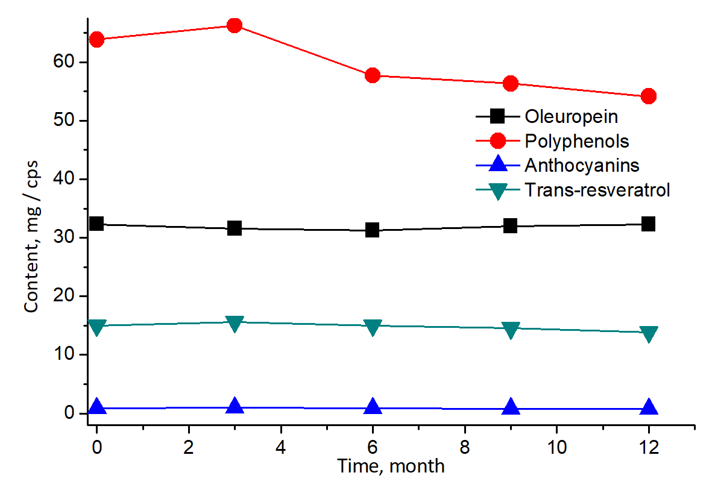
Figure 3. Content of active ingredients in intermediar stability study during 12 months

Table 3. Results for the stability study for vine leaf during 36 months
TESTS |  | Appearence | Poliphenol  content |  |  | Antocyian content |  | Trans resveratrol  content | Disintegration
REQUIREMENTS |  | Hard gelatine capsules filled with red brown powder | (45,00-78,75)  mg/cps |  |  | (0.45-1.50)  mg/cps |  | (7.5-43.05)  μg/cps | Less than 15min. in water 37 °C
Test term (months) | Test condition | R E S U L T S
Initial result |  | Complies |  | 67.80 |  |  | 1.22 | 15.17 | 6
0 | 25°C/  60%RH | Complies | 63.84 |  | 0.88 |  |  | 15.00 | 10
6 | 25°C/  60%RH | Complies | 57.65 |  | 0.86 |  |  | 15.03 | 10
9 | 25°C/  60%RH | Complies | 56.04 |  | 0.84 |  |  | 15.12 | 9
12 | 25°C/  60%RH | Complies | 56.93 |  | 0.86 |  |  | 14.24 | 8
18 | 25°C/  60%RH | Complies | 52.37 |  | 0.87 |  |  | 14.52 | 4
24 | 25°C/  60%RH | Complies | 58.68 |  | 0.86 |  |  | 13.64 | 3
36 | 25°C/  60%RH | Complies | 58.03 |  | 0.85 |  |  | 13.95 | 8
3 | 30°C/  65%RH | Complies | 66.24 |  | 0.94 |  |  | 15.62 | 9
6 | 30°C/  65%RH | Complies | 57.71 |  | 0.86 |  |  | 14.99 | 9
9 | 30°C/  65%RH | Complies | 56.33 |  | 0.83 |  |  | 14.53 | 5
12 | 30°C/  65%RH | Complies | 54.14 |  | 0.82 |  |  | 13.86 | 4
3 | 40°C/  75%RH | Complies | 54.12 |  | 0.85 |  |  | 14.89 | 4
6 | 40°C/  75%RH | Complies | 60.24 |  | 0.88 |  |  | 15.12 | 6

Table 4. Results for the stability study for olive leaf during 36 months
TESTS |  | Appearence | Oleoeuropein  content |  |  | Disintegration |  | Loss on drying  (2h/105°C)
REQUIREMENTS |  | Hard gelatine capsules filled with brown powder | (30,00-50.00)  mg/cps |  |  | Less than 15min. in water 37 °C |  | information
Test term (months) | Test condition | R E S U L T S
Initial result |  | Complies |  | 35.20 | 6 |  | 6
0 | 25°C/  60%RH | Complies | 32.30 |  |  | 4 | 10
6 | 25°C/  60%RH | Complies | 34.09 |  |  | 10 | 10
9 | 25°C/  60%RH | Complies | 33.18 |  |  | 10 | 9
12 | 25°C/  60%RH | Complies | 32.52 |  |  | 5 | 8
18 | 25°C/  60%RH | Complies | 32.40 |  |  | 5 | 4
24 | 25°C/  60%RH | Complies | 33.42 |  |  | 4 | 3
36 | 25°C/  60%RH | Complies | 32.52 |  |  | 6 | 8
3 | 30°C/  65%RH | Complies | 31.57 |  |  | 9 | 9
6 | 30°C/  65%RH | Complies | 31.24 |  |  | 10 | 9
9 | 30°C/  65%RH | Complies | 31.97 |  |  | 8 | 5
12 | 30°C/  65%RH | Complies | 32.27 |  |  | 7 | 4
3 | 40°C/  75%RH | Complies | 35.46 |  |  | 9 | 4
6 | 40°C/  75%RH | Complies | 37.81 |  |  | 10 | 6

4. Conclusion
The critical quality atributes of dry herbal extract from Olive leaf and Vine leaf revealed that it has promising properties, such as low residual moisture and stability in a humid atmosphere, which supports its use in an intermediary product for manufacture of solid dosage forms. On the other hand, the rheological properties of the powder could show limited applicaton for the processes that depend on flow and development of solid dosage forms such as capsules. However the use of excipents such as lactose monohydrate and colloidal silicon dioxide provide significant improvements on the extract properties, demonstrating its feasibility for production of capsules. Results given in this study show that optimal capsule formulation with dry herbal extracts was developed which is confirmed during stability study testing. This ensures precise dosing during administration of API from herbal drug. The development of our own formulation and capsule technology with dry herbal extracts can be carried out on conventional devices: a granulator mixer and a capsule machine as illustrated in this manuscript. Floralend® Galenika dietary product portfolio is thus expanded with new products.

References

[1] GBD 2016 Causes of Death Collaborators. Global, regional, and national age-sex specific mortality for 264 causes of death, 1980-2016: a systematic analysis for the Global Burden of Disease Study 2016. Lancet 2017;390(10100):1151-1210. doi: 10.1016/S0140-6736(17)32152-9.

[2] Martinez-Gonzalez MA, Bes-Rastrollo M, Serra-Majem L, Lairon D, Estruch R, Trichopoulou A. Mediterranean food pattern and the primary prevention of chronic disease: recent developments. 2009;67(Suppl 1):111–6.

[3] Schwingshackl L, Heiner B, Stelmach-Mardas M, Gottschald M, Dietrich S, Hoffmann G, Chaimani A. Dietary Supplements and Risk of Cause-Specific Death, Cardiovascular Disease, and Cancer: A Systematic Review and Meta-Analysis of Primary Prevention Trials–, Advances in Nutrition, Volume 8, Issue 1, 1 January 2017, Pages 27–39,https://doi.org/10.3945/an.116.013516

[4] Lockyer S, Yaqoob P, Spencer JPE, Rowland I. Olive leaf phenolics and cardiovascular risk reduction: Physiological effects and mechanisms of action.Nutr. Aging.(2012);1:125–140.

[5] Lockyer S, Rowland I., Spencer JPE. Impact of phenolic-rich olive leaf extract on blood pressure, plasma lipids and inflammatory markers: a randomised controlled trial. Eur J Nutr (2017) 56: 1421. https://doi.org/10.1007/s00394-016-1188-y

[6] Ivanov M, Vajic UJ, Mihailovic-Stanojevic N, Miloradovic Z, Jovovic D, Grujic-Milanovic J, Karanovic D, Dekanski D. Highly potent antioxidant Olea europaea L. leaf extract affects carotid and renal haemodynamics in experimental hypertension: the role of oleuropein. EXCLI J.(2018). 17, 29-44.

[7] Susalit E, Agus N, Effendi I, Tjandrawinata RR, Nofiarny D, Perrinjaquet-Moccetti T,. Olive (Olea europaea) leaf extract effective in patients with stage-1 hypertension: Comparison with Captopril. Phytomedicine. 2011;18(4):251–8.

[8] Aouey B, Samet AM, Fetoui H, Simmonds MSJ, Bouaziz M. Anti-oxidant, anti-inflammatory, analgesic and antipyretic activities of grapevine leaf extract (Vitis vinifera) in mice and identification of its active constituents by LC-MS/MS analyses. Biomed Pharmacother. 2016; 84:1088-1098. doi: 10.1016/j.biopha.2016.10.033.

[9] EMA/HMPC/464684/2016 Committee on Herbal Medicinal Products (HMPC). European Union herbal monograph on Vitis vinifera L., folium, may 2017.

[10] Kunle OF, Egharevba HO, Ahmadu PO. Standardisation of Herbal Medicines- A Review. Int. J. Biodvers., (2012). 4 (3): 101-112.

[11] Gibson M. Pharmaceutical Preformulation and Formulation 2001. 441-453.

[12] Rastogi S, Pandey MM, Rawat AK. Traditional herbs: a remedy for cardiovascular disorders. Phytomedicine.2016; 23(11):1082-9. doi: 10.1016/j.phymed.2015.10.012.

[13] Costa LJL, Fereira MRA, Souza TP, Soares LAL. Influence of excipients on mixtures containing high amount of dry extract from Aesculus hippocastanum L. 2016. Revista Fitos, Rio de Janeiro, Vol, 10(4), 375-547.
Ispitivanje uticaja ekscipijenasa na kritične tehnološke parametre u FORMULACIJI kapsula sa suvim biljnim ekstraktima

Branka Grujic¹*, Zdenka Vukovic¹, Jelena Veljkovic-Giga¹, Svetlana Ibric²
Dragana Dekanski¹

¹Galenika a.d., Institut za istraživanje i razvoj, Batajnički drum bb, 11080 Beograd, Srbija
²Farmaceutski fakultet, Vojvode Stepe 350, 11000 Beograd, Srbija

Sažetak

U prevenciji i lečenju kardiovaskularnih bolesti, ishrana i dodaci ishrani imaju značajnu ulogu. List masline i list vinove loze, zahvaljujući svojim sastojcima, svrstavaju se u red moćnih prirodnih antioksidanasa i deluju protektivno na kardiovaskularni sistem. Njihovom ekstrakcijom se postiže veća koncentracija aktivnih sastojaka. Suvi biljni ekstrakti su veoma osetljivi na prisustvo vlage i povišenu temperaturu, te sa farmaceutsko-tehnološkog aspekta predstavljaju sirovine nepovoljnih tehnoloških karakteristika. Cilj ovog rada je bio ispitivanje i poređenje uticaja različitih pomoćnih materija u formulaciji kapsula sa ova dva suva biljna ekstrakta, odnosno odabir ekscipijenasa koji će svojim prisustvom obezbediti odgovarajuće tehnološke parametre u procesu proizvodnje. Tehnološki parametri koji su praćeni su protočnost, nasipna i sabijna gustina jer od njih najviše zavisi da li će moći da se izvede tehnološka operacija punjenja kapsula. Ispitivan je uticaj pomoćnih supstanci na navedene parametre i na osnovu dobijenih rezultata došlo se do odgovarajućih, optimalnih formulacija kapsula koje garantuju homogenost i stabilnost preparata.

