Preparation and characterization of activated carbon obtained from apricot pits for Cu(II) removal from aqueous solutions
Liliya Manoilova¹, Kamelia Ruskova², Metodi Mladenov¹, Vesislava Toteva¹ and Georgi Georgiev¹
¹Faculty of Chemical Technology, University of Chemical Technology and Metallurgy, Sofia, Bulgaria
²Department of Chemistry, Faculty of Electronic Engineering and Technologies, Technical University of Sofia, Sofia, Bulgaria

Abstract
Wastewater from chemical, petrochemical, and metallurgical industries contains different dissolved pollutants, characterized with high toxicity. In recent decades, industrial water treatment to remove heavy metal ions has become increasingly important due to their toxicity and the potential risk of accumulation in the food chain. This requires the application of various methods to reduce heavy metal ion concentrations to acceptable levels. In this respect, adsorption processes based on different sorbents are widely used for industrial wastewater treatment. For this investigation, apricot pits were pyrolyzed and chemically activated with potassium hydroxide to produce activated carbon. The adsorption capacity of the resulting material for removing Cu(II) ions from aqueous solutions was then investigated. The results have shown that these carbon-based adsorbents possess a high surface area and favourable textural characteristics, making them promising candidates for the removal of copper ions from aqueous solutions.
Keywords: Adsorption, active carbon, copper ions, water treatment, safety consumption.
Technical paper
UDC 661.183.2:634.21:546.562
Hem. ind. 80(2) 87-94 (2026)

Available on-line at the Journal web address: http://www.ache.org.rs/HI/
1. INTRODUCTION
Water is essential for life on Earth, and access to clean water is critical for both humans and ecosystems. Water quality depends on its physicochemical and biological parameters. Changes in parameters such as pH, temperature and heavy metal content in can render water unsafe for human consumption [1].
The problem of water contamination today is very relevant in connection with the prolonged increase of Anthropogenic pressure on the environment. High water pollution with toxic substances requires adoption of immediate measures to reduce the environmental risk, otherwise the water resources of the planet will be in a catastrophic state [2].
Organic matter, nutrients, pharmaceutical and personal care products, poly- and perfluoroalkyl substances, biocides, heavy metals, dyes, radionuclides, plastics, nanoparticles and pathogens are among the pollutants of major concern. Heavy metal ions are among the most spread contaminants. Heavy metals and metalloids are the elements with an atomic density greater than 4 g cm⁻³ including copper (Cu), cadmium (Cd), zinc (Zn), lead (Pb), mercury (Hg), arsenic (As), silver (Ag), chromium (Cr), iron (Fe) and platinum (Pt). These toxic metals are released daily into aqueous environment from diverse natural and anthropogenic sources. In many regions the average concentrations of Cr, Mn, Fe, Co, Ni, As and Cd found in surface water exceeds the permissible limits for drinking water [3-4].
Nowadays purification processes based on the adsorption methods are widely used for industrial wastewater treatment. Activated carbons are among the most versatile adsorbents, due to their properties that meet the increasing requirements for drinking water purity. Advances in modern technology have continually enhanced the quality and effectiveness of activated carbons [5].
One of the main methods for producing activated carbon involves the carbonization of carbon-containing materials, followed by chemical activation to increase the specific surface area and develop a porous texture. The main selection criteria for activated carbon for specific applications include texture parameters (such as specific surface area, total pore volume, meso- and micropore volumes, and pores size distribution), the chemical nature of the surface (presence of functional oxygen groups), granulometric composition (dispersity), and mechanical properties, among others. It has been established that the high sorption capacity of activated carbons for metal ions in aqueous solutions is mainly due to the presence of oxygen-containing functional groups on their surface. The applications of activated carbons are largely determined by their specific surface area and the characteristics of their porous texture [6-7].
The aim of the present paper was to investigate the relationship between the porous texture and chemical nature of the surface of activated carbon obtained from apricot pits, and to evaluate the sorption capacity and their suitability for wastewater treatment, contaminated with Cu²⁺ ions.
2. EXPERIMENTAL
2. 1. Procedure of obtaining of activated carbon
Activated carbon (AC) was obtained from apricot pits, pyrolyzed at 700 ºC for 1 h (Figure 1). Then the obtained material was milled and mixed homogeneously with activating agent KOH (Merck, p.a., Germany). Two samples with different mass ratios AC:KOH were investigated: 1 : 1 and 1 : 2 AC : KOH, labelled as ACCA1 and ACCA2. The chemical activation process with potassium hydroxide was carried out in a tube vacuum furnace at 500 °C for 1 hour. The samples obtained were neutralized with an appropriate amount of 10 wt.% HCl (Valerus, p.a., Bulgaria) to remove the residual chemicals after the activation process. The obtained samples were washed multiple times with distilled water until neutrality. Finally, the AC samples were subjected to drying at 110 °C for 12 hours.
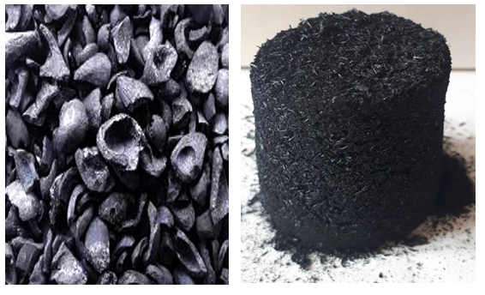
Figure 1. Carbonized apricot pits and AC after carbonization
2. 2. Experimental procedures
Elemental analysis was performed using a EuroEA Analyzer, model 3000 (manufacturer, country), to determine the elemental composition and weight, wt.% of carbon, hydrogen and nitrogen in the activated carbon samples. The oxygen content was calculated by difference, based on these measurements.
The porous texture of the obtained AC samples was characterized by measuring nitrogen N₂ adsorption isotherms at 77 K on an automatic gas adsorption porosimeter Surfer (Thermo Scientific, United States). The specific surface area was determined using Brunauer-Emmett-Teller (BET) method [8]. The total pore volume (V_{t}) was determined at a relative pressure P_{i}/P₀ = 0.9, where P_{i} is the real gas pressure during the measurement, and P₀ is the saturated vapor pressure of the same gas at the temperature of the experiment measurement.
Surface chemistry of the AC samples was analysed by a Fourier transform infrared (FTIR) spectrometer (Nicolet Avatar 360 FTIR spectrometer, Germany) and registered in the region 500 to 4000 cm⁻¹. The spectra were recorded at a spectral resolution of 2 cm⁻¹ and accumulation of 64 scans.
The iodine number of AC samples was determined by a standard test method [9] presenting the amount of iodine absorbed (in mg) by 1 g of the material.
The surface morphology of activated carbons was analysed using scanning electron microscopy coupled with energy-dispersive X-ray spectroscopy (SEM-EDX) by a JEOL JSM-6390 instrument (Philips, Germany). The measurement was done with high resolution in mode 10 kV, 0º and 0.1 mm scan spacing.
2. 3. Procedure for adsorption capacity measurement
The adsorption capacity of the activated carbons in regard to Cu²⁺ ions was determined using the following methodology: aqueous solution of CuSO₄.5H₂O (Valerus, p.a., Bulgaria) at the concentration of 5 g L⁻¹ was prepared. Precisely determined amounts of the CuSO₄×5H₂O solution (10, 20, 30, 40 and 50 mL) were taken and transferred into to flasks. Then samples, labelled as K1 to K4 were diluted with distilled water to 50 mL to obtain the corresponding concentrations K1 to K5. The adsorption experiments were conducted using 0.2 g of activated carbon (type ACCA2) for each flask followed by homogenization for 1 h at 25 ± 2 °C. The initial pH of the copper solutions was in the range pH 4.0 to 4.5, while after the adsorption the final pH value was in the range 6.0 to 6.5. The initial and residual concentrations of Cu²⁺ ions in the solutions were determined with UV-VIS Spectrophotometer, by using the cuprizone [10]. After the treatment with AC, the concentration of Cu(II) ions decreased, and nearly complete removal of the metal ions was recorded. As a result, the pH values change from acidic to approximately neutral. All adsorption experiments were performed in five replicates, and reported values correspond to the average values obtained.
3. RESULTS AND DISCUSSION
3. 1. Elemental composition analysis
The results of the elemental analysis of the AC samples are presented in Table 1.
Table 1. Elemental composition of the activated carbon samples
Sample | Content, wt.%
Sample | Carbon | Hydrogen | Nitrogen | Oxygen
ACCA1 | 95.29 | 2.69 | < 0.01 | 2.02
ACCA2 | 77.34 | 3.33 | < 0.01 | 19.33

The elemental composition of the obtained activated carbon is characterized by high carbon contents (∼77 to 95 wt.%) and low hydrogen contents (up to 3.33 wt.%) for both ACCA1 and ACCA2 samples. There was an increase in the oxygen content in the sample activated with a higher ratio AC:KOH. In specific, the oxygen content increased from ∼2 wt.% in ACCA1 to ∼19 wt.% in ACCA2 because of the activation process, confirmed by FTIR spectra, showing the formation of significant amounts of oxygen-containing forms on the carbon surface.
3. 2. Adsorption-textural parameters determined by BET analysis
The results of the textural analysis of the AC samples are shown in Table 2.
Table 2. Specific surface area and basic textural parameters of the activated carbons
Sample | S_{BET} / m²g⁻¹ | V_{micro} / cm³g⁻¹ | V_{mezo} / cm³g⁻¹ | V_{micro} / % | V_{mezo} / % | V_{t} / cm³g⁻¹
ACCA1 | 929 | 0.3626 | 0.1213 | 74.9 | 25.1 | 0.4839
ACCA2 | 1003 | 0.3882 | 0.1459 | 72.7 | 27.3 | 0.5341

The data in Table 2 show that ACCA2 is characterized by a high specific surface area (S_{BET} = 1003 m² g⁻¹) and total pore volume (V_{t} = 0.5341 cm³ g ⁻¹) compared with the results determined for the sample ACCA1 (S_{BET} = 929 m² g⁻¹ and V_{t} = 0.4839 cm³ g⁻¹). The nitrogen adsorption-desorption isotherms of activated carbon samples ACCA1 and ACCA2 are presented in Figures 2 and 3.
According to the IUPAC classification, the nitrogen adsorption isotherms of the samples correspond to Type I, which is typical of micro-mesoporous textures. The part of the isotherms of relatively low pressures (relative pressure around 0.05 to 0.1) corresponds to micropores filling with tendency to saturation near 0.3 typical for microporous adsorbents. A higher saturation pressure in the sample ACCA2 shows a more developed porous texture of the obtained activated carbon.
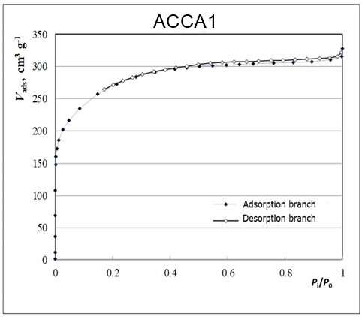
V_{abs} / cm³ g⁻¹
Figure 2. Low-temperature nitrogen adsorption-desorption isotherm for the ACCA1 sample
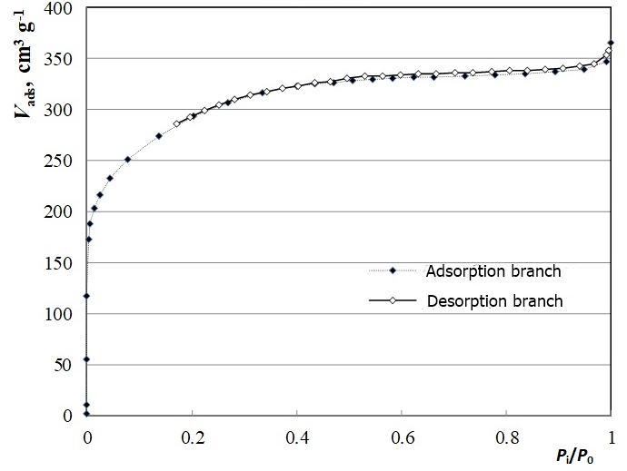
V_{abs} / cm³ g⁻¹
Figure 3. Low-temperature nitrogen adsorption-desorption isotherm for the ACCA2 sample
3. 3. Fourier transform infrared spectroscopy analysis
The FTIR spectra of the obtained adsorbents ACCA1 and ACCA2 are presented in Figure 4.
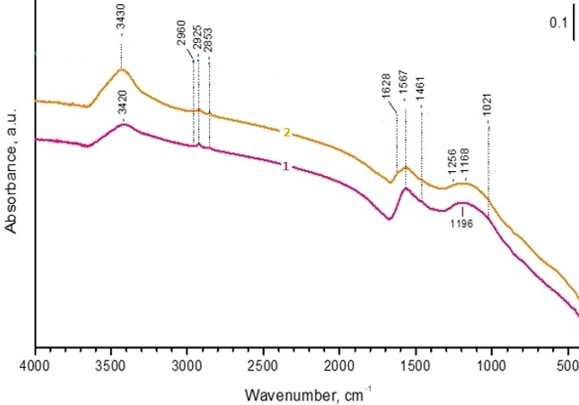
Figure 4. Fourier transform infrared spectra of 1 - ACCA1 and 2 - ACCA2 samples
The absorption peak at 3430 cm⁻¹ can be attributed to the stretching vibration of -OH groups, which is characteristic of hydroxyl functional groups and typically appears in the 3500 to 3700 cm⁻¹ range. The bands around 2900 cm⁻¹ are due to aliphatic C-H structures. The peaks about 1570 and 1630 cm⁻¹ are due to stretching vibration of the C=C functional group [11].
The absorption bands in the 1260 to 1050 cm⁻¹ region are attributed to C–O stretching vibrations of oxygen-containing functional groups present on the carbon surface. The bands around 1400 cm⁻¹ may be associated with O–H bending vibrations, C–H deformation, or symmetric stretching of carboxylate groups [12].
3. 4. Iodine number
The iodine number is a measure of the relative activation level of carbons by adsorption of iodine from an aqueous solution, where a higher value indicates a higher degree of activation. The Iodine number determined for the sample ACCA1 was 599.8 mg g⁻¹ versus 710.1 mg g⁻¹ determined for the ACCA2 sample. This indicates that the sample with higher content of activating agent should have better adsorption properties. This agrees with the increased surface area for the sample activated with the higher content of activating agent, confirmed by the BET analyses.
3. 5. Scanning electron microscopy
The surface morphology of activated carbons was analysed using SEM-EDX technique showing similar features. Figure 5 shows micrographs of the ACCA2 sample, which was selected for its well-developed micro- and mesoporous structure and higher specific surface area, resulting from chemical activation with KOH, as confirmed by BET analysis.
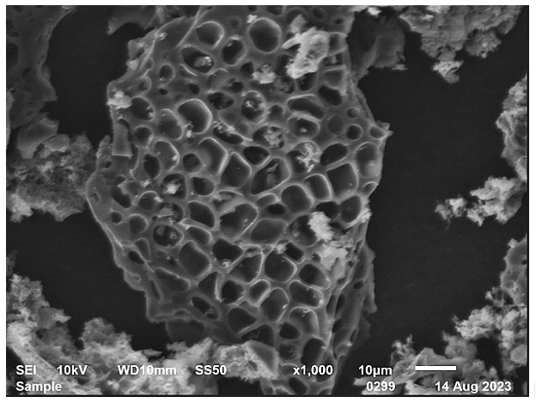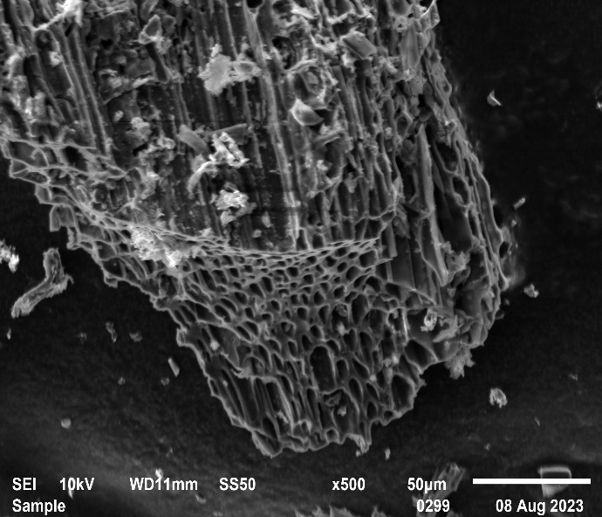
Figure 5. SEM images of the ACCA2 sample at different magnifications
3. 6. Adsorption capacity of the activated carbons for Cu(II) ions in aqueous solutions
The amount of Cu(II) ions adsorbed by ACCA2 was determined by calculating the difference between the initial ion concentration and the concentration measured after the homogenization. The measured concentrations in the initially prepared solutions and after the adsorption experiments are shown in Table 3.
Table 3. Measured Cu(II) concentrations by UV-VIS analysis before and after the adsorption experiments using ACCA2
Solution | Initial concentration of Cu²⁺, g L⁻¹ | Residual concentration of Cu²⁺, g L⁻¹
K1 | 0.933 | 0.737
K2 | 1.867 | 1.424
K3 | 2.800 | 1.915
K4 | 3.734 | 2.996
K5 | 4.667 | 4.371

The UV-VIS analysis confirmed that the activated carbon type ACCA2 produced from apricot pits generally reduces the concentration of copper ions in the investigated solutions. The highest adsorbed amounts were observed in solutions K3 and K4, in which the Cu(II) concentrations decreased to ∼1.9 and 3.0 g L⁻¹, respectively. The highest adsorption capacity was observed for sample K3 where the adsorbed amount of copper per mass of the adsorbent was 221.2 mg g⁻¹. Further increases in the initial Cu(II) concentration did not lead to the increase in adsorption capacity, indicating possible saturation of active adsorption sites.
4. CONCLUSIONS
The results obtained show that produced activated carbons ACCA1 and ACCA2 are with high specific surface area and well developed micro- and mesopores structure. The sample ACCA2 activated with a higher content of the activating agent has shown better texture parameters. In addition, chemical activation with potassium hydroxide increases the number of hydroxyl groups, which in turn favours metal ion adsorption. Cu(II) ion adsorption studies confirmed that the activated carbon produced from apricot pits generally reduces the ion concentration in the investigated solutions. All those results permit us to conclude that the generated ACs can be used effectively as adsorbents in liquid-phase applications and water purification processes.
Acknowledgement: The study is funded by the European Union-Next GenerationEU, through the National Recovery and Resilience Plan of the Republic of Bulgaria, project № BG-RRP-2.004-0002, „BiOrgaMCT“.
REFERENCES
Zhang P, Yang M, Lan J, Huang Y, Zhang J, Huang S, Yang Y, Ru J. Water Quality Degradation Due to Heavy Metal Contamination: Health Impacts and Eco-Friendly Approaches for Heavy Metal Remediation, Toxics. 2023; 11: 828. https://doi.org/10.3390/toxics11100828
Trus I, Gomelya M, Vorobyovа V, Skіba M. Effectiveness of complexation-nanofiltration during water purification from copper ions, J Chem Techno. Metall. 2021; 56 (5): 1008-1015. https://journal.uctm.edu/node/j2021-5/16_20-65_p_1008-1015.pdf
Zamora-Ledezma C, Negrete-Bolagay D, Figueroa F, Zamora-Ledezma E, Ni M, Alexis F, Guerrero V. Heavy metal water pollution: A fresh look about hazards, novel and conventional remediation methods, Environ Technol Innov. 2021; 22: 101504. https://doi.org/10.1016/j.eti.2021.101504.
Koliehova A, Trokhymenko G, Magas N, Gomelya N, Trus I. Study of the Process of Electro Evolution of Copper Ions from Waste Regeneration Solutions, J Ecol Eng. 2020; 21(2): 29-38. https://doi.org/10.12911/22998993/116351.
Monser L, Adhoum N., Modified activated carbon for the removal of copper, zinc, chromium and cyanide from wastewater, Separ Purif Technol. 2002; 26: 137-146. https://doi.org/10.1016/S1383-5866
Boehm H. Some aspects of the surface chemistry of carbon blacks and other carbons, Carbon 1994; 32(5): 759-769. https://doi.org/10.1016/0008-6223(94)90031-0
Bhatnagar A, Hogland W, Marques M, Sillanpaa M. An overview of the modification methods of activated carbon for its water treatment applications, Chem Eng J. 2013; 499-511. https://doi.org/10.1016/j.cej.2012.12.038
Determination of the specific surface area of solids by gas adsorption-BET method, ISO 9277:2022, 2022. https://www.iso.org/standard/44941.html
Freese SF, Trollip DL, Nozaic DJ. Manual for testing of water and wastewater treatment chemicals, WRC Report No: 1184/1/04. ISBN No: 1-77005-101-5, 2004. https://www.wrc.org.za/wp-content/uploads/mdocs/1184-1-041.pdf
Bulgarian Institute for Standardization, БДС 6401:1979. Reagents. Determination of copper impurity content by colorimetric methods. https://bds-bg.org/bg/project/show/bds:proj:25205 (in Bulgarian)
Gomez-Serrano I, Piriz-Almeida F, Duran-Valle C, Pastor Villegas J. Formation of oxygen structures by air activation, A study by FT-IR spectroscopy, Carbon. 1999; 37: 1517-1528. https://doi.org/10.1016/S0008-6223(99)00025-1
Hendawy A. Variation in the FTIR spectra of a biomass under impregnation, carbonization and oxidation conditions, J Anal Appl Pyrol. 2006: 75: 159. https://doi.org/10.1016/j.jaap.2005.05.004.

Priprema i karakterizacija aktivnog uglja iz koštica kajsije za uklanjanje Cu(II) jona iz vodenih rastvora
Liliya Manoilova¹, Kamelia Ruskova², Metodi Mladenov¹, Vesislava Toteva¹ i Georgi Georgiev¹
¹Faculty of Chemical Technology, University of Chemical Technology and Metallurgy, Sofia, Bulgaria
²Department of Chemistry, Faculty of Electronic Engineering and Technologies, Technical University of Sofia, Sofia, Bulgaria

(Stručni rad)

Izvod
Otpadne vode iz hemijske, petrohemijske i metalurške industrije sadrže različite rastvorene zagađujuće materije koje se odlikuju visokom toksičnošću. Tokom poslednjih decenija, tretman industrijskih otpadnih voda u cilju uklanjanja jona teških metala postao je od izuzetnog značaja zbog njihove toksičnosti i mogućnosti akumulacije u lancu ishrane. To zahteva primenu različitih metoda za smanjenje koncentracije jona teških metala na prihvatljiv nivo. U tom kontekstu, adsorpcioni procesi zasnovani na primeni različitih sorbenata široko se koriste za prečišćavanje industrijskih otpadnih voda. U ovom istraživanju, koštice kajsije su podvrgnute pirolizi i hemijskoj aktivaciji kalijum-hidroksidom radi dobijanja aktivnog uglja. Nakon toga ispitivan je adsorpcioni kapacitet dobijenog materijala za uklanjanje Cu(II) jona iz vodenih rastvora. Rezultati su pokazali da ovi adsorbenti na bazi ugljenika poseduju veliku specifičnu površinu i povoljne teksturalne karakteristike, što ih čini perspektivnim kandidatima za uklanjanje jona bakra iz vodenih rastvora.
Ključne reči: Adsorpcija, aktivni ugljenik, joni bakra, obrada otpadne vode, bezbedna potrošnja

t

Corresponding authors: Liliya Manoilova E-mail: lili_manoilova@abv.bg; https://orcid.org/0009-0002-8218-0393 Faculty of Chemical Technology, University of Chemical Technology and Metallurgy, Sofia, Bulgaria Co-authors: Kamelia Ruskova https://orcid.org/0009-0006-7719-9419, Metodi Mladenov https://orcid.org/0000-0002-8548-1856, Vesislava Toteva https://orcid.org/0000-0002-5366-8798 and Georgi Georgiev https://orcid.org/0009-0005-9752-7654 Paper received: 9 January 2025; Paper accepted: 15 June 2026; Paper published: 20 June 2026. https://doi.org/10.2298/HEMIND250109006M

